Activate Fund – Guidance for Applicants
Thank you for your interest in applying to the Activate Fund. Please read this guidance and our FAQs before you complete your application form.

- What is Activate
- Who can apply
- What you can do with an Activate grant
- What makes a strong application
- What you can spend the money on
- What we’re unable to fund
- How to apply
- The questions we ask
- What you need to apply
- What happens next
11. Important to know

What is Activate
The Activate Fund offers grants of up to £30,000 for a project of up to 2 years to Fellows who have a clear vision and plan for applying their Fellowship learning to benefit people in the UK.
You can apply to deliver a project in any sector; it does not need to be the same as your Fellowship, as long as you can demonstrate that your Activate project builds on what you learned during your Fellowship and falls within one of our eight universal themes. The focus of your activities and the change you are working to create can be local, regional, or national.

Who can apply
Activate is open to all UK-based Fellows who have completed their overseas learning and published their findings. This would usually be by submitting a report for publication on our website. Fellows who have already received an Activate grant in the pilot are not eligible to apply but if you applied and were unsuccessful you can re-apply.
The Fund will be open for at least five years, so if you have not yet completed your Fellowship report do not worry as there will be further opportunities to apply with more awards being made in each year.
If we have not sent you an email invitation to apply and you think that you are eligible (especially if you completed your Fellowship before 2005), please contact the Activate team.
In line with the Fellowship, we are looking for committed and motivated people, those driven by personal and professional experiences and dedicated to tackling a societal challenge about which they care passionately.

Apply as an individual
You can apply to the Activate Fund as an individual and, if successful, hold and report on the grant yourself.

Apply as an organisation
You can also apply as part of an organisation by whom you are employed or in some way associated and request the grant to be paid to and held by the organisation. You will still be personally responsible for the grant; you must play a leading role in the delivery of the activities it is funding. If you leave the organisation during the grant period, you will need to demonstrate how you will remain involved in the project.

Apply as a group
We welcome projects which are delivered in collaboration between two or more Fellows, if they meet the eligibility criteria. One Fellow must lead and hold the grant, and we will ask a few additional questions in the application form and at interview to explore the benefits and feasibility of your proposed collaboration. If your project is shortlisted for interview, all Fellows involved in the bid will be invited to attend. Fellows applying within a collaboration will not be eligible for separate Activate Fund awards as individuals.

What you can do with an Activate grant

Activate is designed to support Fellows wishing to create change in their chosen field. You might find these prompts helpful to think about:

- Where do you see gaps in thinking, provision, or policy?
- What could you start, test, or catalyse that would deliver the change you have seen in the countries you visited on your Fellowship?
- What support do you need that will take you and your idea beyond what would be possible without our funding?
- What have you tried and failed to get other funders to support?
- What inspiration did you take from your Fellowship learning that you have not had the time or space to develop and apply in your sector or community since?

Activate is Fellow-led; you will know best which activities will deliver the change you seek. However, to provide some steer to your project design and to help us evaluate diverse projects across a range of sectors, we have identified three possible routes to change.
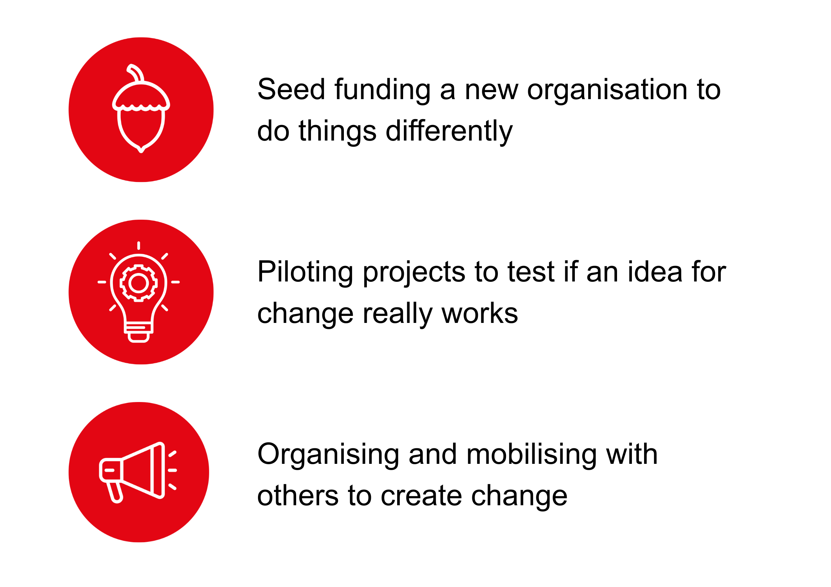

a. Building capacity and infrastructure
Seed funding for a brand new or emergent organisation, or a new or evolving partnership or programme that responds to unmet or inadequately met needs. It’s likely that we will be one among other funders supporting this kind of project – we may be the first brick in the wall that encourages others to join. We don’t require you to have match funding in place at the time you apply to Activate, but we will want to understand more about your plans for sustaining what Activate enables you to start.

b. Experimenting to see if what works overseas could work in the UK
This could be by piloting new approaches to delivering a service, a new model or intervention trialled on a local or regional level, or with a particular group or community. The trial could take different forms depending on your sector, but the aim is to test that the idea really works in practice, to build an evidence base, to engage key stakeholders in participating in delivery and supporting wider adoption.

c. Building narrative and movements for change
This could be a national or local campaign for policy or legislative change; further publication or events to disseminate and promote your Fellowship recommendations; community organising; or bringing networks and alliances together to build momentum for change.

What makes a strong application

We’re more likely to fund ideas where:
- there is a credible connection with the Fellowship learning
- there is a clear vision for change which fits comfortably into one of the three routes set out above
- the applicant/s have relevant experience (lived or learned)
- it is clear how beneficiaries of the project will inform its design and delivery
- there is a strong rationale for why the funding is needed now and evidence that there’s momentum behind the idea
- the plans are realistic, with achievable goals and a clear delivery plan
- there's a good understanding of what progress looks like and how it’ll be evaluated
- thought has been given to centring care, for the applicant/s and others involved in the project
- thought has been given to the sustainability of the project beyond the life of the grant

We will prioritise awarding grants to applications from Fellows who would find it difficult to find funding elsewhere, for example:

- those who have a limited track record in applying for or receiving funding;
- those who are newly established in their career or returning from a career break and they don’t yet have the platform within your organisation, sector, or profession to achieve change;
- those who are from an underserved community with limited access to, or experience of, securing funding;
- those who are self-employed and have taken a leap of faith to go it alone to try and get their idea off the ground;
- those who are working part-time to manage caring responsibilities.

We will also prioritise applications to deliver a project which is particularly innovative, experimental, groundbreaking, or would carry too great a risk for a funder with whom the applicant has no prior connection.

What you can spend the money on

Your time working on your Activate project
If you are employed, an Activate grant can cover part of your salary or backfill to allow you to focus for a defined period on your project. If you are self-employed or plan to reduce your employed working hours to deliver your project, a proportion of the grant can contribute to your income. These costs should not constitute more than 50 per cent of your total budget.

Contribution to the salary of other staff
If more than 50 per cent of your budget is to pay staff in the organisation in which you work, you must be able to explain why these costs cannot be covered by the organisation (e.g. staff are being seconded to your project to contribute specific skills, being trained to become champions of a new approach). The Activate budget cannot be used to fill a funding gap in the organisation or department budget.

Consultancy or partnership fees
These should be directly related to the delivery of your project. For example, partnering with a university department to evaluate your pilot project.

Enabling participation
This can include a reasonable day rate as an honorarium paid to enable participation and can also include reasonable expenses to pay for a participant’s travel, subsistence, and additional caring costs.

Care or access costs
This could include a contribution to extra childcare or carer costs for family members or others for whom you are responsible.

Training
To develop your own or others’ capacity, skills, or qualifications to carry out your project.

Specialist advice
Access to professional supervision or advice, technical or digital expertise, legal costs, trademarking, accountancy, business support, fundraising support, website design, copyrighting, translation, the adaptation of resources for different audiences, equipment, etc.

Training workshops and events if these are essential to convening stakeholders, building movements or communities of practice, or sharing your project’s learning.

Resources
Production of online or offline training materials or other resources connected to delivering your project or enabling inclusive participation.

Equipment
Small items of equipment if essential to the delivery of your project. These cannot constitute more than 15 per cent of your total budget.

Travel costs
For travel within the UK, if essential to delivering your project, sharing the results, convening, building alliances, or networks.

Contingency
You can also include a 15 per cent contingency to be able to use your budget flexibly in response to changing needs.

This grant can support projects of 12, 18, or 24 months. Please consider the timeline of your project carefully and be realistic about the time it takes to develop relationships, bring stakeholders on board, or build partnerships if these are core to your work.

What we’re unable to fund

- Work that is not for public benefit
- Promotion of a political party
- Proselytising on religious grounds
- Academic studies, dissertations for undergraduate degrees, degree placements, medical electives, student grants, internships, etc
- Gap year activities or sabbaticals that are solely for personal development
- Art projects or artists’ residencies that will have no direct public benefit
- Research, writing, or publication of a book unless it is part of a wider strategy for change and has a clear public benefit
- Where the project is solely about enabling an individual to volunteer
- Organisational running costs that are not proportionate and directly related to the delivery of the project
- University or large institutional overheads
- One-off activities, such as attending a conference, festival, workshop, or making a trip
- Moving existing services online, unless part of a wider strategy for change.
- Supplying equipment
- Travel outside of the UK.

How to apply
We use an online application form. If you are eligible to apply you will be emailed a personalised link to the form. If it is difficult or impossible for you to complete the form online, please get in touch with us for further advice and support.

The questions we ask
We have one application form which asks a range of questions, including:
- How does your project relate to your Fellowship?

- Why is your project needed and why is it needed now?

- Why are you the right person / group / organisation to carry out this project?

- How would an Activate grant make a difference to your ability to carry out this project?

- Who will benefit most from your project and what difference will it make to them?

- When your project ends what do you hope might have changed because of your project? How will you know?
- What is your long-term vision, beyond the scope of this funding?

We also ask about your approach to keeping people safe and about any support needs you might have.

What information you need to apply
- If you are applying as a group, you’ll need the details of each member, which can be found on the Invitation to Apply email
- If you are applying as an organisation, you’ll need to share audited or management accounts
- You will need to include a project plan with the key dates for your project
- You will need an outline budget showing us how you would spend the grant

What happens next
We will review all applications against our criteria. We will write and tell you if your application has been longlisted in mid-August. Our assessors will shortlist approximately 40 applications. We will write and tell you if you have been shortlisted for interview in mid-September.
Interviews take place throughout the week beginning 5 October 2026. We will write and tell you if you have been awarded an Activate grant by the end of October.
An Activate welcome event will take place in London at the end of January 2027.

Important to know
A grant from the Activate Fund may affect your tax or benefits status, so you need to consider carefully your personal circumstances when choosing to apply.

