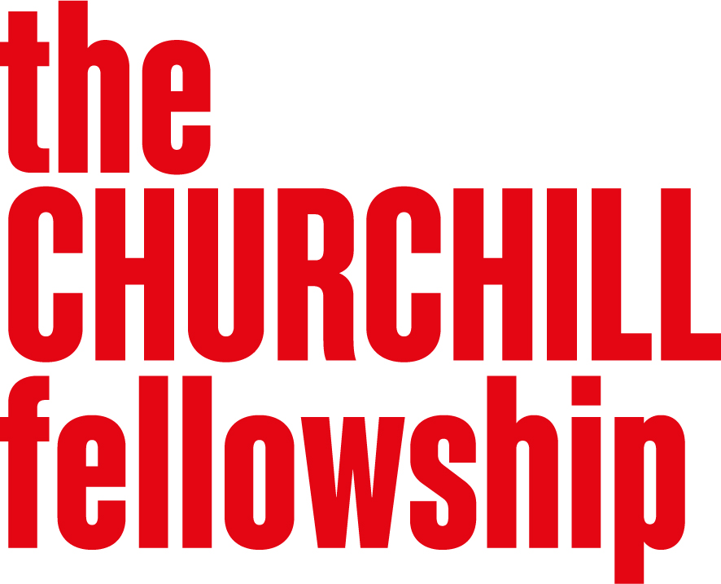
Building prosperous resilient economies
Programme Brief
  - Background
A strong economy creates opportunities for people and communities to thrive. Yet many places continue to experience economic challenges including unequal access to opportunity, insecure work and barriers to participation in economic life. While economic growth remains important, there is growing recognition that prosperity must be shared more widely if communities are to thrive over the long term.
In response, communities, social enterprises, businesses, public services and policymakers are developing new approaches to create opportunity and strengthen economic resilience. Many of these approaches are rooted in local strengths and seek to address economic challenges while also improving wider social outcomes.
Building prosperous, resilient economies was created to explore practical and innovative solutions to these challenges. The programme seeks ideas that foster economic resilience, adaptability and inclusion, helping communities create lasting prosperity and opportunity in a changing world.
You can find examples of projects previously supported through this programme on our website. Exploring a similar issue will not count against your application, but we encourage you to consider the unique perspective, experience or approach you would bring to the challenge.

  - Why this programme matters
Prosperity can be created in many ways. People across the UK are exploring how economic activity can better support communities, create opportunities for those who have traditionally been excluded, and strengthen resilience in the face of economic, social and environmental change.
We are particularly interested in practical approaches that help communities generate and retain economic value, create inclusive opportunities and build stronger local economies. This may involve developing new models, adapting existing approaches or influencing the policies and systems that shape economic outcomes.
Many of the most promising ideas emerge from people who are closely connected to the challenges they are seeking to address. We are interested in learning from those testing new approaches in practice, as well as those exploring how change can happen at a wider systems level.

  - What we are looking for
We are particularly interested in projects that explore one or more of the following areas:
- Strengthening economic resilience
Exploring how communities can create, shape and sustain economic opportunities that reflect local strengths, needs and aspirations. This may include community businesses, local enterprise, neighbourhood regeneration, local partnerships or other approaches that help communities become more resilient and adaptable.
- Creating inclusive economic opportunities
Examining ways to increase access to employment, enterprise, skills, finance and other opportunities for people and communities that have traditionally been underserved or excluded from economic participating.
- Developing sustainable approaches to prosperity
Exploring practical and innovative approaches that generate long-term social and economic value. This may include social enterprises, co-operatives, community ownership models or other innovative socio-economic solutions that seek to create lasting prosperity while addressing wider social challenges.
- Influencing systems, policy and practice
Exploring how policy, governance, investment and institutional practice can help create more prosperous, resilient and inclusive economies. We are particularly interested in ideas that have the potential to inform wider practice, influence decision-making or be adapted and scaled in other places and contexts.
  - We are less likely to support projects that:
While we welcome a wide range of ideas, projects are less likely to be a strong fit for the programme if they:
- Focus primarily on the development of a single organisation or commercial venture without a clear wider benefit.
- Do not demonstrate a clear connection to economic resilience, inclusion or long-term prosperity.
- Are unlikely to generate learning that could inform wider practice, policy or approaches in the UK

  - Developing your application
When developing your application, we encourage you to:
- Identify a clearly defined economic challenge or opportunity
- Explain how your project could contribute to greater prosperity, resilience or inclusion
- Consider who benefits from the approach and how impact could be sustained over time
- Think about how your findings could be shared, adapted or applied by others
Who should apply
We welcome applicants from a wide range of backgrounds, sectors and communities.
This programme may be of particular interest to:
- community leaders and organisers
- social entrepreneurs and enterprise leaders
- people working in economic development, regeneration and place-based change
- policymakers and those involved in shaping economic systems
- people working in employment, skills, finance or inclusive growth
- people with lived experiences of the economic challenges they wish to address
- innovators exploring new approaches to creating social and economic value

