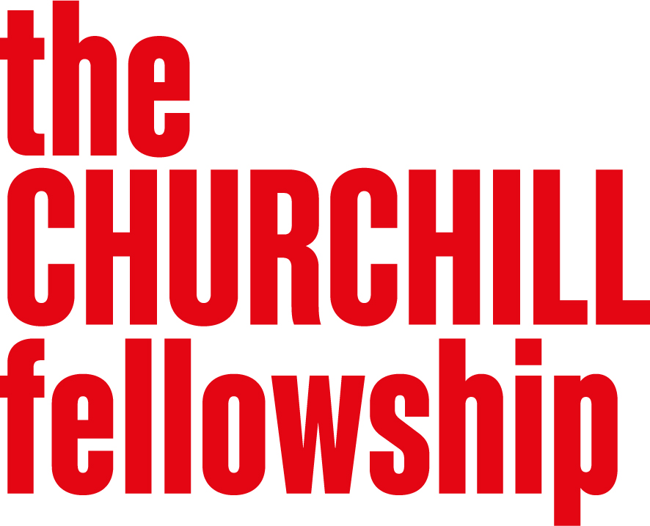
Civic and Democratic Engagement
Programme Brief

  - Background
Democracy works best when citizens feel heard, valued, and empowered to shape their communities. Yet many people across the UK feel disconnected from the decisions that affect their lives. Trust in government and institutions have fallen to an all-time low. A 2024 British Social Attitudes survey conducted by the National Centre for Social Research found that just 12% of people trust the government to put the needs of the nation above those of their party – a new record low, while 46% say they “almost never” trust the government – the highest on record. Public discourse has become more polarised, making constructive civic engagement more difficult amid contested information and declining trust.
At the same time, communities around the world are proving that meaningful civic engagement is possible, that trust can be rebuilt across divides, and that people working together can solve complex issues that matter to them. From citizens’ assemblies bringing together people to find common ground on polarising issues to rural communities using participatory budgeting to revitalise their towns, there is no shortage of energy or innovation to inspire hope and a way forward.
This is a new three-year programme under our Governance and Public Services universal theme. It is grounded in the belief that the right to participate, to be heard, and to hold power to account are fundamental for a healthy democracy. Civic and democratic engagement is how those rights are protected and made real in practice.
We are looking to fund passionate individuals to learn from the most promising civic and democratic innovation anywhere in the world and return not just with ideas, but with practical strategies, international networks, and the support of a growing community of Fellows working together to strengthen how people participate, how institutions listen, and how communities hold together.

  - Why this programme matters
This programme aims to strengthen civic and democratic engagement at all levels of society: supporting innovative approaches that give people genuine power over the issues that matter to them; reforming and rebuilding trust in our institutions and how they can be more responsive; and how trust and cohesion can be rebuilt across diverse communities.
Policy developments also reinforce the need for such a programme. The next UK general election is expected to occur by August 2029. The English Devolution and Community Empowerment Bill is reshaping local governance in England, creating new opportunities – and challenges – for civic participation. The lowering of the voting age to 16 similarly presents both challenges and opportunities for how young people can be supported to engage with democratic processes.

  - What we are looking for
This programme is built around three interconnected areas of focus. We do not expect applicants’ projects to encompass across all three – a strong application will have a clear focus – but we see these as genuinely related.
Across all three areas, we are particularly interested in the intersection where grassroots energy meets institutional power – where people working outside traditional structures are pressing for change, and where those inside institutions are trying to open them up.
- Institutional trust and reform
How can institutions – in local and central government, in the public sector, and beyond – become more open, responsive, and genuinely accountable to the people they serve? We are interested in approaches that go beyond consultation to genuine co-production and shared decision-making, and how individuals, whether working inside or outside institutions, can drive that change.
- Meaningful civic participation
How do we create real opportunities for people to shape the decisions that affect their lives – not just to be consulted but have genuine influence? We are especially interested in approaches that reach people who are currently least heard, and that makes participation durable rather than a one-off exercise.

- Cohesion and countering division
How do we build trust across deep differences in ways that are durable rather than superficial? How do communities and institutions navigate genuine disagreement to find fairness and common ground? This includes projects where media, journalism, or the information landscape is central to this work – provided the focus remains on civic and democratic life rather than on media or technology as ends in themselves.

We are less likely to support projects that:
- are primarily about academic research or the production of policy analysis, rather than practical implementation or change
- are primarily focused on general community engagement or social prescribing. If your project is focused on building connection and wellbeing within communities, you may want to consider our Communities programme, Building a Society that Cares.
- treat media or technology as the primary subject, rather than as they relate to civic and democratic life – if technology and its societal implications are your primary focus, our Tech for All programme may be a better fit.
However, if your project touches the edges of these boundaries but is clearly grounded in civic or democratic engagement, we encourage you to apply and make that case in your application.

  - Developing your application
When developing your application, we encourage you to:
- start with a clearly defined challenge, question or opportunity within civic or democratic life
- explain why international learning is essential – what can you find abroad that you cannot find at home, and how it connects to your work in the UK
- show the potential for your learning to contribute to change in the UK, whether in your own community, organisation and beyond
- think ambitiously about where you will go to learn. Democratic innovation may be happening in many places beyond the obvious locations (e.g. English-speaking or developed countries), including places that have faced significant democratic stress and can offer hard-won practical expertise.

  - Who should apply
We welcome applications from anyone who is working or ready to work on the practical challenge of making democratic and civic life work better for people. Community organisers and advocates, human rights advocates, local government practitioners, journalists, educators, civil society workers, youth workers, grassroots volunteers, trade union representatives, those working in faith, arts or cultural organisations are all encouraged to apply, as is anyone working at the interface of people and power. The most important thing is that you have a clear sense of what you want to learn, why it matters, and how you will use it.
We are particularly interested in people who:
- are working in practice rather than primarily in research
- are operating at a local or regional level, or outside traditional institutions, who may not have the platform or resources that more prominent organisations might have access to
- bring perspectives and experiences that are not already well-represented in debates about democratic renewal
- have the ambition to turn their learning into real change

