RURAL LIVING
(STRENGTHENING COUNTRYSIDE COMMUNITIES)

A Report for the Churchill fellowship highlighting the role of young carers.

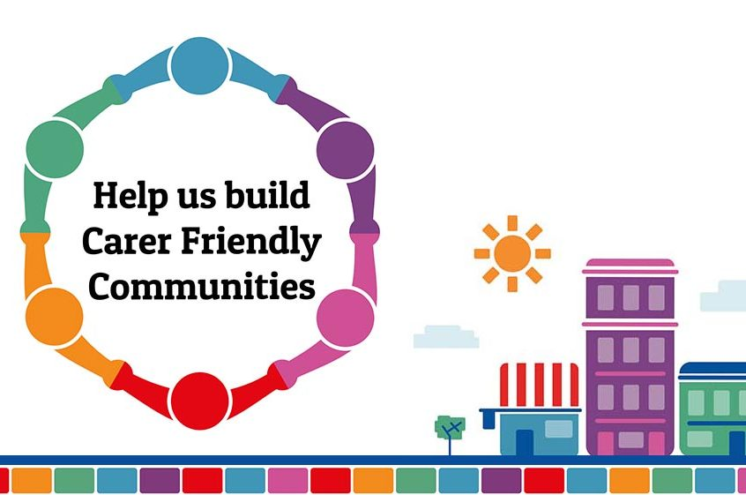

(socialcare.blog.gov.uk)

Copyright@ 25th November 2024 by Myra Clark. The moral right of the author has been asserted.

The views and opinions expressed in this report and its content are those of the author and not of the Churchill Fellowship or its partners, which have no responsibility or liability for any part of the report.

INDEX

Report

Appendices
App. 1 Estimated Young Carer Figures
App. 2 Young Carers Quotes
App. 3 Completed Questionnaire (1)
App. 4 Completed Questionnaire (2)
App. 5 Thank You

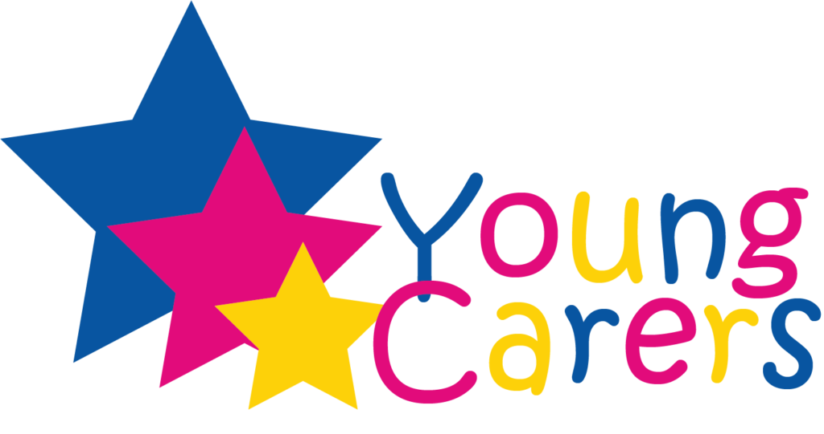
(www.logolynx.com)

RURAL LIVING……. STRENGTHENING COUNTRYSIDE COMMUNITIES.
-----------------------
(WITH A FOCUS for YOUNG CARERS and the IMPACT on their MENTAL HEALTH)
-----------------------
(“We are the forgotten ones, we are invisible to all”)

MYRA CLARK
2024



Background
Young carers in rural areas face unique challenges that can impact their mental health and well-being. They take on adult responsibilities, providing care for family members living with physical or mental health need (or both), addictions, terminal illnesses or short term illness. Their lives are even more impacted due to living in some of the more remote and rural areas of our country, where they face geographical isolation, limited healthcare resources and little access to social support and activities.

Understanding the struggles these young people encounter on a daily basis, is essential to building resilience and well-being with the aid of Community support- based mechanisms.

CHALLENGES FACED BY YOUNG CARERS IN THE UK
General
Young carers frequently experience social isolation due to the widespread nature of rural communities and limited public transport which reduces their opportunities to meet up with friends and relatives leading often to feelings of loneliness, poor mental health and exhaustion.

In addition, educational access can be difficult as they try to balance school and home care. Many fail to complete studies and face huge pressures, missing out on extra-curricular activities that could help personal development.

Healthcare services can also be sparse and harder to reach for such carers resulting in physical and mental healthcare services, counselling, dentist appointments being missed or not accessed at all.

The stigma surrounding care giving responsibilities are more evident in small communities, where everyone knows one another. The fear of judgement and criticism of one’s family can make it more difficult to seek help or to discuss any issues.

As a consequence of all of the above, caregiving can lead to increased rates of anxiety, depression, and emotional stress among young carers. This stress often stems from the demands of their caregiving roles and feelings of guilt or inadequacy when they cannot meet all the needs they face.
Low Self-Esteem and Sense of Control
Young carers frequently report feelings of low self-esteem and a lack of control over their lives. This stems from the responsibility they bear, often without the option to choose or escape their roles. Consequently, they may feel overwhelmed, leading to decreased motivation and feelings of helplessness.
Social Anxiety and Fear of Missing Out
Young carers may develop social anxiety and a strong sense of "missing out" due to reduced social engagement. The inability to participate in normal childhood or teenage activities, such as going out with friends, increases feelings of isolation and resentment, further impacting their mental health

Example of a typical rural young carer’s day:

“Lorna”, a 13-year-old girl, cares for her mother who has a terminal illness. Dad has left, so she also looks after her younger brother (9) and sister (5). She has no extended family living nearby to provide help.

Lorna gets up at 6am every morning to prepare breakfast for her siblings, get their clothes ready for school, prepare packed lunches and organise school bags.

She then gets them up and once breakfast is over she supervises, face washing, teeth brushing and getting dressed. She then gets herself ready before giving mum a cup of tea in bed prior to leaving for the school bus at 8am.

Lorna and her siblings get home from school around 4.30pm. Mum has had a bad day and is in bed’ so Lorna gets homework for the little ones started as she prepares to make dinner. She does a bit of housework including washing and ironing and clearing up in the kitchen as her siblings watch television.

She helps mum with her personal care and makes her something to eat and sits with her for a while. Mum tells her what needs to be done, including, bills to be paid, shopping that needs to be ordered.

Bedtime and she supervises the bedtime routines before starting on her own homework. Often she is too tired to finish her homework and falls asleep.

Her day has finished and she is exhausted.

What could support look like for young carers in rural areas?
Support for rural young carers across Scotland and the UK is sparse and variable to say the least. I have often wondered how other communities supported their young carers, at home and around the world. What could our systems learn from others? Could programmes from other areas be adapted to fit our forms of rural living?

My journey to my Churchill Fellowship started several years ago while working as Project Manager of the Charity, TYKES, (The Young Karers East Sutherland),
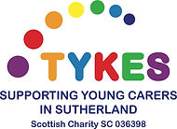
https://www.tykesyc.co.uk/, which I set up in 2003 after realising that there was little or no support available for young carers in our area.

One of my Directors Mr. Ron Munro, a Churchill Fellow of 1990, encouraged me to apply for a Fellowship. It took a few false starts before I actually applied and in 2019, I did!

After an interview in London in 2020, I was awarded a Fellowship ……… and then COVID-19 landed! Lockdown began, no leaving homes, going to offices, meeting people (outside your bubble) and no travel!

So my intended Fellowship journey became a digital one, not one that was expected but, extremely fruitful and enjoyable nonetheless. As everyone worldwide was in the same situation everybody was more than happy to “talk” online. The support from Churchill staff was second to none and the patience superb.

I had chosen to seek information from USA, Italy and Switzerland as well as from home, but as we were now on a digital journey, the whole world was opened up!

USA
While the USA does not have National Policy specifically geared towards young carers, many state-level programs and non-profit organisations offer targeted support.

Organisations like… The American Association of Caregiving Youth (AACY), website https://aacy.org/. This organisation provides counselling, academic support and family resources to young carers in select States and are also focussed on increasing awareness and support for young carers.

There is some limited school based support although programs such as flexible attendance or homework assistance are increasing. Advocacy efforts are ongoing bringing the challenges of young carers to the forefront, pushing all the time for a more comprehensive support programme at national level.

After learning these facts, I contacted Aspire Health Alliance, https://www.aspirehealthalliance.org/, based in Boston Massachusetts and spoke with Professor Antony Sheehan, President and CEO. He was extremely helpful and phoned for a chat even before I had my application to the Fellowship accepted!

He spoke about programmes to support young people that they provided and how they were delivered. He had served previously as President and CEO within the UK’s National health service (NHS), directing the provision of mental health, learning disabilities, and community health – primary care and public services for children, adults, seniors and special populations including homeless – to a total population of 1.2 million citizens prior to taking up an appointment with The Institute for Health Care in Cambridge Massachusetts.
(Support systems highlighted included school – based support with group training given to staff and consultation to teachers and administrators on how to identify students with emotional and developmental difficulties and those at risk of dropping out of school.
There was also home – based support and Outreach support available.)

Professor Sheehan is now the President and Executive officer of Aspire Indiana Health Inc. https://www.aspireindiana.org/ having taken up this new post in 2023. Here they run a programme called Kid’s Talk,
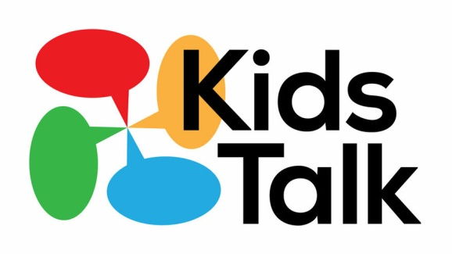
https://www.aspireindiana.org/community-programs/kids-talk which is a safe place for children suffering the effects of child abuse, neglect, violent or abusive instances, in a safe and comfortable environment with a range of various agencies.

Could this work for our young carers, many of whom are too frightened to speak up at school or to other family members for fear of any reprisals? Could it be adapted to suit individual cases?

I recently spoke with Professor Sheehan on a video link to discuss changes since Covid-19. They have found that more people are aware of mental health in young people and mental health discussions have exploded. Some young people have gathered themselves into specific groups and are completely student led. Covid shone a light exposing a desire to talk openly about various issues affecting young people.

Although the USA lacks a comprehensive national strategy for Young Carers, some organisations, such as Aspire Health, have developed support services.
The American Association of Caregiving Youth (AACY) provide support programmes including the Caregiving Youth Project, https://aacy.org/what-we-do/caregiving-youth-project/, which offers counselling, academic assistance and respite care to Young Carers in select States.

Some school districts in the USA recognise Young Carers and offer flexibility with assignments and attendance policies. Though this support is not standardised or widely available.

While formal support systems are limited there is growing research and advocacy focussed on Young Carers with groups pushing for better recognition and resources.

ITALY
Italy supports the EDY-CARE Project, https://edycare.eu/.



This is a project delivered in schools throughout Europe. It is described as “Innovative School Education Methodologies and Tools for Guaranteeing Social Inclusion of Young Carers”. EDY-Care aims to empower teachers and other school staff to recognise adolescent young carers in classes and maximise their learning opportunities, while ensuring their social inclusion.

The EDY-CARE objectives are as follows:

- To develop an assessment tool that could help teachers and school staff to identify young carers.
- To develop and test a package of educational strategies and organisational adjustments that schools can take to facilitate young carers and to support them in their scholastic journey.
- To produce a handbook providing guidelines and recommendations on how teachers and school staff can best work with young carers.
- To develop a massive open online course (MOOC) for training teachers and school staff on the needs and preferences of young carers.

The Handbook,
eurocarers.org/wp-content/uploads/2020/01/edycare_handbook-1.pdf,
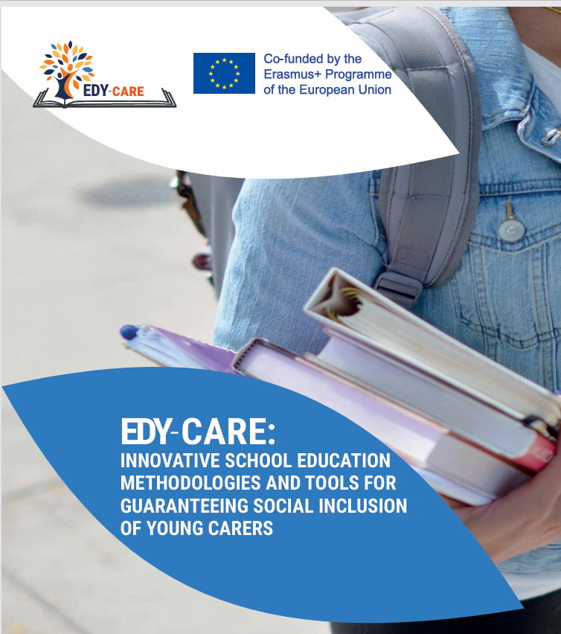
was developed with Italy as a main partner. This was due mainly to the fact that young carers were not on the agenda of Italian policies, although issues were addressed by law declaring the rights of all children and teenagers, including those with differing needs.

Schools were required to be flexible to meet the needs of each student and provide individualized assistance. There are several schools in Italy currently using this handbook to implement specific supports to meet the educational needs of young carers.

I have highlighted below two of the actions that schools in Italy are implementing which, I believe, could work in our schools.

- A 2 hour workshop is offered to all classes, aimed at raising awareness among students about the specific needs of young carers and to support self-recognition.
- Students are encouraged to self-referral. The use of a “mail-box” located in the school hall, in a private area, allows students in need to leave messages and self-refer themselves to a professional ready to help them.

The EDY-CARE Handbook is available to all online.

SWITZERLAND
It is estimated that there are 38,400 young carers in Switzerland between the ages of 10 and 15 years of age. It is also known that some children as young as 5 years had caring responsibilities too.

Research into young carers is very much a priority in Switzerland with many professional experts including Professor Agnes Leu, who has written many papers on Young Carers and Young Adult Carers. I was very fortunate to be able to speak with her over a video link about how young carers were being supported.

Most of the support for young carers is from school. As part of some research, a guided peer- support programme was developed in collaboration with young carers as the first specifically produced programme for young carers in Switzerland. This aims to achieve four main goals.

- Strengthening Social Support among Young Carers
“Get-togethers”, to offer Young Carers the possibility to exchange views with young people in a similar situation and to support each other. This fosters a sense of mutual understanding

- Promotion of Life Skills of Young Carers
Young Carers feel more conﬁdent in dealing with difﬁcult situations and are better equipped to deal with future challenges as a result of participating in the Get-together

- Strengthening the Social Network of Young Carers
Young carers get to know other young people in a similar situation through the Get-togethers, establish contacts and strengthen their resources in the sense of social capital

- Promotion of the Inclusion and Participation of Young Carers
Get-togethers provide Young Carers with space to explore their role. Young Carers are involved in decision-making processes and actively contribute their ideas and suggestions.

Get-togethers are low-threshold exchange meetings for and with YCs and Young Adult Carers (YACs) aged 15 to 25, as well as for former YCs. The Get-togethers offer young people the opportunity to exchange ideas and experiences and to undertake fun activities with a group of peers under the guidance of a trained facilitator. The recruitment of participants mainly took place via professionals in education, healthcare and social services who have
contact with YCs in their daily work and via social media.

Since the end of 2018, these Get-togethers (at no cost to the participants) have taken place 6–8 times a year (on-site and online). After a pilot phase from December 2018 until February 2021, the Get-togethers have taken place within the three-year project “Switzerland-wide Support Programmes for Young Carers”.

CHINA
The Hangzhou Municipal Government put mental health related activities on the official agenda. The Education Committee established a mental health tutoring centre for students, with infant tutoring established at kindergarten level. The Youth League was tasked with organising youths to carry out mental health training related to self-protection.

AUSTRALIA
Australia recognises the challenges young carers face and has developed several programs and resources to help them.

In addition to the main support services there is a Young Carer Bursary program, https://youngcarersnetwork.com.au/bursary/young-carer-bursary/, administered by Carers Australia, https://www.carersaustralia.com.au/, on behalf of the Australian Government which provides financial support to young carers so they can continue their education alongside their caregiving responsibilities.

These dedicated Young Carer services, such as the Young Carers Network offer online resources, peer connections and mental health support. The Carer Gateway provides mental health support and counselling services for Young Carers helping them cope with the emotional demands of caregiving.

CANADA

Canada’s approach to supporting Young Carers is largely community-based.
A Young carers Project in Ontario and Young Carers Programme of Hospice Toronto offer mental health support, peer groups and educational workshops.
Programmes emphasise emotional and mental health support often providing online counselling and mental health resources specific to Young Carers.
Some Canadian Provinces run campaigns to increase public understanding and awareness of Young Carers’ roles, fostering community support and reducing stigma.

UK

While the UK has some of the most comprehensive support systems for young carers, it has to be asked does it reach far enough, especially to those living unnoticed in rural areas. Limited access to services, peer support and lack of extended family support. They are the forgotten children. There is so much more we could do by pulling different ideas from other areas.

Some examples of innovative approaches and best practice I have found in my Fellowship researches are listed below. These could be usefully trialled, or piloted, in the UK for the benefit of our young carers.

Innovative Approaches and Best Practice

Flexible Education Models (UK and Australia)
Schools that provide flexibility in assignments and attendance for Young Carers allow them to balance their studies with their caregiving roles. This also helps to prevent school drop-outs.

Financial Assistance (Australia)
Financial bursaries, such as Australia’s Young Carer Bursary Programme, provide financial support that enables the Young Carers to continue their education.

Community–based Peer Support (UK and Canada)
Peer support networks, such as those created by Carers UK and Canada’s Young Carers Project allow Young carers to share experiences and find emotional support, alleviating the feelings of isolation.

Early Identification (Sweden)
Sweden’s approach, which involves early identification and support through schools and social services ensures Young carers receive help before their responsibilities become too much of a burden.

Respite Care (UK and Australia)
Respite Care gives Young Carers a temporary break from their caregiving allowing them to rest and enjoy recreational activities. Recharging batteries.

Community Awareness and Stigma Reduction Campaigns
Raising community awareness about the challenges young carers face could help reduce stigma and foster empathy. Workshops, community events, and campaigns could educate rural communities, encouraging support for young carers rather than judgment.
Financial and Practical Support Initiatives
Financial strains often accompany caregiving. Community support programs could provide grants, or practical assistance, such as transportation vouchers or meal delivery, to alleviate some of the stress young carers face. Additionally, local businesses could collaborate with non-profits to offer resources that reduce the financial burden on young carers and their families.
CARERS TRUST UK is a valuable resource online with information and guidance to young people, families and professionals.

Conclusions and Recommendations
Addressing the mental health and well-being of young carers in rural areas requires a community-driven approach that emphasizes accessible support, reduces stigma, and fosters empathy. By implementing flexible educational options, enhancing access to mental health resources, and raising community awareness, rural areas can improve the quality of life for young carers and support their mental health and well-being.
General recommendations:
- Increase investment in telehealth and online mental health resources.
- Develop local support networks that provide peer support and respite care within communities.
- Create awareness campaigns to reduce stigma surrounding caregiving and mental health.
- Partner with schools to implement flexible educational policies and counselling programs specifically for young carers.
- Encourage local businesses and non-profits to offer practical support for young carers’ families.
Recommendations using programmes from other Countries.
- USA
Kid’s Talk ……providing a safe and comfortable environment with a range of various services.
The school based approach must also be worth looking at in greater depth. Could it work in a small rural community where privacy is paramount, although everyone appears to know your business! The benefits to both the young carers and the cared for person in experiencing a wraparound service based in your own home has to be worth trying.

- ITALY
EDY-CARE handbook. A project delivered in schools throughout Europe.

- SWITZERLAND

Guided peer support with 4 main objects. The “Get-together” programme is something, I feel, that could be implemented almost immediately with little organising.

Closing remarks
As I draw to a close I can’t help but feel that we can learn so much more and adapt programmes to suit rural community living. We all know or knew someone who is/was a young carer and as a community it is in the best interests not only of the Young Carer but the community as a whole to help. We have an obligation to support for the good and positive progress of our communities.
Access to services, clubs, schools, health support and transport are freely available in our Towns and Cities, but very spread out in rural communities and in many cases, inaccessible for a young person.
We must try harder to support Young Carers.
They are our future.

DEFINITION OF A YOUNG CARER.

A Young Carer is someone aged 18 years and under who cares for a family member who, due to illness, disability, mental health issue or an addiction, cannot cope without their support. Young Adult Carers are aged up to 25 years who may have different support needs to that of Young Carers.

With this in mind, caring situations are not only within single parent families. It can affect any family, in varying degrees no matter who they are. And in this regard I am mindful of the current issues within our own Royal Family.

At the beginning of this report was a heart-rending quote from a young carer who developed a video about the life of a young carer……her life, living with her mum who had an addiction. She ended it with a thank you to everyone who had listened but more importantly to those who had heard!

I hope those of you who have taken the time to read about my journey
Have also heard. We must do better.

Thank you.

Acknowledgements
I would like to express my gratitude to all those who have supported me throughout the completion of this report.
- To the Churchill Fellowship for the opportunity, support and financial assistance over the years of my Fellowship. In particular I would mention the help given to me by ….
- To Professor Antony Sheehan of Aspire Health Alliance for his valued input into practices in the USA
- To Professor Agnes Leu of the University of Basel Switzerland
- To my colleagues at TYKES for their support and understanding during the pandemic years
This report would not have been possible without the backing of all these individuals and organizations.

Appendix 1.

No. of Young Carers

UK……..England an estimated 120,000
Scotland an estimated 30,000
Wales an estimated 30,000
N.Ireland an estimated 8,480.

An estimated total of 188,480 Young Carers.
1 in 5 schoolchildren in England are Young Carers.

ITALY……. Shows 391,000 Young Adult Carers aged 15 – 24.

USA………an estimated 1.4million Young Carers.

"Being a young carer, there is no time to have a childhood. It's like living in "dog years," you grow up much quicker than everyone else your own age. I feel as if my life has been much longer than it actually has, I have brought up a family from the age of 8."
Siobhan, 19 years
(Taken from The Scottish Government site G.I.R.F.E.C. Getting It Right For Every Child)

Appendix 2.
At first I was embarrassed taking my mum to the bathroom to clean her up and give her a bath. Now she gets upset because I have to do it.
(Mel aged 14)
When doctors and the specialists make plans for my mum I wish they’d include me. I get annoyed that they don’t consider me as the carer or that I have a life too. If they explained things to me I wouldn’t get so scared.
(Michael aged 15)
We can’t have friends in because it upsets the routine and routine is the only thing that gets us through what has to be done.
(Jane aged 10)

Sometimes I wonder what will happen to us if my sister leaves home.
(Steve aged 8)
At first I was embarrassed taking my mum to the bathroom, cleaning her up and bathing her. Now she’s the one who gets upset because I have to do it.
(Meg aged 13)
We are the forgotten children. We are the ones who are not able to join clubs, can’t make friends, who are constantly told off for incomplete homework or being late for school.
(Lauren aged 17)

These are some quotes from young carers I spoke to from a local Project. The feelings are replicated world-wide. These feelings were prior to Covid -19, so I issued a Questionnaire to local Projects to find out how feelings and situations may have changed.

Appendix 3.
CHURCHILL FELLOWSHIP REPORT.
QUESTIONNAIRE/SURVEY
YOUNG CARERS LIVING IN RURAL AREAS
COVID-19 RESPONSE.

OVERALL EXPERIENCE.

- Can you describe a typical day for a young carer before the pandemic and how it changed after Covid-19?
I would say there is no such thing as a typical day in the life of a young carer, but their days are probably quite similar now to pre-pandemic times. The huge change for them was during the pandemic where they had to step into a full-time care role that they were not used to.
- What, do you believe, to be the most challenging aspect of being a young carer during the pandemic?
The most challenging aspect was being a full-time carer at home while trying to fit in schoolwork, not getting out to see friends and family and worrying constantly about the cared for person getting Covid.

EMOTIONAL AND WELLBEING HEALTH

- How did the pandemic affect mental health and well-being?
The pandemic had a huge impact on mental health and wellbeing with the additional stresses added to their care roles.
- Did they feel more isolated or stressed during the pandemic? In what ways?
Isolation was one of the biggest causes of stress, feeling trapped in their homes with no respite/time out.
- Were there any resources or support systems in place that helped them to cope emotionally?
There were none locally that I was aware of other than us providing daily/weekly phone or video calls along with online group sessions.

EDUCATION AND SCHOOLING

- How did the shift to online learning impact on responsibilities as a young carer?
This was an added stress, going to school for some young carers is their time out from their caring responsibilities but this was taken away.
- Did they face difficulties balancing caregiving and schooling?
Yes, there were many young carers that did little or no schoolwork during lockdown due to their care roles which led to them being so far behind their peers.
- Were they able to keep up with schoolwork?
No, as above

SOCIAL LIFE AND RELATIONSHIPS

- What was the impact on social interactions and relationships with both family and friends?
For some it was a good time to spend with family, for others we have had a few family breakdowns due to the time spent together with heightened levels of stress and anxiety within their homes.
- Were there opportunities to connect with other young carers or support groups?
We held weekly online group sessions so the young carers had a chance to catch up with their peers, it was evidenced during these sessions that some young carers weren’t getting the free time to fully focus due to what was happening at home.

ACCESS TO SERVICES AND SUPPORT

- Was it easy to access healthcare and other support services when needed?
No, the NHS services were diabolical during this time. The only services that were still running as fully as they could were 3rd sector organisations.
- Was there a marked change in availability or quality of support?
Yes, there was none.
- What, do you feel, would have been more helpful?
More services available online and services reacting more quickly to the pandemic.

FUTURE CONCERNS

- Are there any ongoing challenges being faced as a result of the pandemic?
There are an increased number of young carers with mental health and anxiety issues.
- What are the main concerns for young carers in moving forward?
Mostly from the older young carers who missed a large part of their school years, some of them have now left school with little or no qualifications and wonder if they will ever get the chance to gain more, they don’t want another period of lockdown.

Appendix 4.

CHURCHILL FELLOWSHIP REPORT.
QUESTIONNAIRE/SURVEY
YOUNG CARERS LIVING IN RURAL AREAS
COVID-19 RESPONSE.

OVERALL EXPERIENCE.

- Can you describe a typical day for a young carer before the pandemic and how it changed after Covid-19?
Typical day for a young carer can be unpredictable, in a way that the cared for persons needs can change.
- What, do you believe, to be the most challenging aspect of being a young carer during the pandemic?
Challenges that Young Carers faced in lock down were being unable to get away from their home environment, and their caring role and responsibilities. On occasions complete isolation involved young carers being unable to connect with the outside world or be able to keep up with school work. Also financial restraints affected families.

EMOTIONAL AND WELLBEING HEALTH

- How did the pandemic affect mental health and well-being?
The pandemic affected the young carers mental health in a way that has taken a very long time to recover from. Confidence and social skills are most impacted.
- Did they feel more isolated or stressed during the pandemic? In what ways?
Some parents were unable to support their young person to be able to engage with school, due to their own anxieties. There was also lots of frustration at not being able to get out and about, no body checking in with them regularly.
- Were there any resources or support systems in place that helped them to cope emotionally?
Local High school held well-being class rooms on line and PSA & Pastoral Staff were very available for the all the pupils to access, although if they weren’t engaging in school this was not available to them.
YC project offered on line drop ins, which again worked well for the YC s who could access online gadgets.
YC project made up well-being kits and distributed to all YCs.

EDUCATION AND SCHOOLING

- How did the shift to online learning impact on responsibilities as a young carer?
Pressures around learning and being a YC were relentless, although local schools were very aware of that.
- Did they face difficulties balancing caregiving and schooling?
A lot of it was unknown and the YCs were very quick to adapt to the situation.
- Were they able to keep up with schoolwork?
Many were unable to keep up with the school work due to no regular contact with the school.

SOCIAL LIFE AND RELATIONSHIPS

- What was the impact on social interactions and relationships with both family and friends?
Friendships fell apart due to isolation and abilities to communicate became difficult and are very much still in recovery with youngsters’ perceptions of good relationships being distorted at times.
- Were there opportunities to connect with other young carers or support groups?
Opportunities to connect were made available with YC group, which suited some YCs but not all, YC project ensured that all YCs had access to gadget to access on line.

ACCESS TO SERVICES AND SUPPORT

- Was it easy to access healthcare and other support services when needed?
This was difficult for everyone, including accessing birth control.
- Was there a marked change in availability or quality of support?

- What, do you feel, would have been more helpful?

As a worker much more communication of what was available and how to access it would have been helpful so that it could be passed on to the YC & families.

FUTURE CONCERNS

- Are there any ongoing challenges being faced as a result of the pandemic?
Education is still on catch up, as well as young people’s risk taking and boundary setting is questionable.
- What are the main concerns for young carers in moving forward?
Concerns have not changed overly from before lock down. A bit of encouraging kids to get involved is a struggle at times. Families with parents that are struggling are the ones that have YCs who are of concern.

Appendix 5.
Thank You.

My grateful thanks go to the following people who have helped me enormously during this Journey.

Mr. Ron Munro. A Churchill fellow, Mentor and friend.
Mrs. Ann Pascoe (CF 2012). Advisor.
Dr. Antony Sheehan. Aspire Health, Indiana.
Professor Agnes Leu. University of Basel.
Ms. Denise MacKay, CEO, TYKES Young Carers, Golspie.
Ms. Wendy Thain, CEO, Caithness Klics Young Carers, Wick
Mr. Grant MacKay, CEO, Skye and Lochalsh Young Carers.
Mr Nikesh Patel, Churchill Fellowship for his support and unstinting patience.

To everyone involved with the Churchill Fellowship for giving me this wonderful opportunity to “meet” people with similar objectives to myself.
I will be forever grateful.

 Myra Clark
25th November 2024

