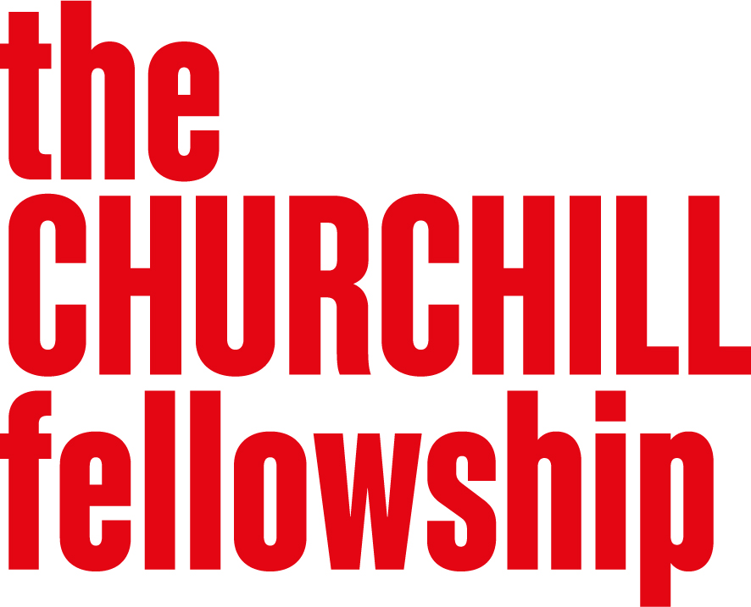
Climate Change
Programme Brief

Background
The Climate Change programme was launched in 2023 in response to the increasing urgency of climate change and its impact on people, systems and places across the UK and internationally.
Through the programme so far, Fellows have explored practical and policy approaches to addressing climate change across a wide range of sectors, including conservation, energy, housing, communications, agriculture and community settings. Their work has highlighted both the need to reduce emissions and the importance of responding to the impacts of a changing climate.
Climate change is already affecting communities, infrastructure, economies and the natural environment. Alongside efforts to reduce its causes, there is a growing need to support adaptation and resilience, particularly in communities most affected by environmental and social change.
This programme recognises that responding to climate change requires action across society. It is not only a technical or environmental challenge, but one that involves systems change, public engagement and collective responsibility.
We will continue to support individuals working closest to these challenges, enabling them to learn from international practice, develop new approaches and share insights that can improve policy, practice and systems in the UK. At the heart of the Fellowship is the expectation that this learning is applied to drive change in the UK.
You can find more information about the projects supported under this programme on our website. Exploring a similar issue will not count against your application, but we encourage you to consider your unique perspective and approach.

Why this programme matters
Climate change is already reshaping how societies function, from infrastructure and public services to local economies and community life. While there is increasing action to address its causes, significant challenges remain in how societies adapt and respond in ways that are fair, effective and sustainable.
There is a continued need for informed, practice-based work that considers:
- how climate change can be addressed through system-wide, not just individual, change
- how communities and services can adapt to the impacts of climate change and build resilience
- how policy, practice and innovation can support more effective climate action
- how climate responses can be delivered in ways that are fair and equitable across society

What we are looking for
This programme supports projects that help the UK minimise climate change and adapt to its effects. We are particularly interested in approaches that go beyond individual behaviour change and instead explore how wider systems, policies and practices can shift to enable more effective and equitable responses to climate change.
Projects can come from any area of society, but should fall into one or more of the following categories:
- Reducing climate impact
Developing practical and policy solutions for decarbonising UK economies and society at every level. This includes approaches that reduce emissions and support more sustainable systems, services and ways of living.
- Adaptation and resilience
Helping communities, infrastructure and public services prepare for and respond to the impacts of climate change.
- System-wide and societal change
Exploring how we can encourage behavioural change on an individual, community or national scale, for example through innovative education, communication, participation, or policy initiatives.
- Fair and inclusive climate responses
Ensuring that climate action considers inequality, access and differing community experiences, and supports a fair and equitable transition to a carbon-neutral future for all parts of society.
Over the past three years, most applications have proposed visits to the US, Canada, and Australia. While your choice of countries will not affect your application, we welcome project proposals that draw on learning and best practice from a wider range of countries.

Developing your application
When developing your application, we encourage you to:
- identify a clearly defined climate-related challenge or opportunity
- explain how your project addresses both the causes and/or impacts of climate change
- consider how wider systems, policies or practices need to change, not just individual behaviour
- show how your work could contribute to practical change in the UK
We also run a Caring for our Natural Environment programme under our Environment universal theme. You can only apply into one programme, but we recognise that both our Environment-themed programmes are linked, so we welcome applications that straddle both programmes, e.g. nature-based approaches that help communities address the causes and impacts of climate change.

Who should apply
We are looking for people with novel ideas, the passion and potential to make a real difference to their community or professional sector, and we assess on future possibilities, not past achievements. We value both lived and learned experience and prioritise those less likely to receive funding from elsewhere.
We are particularly interested to hear from individuals working directly with climate-related challenges in practice, policy or community settings:
- people working in sectors such as energy, transport, housing, agriculture, planning, education, local government and civil society
- individuals supporting communities to adapt to climate impacts and build resilience
- practitioners and policymakers working on system-wide approaches to climate action
- community groups and individuals with lived experience of climate impacts or climate adaptation challenges

