Beyond Marginality
Transhumant Dairying, Institutions, and the Future of Upland Land Use
Col Gordon
2025 Churchill Fellow


List of Contents

Abbreviations
Glossary
Executive Summary

1. Introduction
2. Key Learnings: Transferable System Logics from Alpine Transhumant Dairy
4. Institutional and Land-Governance Foundations of Alpine Systems
6. Implications for the Gàidhealtachd
7. Recommendations: From Marginality to Intentional Design
8. Conclusion: Repair, Not Restoration

Acknowledgements
About the Author
References

Copyright © 2026 by Col Gordon.
The moral right of the author has been asserted. The views and opinions expressed in this report and its content are those of the author and not of the Churchill Fellowship or its partners, which have no responsibility or liability for any part of the report.

Abbreviations
- AOP – Appellation d’Origine Protégée
- DOP – Denominazione di Origine Protetta
- PDO – Protected Designation of Origin
- GAEC – Groupement Agricole d’Exploitation en Commun (France)
- GFA – Groupement Foncier Agricole (France)
- SAFER – Société d’Aménagement Foncier et d’Établissement Rural (France)
Glossary
- Alpage/ alpeggio
High-altitude summer pasture used for seasonal grazing and, in transhumant dairy systems, on-site milk processing.
- Appellation (AOP / PDO / DOP)
A legally defined production system that establishes binding rules around geography, methods, breeds, and volumes, functioning as a form of collective governance rather than a marketing label.
- Common grazings
Land used collectively by the croft holders of a township for grazing livestock, under rights regulated by crofting legislation. Common grazings typically cover upland and hill ground beyond individually held croft plots and form a significant proportion of the agricultural land base in the Gàidhealtachd.
- Common grazing committees
Elected bodies responsible for the management of common grazings on behalf of a crofting township. Committees hold legal powers under crofting legislation to regulate use, maintain shared infrastructure, and apportion grazing rights among shareholders.
- Consorteria / Consorterie
A form of collective landholding found in parts of the Alps, particularly the Aosta Valley, in which land is held in common, removed from the market, and governed through membership tied to place.
- Consortage
Swiss and French variants of collective land and pasture governance, organising shared rights and obligations over alpine land and infrastructure.
- Consortium
A producer-owned body that governs an appellation or regional product by defining production rules, certifying compliance, and coordinating collective quality control and market identity.
- Croft
A small unit of agricultural land held under crofting tenure in the Scottish Highlands and Islands, typically comprising an area of inbye land for cultivation and grazing, alongside a share in the township's common grazings. Crofts vary considerably in size but are generally insufficient as a sole source of livelihood.
- Crofters
Holders of a croft under Scottish crofting legislation, which grants security of tenure, the right to assign or bequeath the tenancy, and a regulated relationship with the land. Since legislative changes allowing owner-occupation, crofters may be either tenants or owner-occupiers. Most combine croft work with other employment or income.
- Crofting
A form of small-scale, tenure-regulated land use unique to the Scottish Highlands and Islands, governed by a distinct body of legislation and overseen by the Crofting Commission. It combines individual tenure of small inbye plots with shared access to common grazings, and has historically formed the backbone of rural land use and community life in the Gàidhealtachd.
- Gàidhealtachd
The Scottish Highlands and Islands where Gaelic language, culture, and crofting traditions have historically been concentrated.
- Shieling system
The historical transhumant dairying system of the Gàidhealtachd, involving seasonal movement of livestock and people to upland summer pastures for milk production.
- Transhumance
Seasonal movement of livestock between lowland and upland pastures, typically linked to milk production and on-site processing in mountain environments.
- Territorial scale
A scale of organisation larger than individual holdings but smaller than national systems, within which production, governance, infrastructure, and identity can be aligned.

Executive Summary
Across the Scottish Highlands and Islands, upland and hill land is routinely treated as marginal. Unproductive, hard to farm, a landscape of decline. This report argues that framing is wrong, and that the evidence to prove it wrong already exists — a short distance away, in the Alps.
Before the Clearances, communities across the Gàidhealtachd practised seasonal transhumant dairying, moving livestock and people to upland summer pastures — àirigh, the shieling system — to produce milk, butter, and cheese at the point of peak grass growth, while freeing lowland ground for arable crops. This was not a marginal custom. It was the land use these landscapes selected for over centuries, and its disappearance was not a fading of local tradition but the deliberate outcome of a reorganisation of Highland land use from the eighteenth century onward. Its disappearance was a political event, not an agricultural inevitability.
Drawing on fieldwork across French, Swiss, and Italian Alpine dairying regions — including Beaufort, Reblochon, Gruyère, and Fontina production systems — this research asked whether a modern, institutionalised form of transhumant dairying could make Scotland's upland landscapes more productive, liveable, and ecologically regenerative. The Alpine evidence answers that question directly. Across these countries, under conditions of altitude, slope, and market distance at least as severe as those of the Gàidhealtachd, transhumant dairy systems are not merely surviving. They are producing high-value food, sustaining culturally rich communities, and maintaining extremely biodiverse pastures. What makes this possible is not climate or terrain but institutional design. It is the infrastructure, which is often held in common, governance that is producer-owned and enforceable, scale achieved collectively rather than by individual holdings, and systems built around the realities of seasonal human labour.
This has direct significance for a debate that is currently stuck. Upland land use in Scotland is increasingly framed as a contest between ecological recovery and food production — rewilding advocates on one side, crofting and farming communities on the other, routinely cast as adversaries. Transhumant dairying offers a genuine bridge across that divide. Well-managed grazing by cattle produces much of the biodiversity outcome the regeneration movement is working toward, not despite agriculture but because of it. A well-designed transhumant system is not a compromise between food and nature; it is the point at which the two stop being a zero-sum choice and, for the crofting and upland farming sector, a potential route to differentiate itself with a high-value form of production that lowland systems cannot replicate.
This is not a case for heritage reconstruction — a recreated shieling economy staged as it once was. It is a case for repair: mending a system enough that it can function again on its own terms, under modern conditions, because what was dismantled was dismantled by external forces and can, in principle, be mended.
The report's central recommendation is that this work cannot proceed as a scatter of small pilot projects. What is required instead is sustained institutional commitment, beginning with:
- A commissioned Scottish feasibility study, led by the Centre for Mountain Studies at UHI Perth, jointly commissioned by rural development and enterprise bodies with crofting organisations as active partners, to identify two or three territories where the conditions for collective, dairy-led transhumant systems are strongest.
- Cooperation resourced at the right scale — larger than the individual croft, smaller than the state — matching the territorial governance models found in the Alpine case studies.
- A dedicated study of the French institutional toolkit (GAEC, GFA, SAFER-type mechanisms) for its applicability to Scottish land tenure and crofting law.
- Investment in native breed development suited to mountain and shieling conditions.
- Development of territorial, AOP-equivalent products and the governance structures needed to support them.
- A Scottish regulatory framework for seasonal upland dairy production, adapted from the Alpine model of food safety regulation designed specifically for alpage-style systems.
- Investment in domestic capability and access infrastructure, and appropriate infrastructure provision on common grazings, treated as strategic enablers rather than incidental costs.
- An ecosystem-level approach rather than a project-level one — building the surrounding conditions (markets, skills, regulation, cooperation) rather than isolated pilots.
The report's most immediate ask, however, is not technical or legislative but narrative. Before infrastructure is built or institutions designed, there needs to be a clear, evidence-grounded case — one capable of being believed and backed — that transhumant dairying has a future, and that this future is open to many hands, including a generation of young people for whom conventional routes into agriculture are largely closed.

1. Introduction
"Before the clearances, the crofters of the north of Scotland practiced transhumance very much as the Alpine farmer still does today. Transhumance or the shieling system — the movement of stock and herders from the valley to the hill pasture in summer and back downhill again in autumn — is a system in perfect ecological balance.
The damage done to the environment by the abandonment of the transhumance system has not been widely recorded."
— Reay D. G. Clarke, farmer and 1977 Churchill Scholar
Across the British Isles, people have long lived in landscapes today described as marginal. Upland and mountainous regions — characterised by short growing seasons, thin soils, high rainfall, and distance from markets — are often treated as inherently unproductive. Yet over centuries these landscapes supported settled populations with distinct languages, cultures, and social institutions. That survival was not accidental. It was made possible by land-use systems explicitly designed to work with constraint.
Central among these was a shared practice of seasonal transhumant dairying. Across what are now England, Scotland, Wales, and Ireland, communities moved livestock from low-lying land to upland pastures each summer, milking them and producing dairy products on site. These systems carried different names in different languages — àirigh in the Gàidhealtachd, hafod in Wales, booley in Ireland, shielings in southern Scotland — but the underlying logic was remarkably consistent.
These were not peripheral or symbolic practices. Livestock moved to upland pastures when grass growth was at its peak, extending the productive season, freeing scarce arable land from grazing pressure, and converting marginal upland biomass into dense, storable nutrition — milk, butter, and cheese. Alongside collectively organised arable production in the glens, transhumant dairying formed the core of subsistence economies in marginal regions: arable systems supplying carbohydrates, dairying supplying fats and proteins, the pairing buffering climatic risk and enabling communities to persist in environments where either system alone would have been insufficient.
Their disappearance was not the fading of local custom. It was the loss of practices that had enabled permanent settlement in difficult landscapes. The question this research asks is a forward-looking one: whether a modern, institutionalised form of transhumant dairying could once again make marginal upland landscapes productive, liveable, and ecologically regenerative. That question necessarily involves infrastructure, governance, markets, labour, regulation, and scale.

Why this place?
While transhumant dairying once existed across much of the British Isles, this report focuses on the Scottish Highlands and Islands — the Gàidhealtachd — as its primary test case. From this point on, "shieling system" is used as shorthand for these transhumant dairying practices within the British Isles.
The critical distinction between the Gàidhealtachd and the Alpine regions studied is not ecological. Both are characterised by mountainous terrain, seasonal grass growth, and land unsuitable for intensive arable farming. In both contexts, transhumance emerged as a rational response to constraint. The difference lies in institutional continuity.
Over the last two to three centuries, Scotland's land use was progressively replaced by a meat-led, export-oriented system. The droving of beef cattle, followed by sheep production alongside large sporting estates, came to dominate the landscape. This was a profound reorganisation of how land was used, valued, and integrated into wider economic systems. Scotland's current agricultural model is often treated as traditional simply because it is familiar, but it represents a comparatively recent adaptation to export-driven political economies, one that obscured the fact that earlier systems were organised around different priorities: diversification, seasonal movement, collective management, and food production rather than commodity production.
The purpose of the Alpine comparison is not aspirational or cultural. It is diagnostic. The Alpine regions examined here represent places where transhumant dairy systems have faced similar ecological constraints to the Gàidhealtachd yet retained institutional continuity and economic viability. They provide live evidence of what is possible when marginality is treated as a design condition rather than a problem to be eliminated.
Why now?
A set of converging pressures is rapidly reshaping how upland land use is understood, governed, and financed, making this an unusually consequential moment to revisit not only what happens on marginal land, but how and why.
Across Scotland, upland landscapes are entering a period of accelerated transition. Climate targets, biodiversity obligations, and commitments to carbon sequestration are being translated into policy frameworks and land-use strategies with real effects on the ground. Woodland expansion, peatland restoration, and reduced grazing pressure are increasingly framed as requirements rather than aspirations.
In this context, the question is no longer whether land use will change, but who shapes that change and for whose benefit. Where change is driven primarily by external objectives, without viable economic alternatives rooted in place, the risk is not only ecological displacement but social erosion. Farming and crofting systems that cannot articulate a forward-facing role within these transitions are vulnerable to being treated as obstacles rather than partners. This moment demands credible, place-appropriate models that demonstrate how food production, ecological restoration, and rural livelihoods might coexist in the same landscapes.
Such coexistence is harder to achieve than it sounds, because the debate about upland land use has settled into an entrenched opposition. On one side stand the advocates of rewilding and natural regeneration; on the other, the crofting and upland farming communities who have worked these landscapes for generations. The two are routinely cast as opponents — one charged with wanting to empty the land of agriculture in the name of nature, the other with defending livelihoods against ecological recovery — and the argument has hardened into a divide that neither side seems able to cross. Yet the opposition is, in large part, a false one. Both want living, functioning upland ecosystems; both have reason to resist a future of depopulated, abandoned, or speculatively managed land. They are, in principle, natural allies who have not yet found the common ground on which to act together.
A repaired form of transhumant dairying — the shieling system carried forward under modern conditions rather than reconstructed as heritage — is one of the few land uses capable of occupying that common ground. It is unambiguously food production, and so legible to farmers and crofters; yet it produces, as a direct result of how it grazes, much of the biodiversity and habitat that the regeneration movement is working towards. It requires people living and working on the land, which speaks to the social question, and it generates high-value goods, which speaks to the economic one. A central premise of this report is that such a system could begin to bridge a divide that currently consumes a great deal of energy to little effect. Whether that bridge is real — whether, in the places where transhumance has survived, ecological richness and productive agriculture genuinely reinforce one another, and what practical form that takes — was among the questions the Alpine fieldwork set out to answer.
Alongside these policy pressures sits a more fundamental constraint: how efficiently land is used to produce food. Recent research has concluded that dairy-led systems deliver significantly more human-edible protein per hectare than meat-only systems. They make more effective use of grass, distribute nutritional output across multiple products, and allow meat to emerge as a secondary output rather than the sole objective. This is particularly important on marginal land, where growth rates and yields are inherently limited. A shift from meat-only upland systems to dairy-led transhumant systems is not a nostalgic gesture. It is a resource-rational response to contemporary constraints.
Yet recognising the ecological or nutritional logic of transhumant dairying is not enough. As Iain MacKinnon (2018) has described, the erosion of commons-based systems in the Gàidhealtachd was not only material or legal but cognitive. The dismantling of shared institutions over generations has undermined the capacity to imagine collective systems as viable or legitimate. Recovering transhumant dairying requires not only rebuilding physical infrastructure but recovering the institutional imagination needed to govern shared systems at territorial scale — designing cooperatives that persist beyond individual enterprises, enforcing quality and production limits, and aligning ecological objectives with economic viability.

Why transhumance specifically
This research did not begin with a policy question. It began with a conviction — one formed over years of farm work in the Gàidhealtachd, of reading the historical record, and of watching a landscape simultaneously being asked to produce food, restore ecology, and sustain a living culture, without being given the institutional conditions to do any of those things properly.
The conviction is this: that the shieling system was not simply one historical land use among many. It was the land use that this landscape selected for, over centuries of trial and adaptation. It endured because it worked. Because it made productive use of terrain that resists every other form of intensive agriculture, converted the short Highland summer into dense, storable nutrition, and did so in a way that maintained rather than degraded the ecological fabric of the land. Cattle and landscape were, as Frank Fraser Darling (1956) observed, compatible and even complementary. The forests benefiting from the grazing, the whole system held in a balance that was neither wilderness nor agriculture in the modern sense, but something more accurately described as stewardship.
That system was not abandoned because it failed. It was dismantled. The shieling grounds were among the first things cleared. The collective township structures that organised seasonal movement were replaced with individual crofts, deliberately undersized and insufficient as subsistence systems, designed to push people into the wage economy. What replaced transhumance — the meat-led, export-oriented livestock system that now dominates the Highlands — was not something better adapted to the landscape. It was an imposition from outside, serving different interests.
This history matters not as grievance but as diagnosis. If the shieling system was the form of land use most genuinely suited to these landscapes, then its loss was not an ecological or agricultural inevitability. It was a political event. And if it was a political event, then it is — at least in principle — reversible: not through nostalgia or wholesale recreation of a vanished world, but through the deliberate design of new institutions capable of carrying the same underlying logic forward under contemporary conditions.
Transhumance offers something that current Highland land use has largely lost access to: a way of being productive on marginal ground without requiring a choice between food, ecology, and culture. Where grazing systems are organised around restraint, seasonality, and movement, they can generate the kind of biodiversity the rewilding movement describes as a goal. Not as an outcome of removing agriculture, but of practising it well. And these are systems that require people to live and work in the landscape, in patterns of collective organisation that have historically sustained not just livelihoods but the cultural life — the language, the knowledge of place, the seasonal rhythm — that makes the Gàidhealtachd what it is.
The Gaelic word tuath meant both the territory and the people of the territory, understood as inseparable. The dismantling of the shieling system was therefore not only an agricultural change. It was a severing of that relationship. Any serious attempt to revive transhumant systems in the Gàidhealtachd is not only an agricultural or ecological project. It is, at least in part, a cultural one.
This report does not attempt to make that case in full. Its focus is institutional and comparative. But the motivation behind it is rooted in the belief that the Gàidhealtachd has, in the ruins of its shieling system, something worth recovering. Not as heritage, but as a genuinely better way of inhabiting and producing from this landscape under the conditions it now faces.
Why the Alps?
This research focuses on a very specific category of agricultural system: transhumant mountain dairying in which livestock are moved seasonally to high-altitude pastures where milk is processed close to the point of production during the summer months. These systems operate within tight ecological, climatic, and logistical constraints — shaped by altitude, weather, labour availability, pasture capacity, and the short seasonal window in which production is possible.
By conventional economic logic, such systems ought to be fragile. They cannot pursue volume-led growth, lower unit costs through industrial scale, or respond to market volatility by producing more. And yet, in a small number of Alpine regions, transhumant dairying has not only survived but become economically robust. The cheeses examined in this research — Gruyère d'alpage, Fontina, Reblochon, L'Etivaz, and Beaufort — are the products of territorially anchored food economies operating at regional scale, with international reputations and significant economic weight. Each relies on active transhumance: cows grazing alpine meadows, milked at altitude, cheese made on site throughout the summer.
These regions were selected precisely because they contradict the assumption that mountain dairy systems are marginal or economically dependent on cultural subsidy. They have developed institutional arrangements that convert environmental limitation into economic differentiation — competing on quality, territorial identity, and collective organisation rather than volume or price. Production limits are enforced. Quality standards are institutionally embedded. Scale is achieved through coordination and shared infrastructure, not individual expansion.
The question this research asks is not whether such systems can be replicated wholesale elsewhere. It is whether the underlying conditions that make them viable — conditions that have been actively built, defended, and renewed — could plausibly be created in other marginal landscapes, including the Gàidhealtachd.

Fieldwork locations and scope
This research was conducted through a series of site visits, interviews, and observations across Alpine regions where transhumant mountain dairying remains an active and economically significant practice. Fieldwork focused on systems that combine seasonal use of high-altitude pastures with on-site milk processing and collective governance structures.
The fieldwork itinerary included:
- Jura / Franche-Comté (France):
Visit to the Maison du Comté to understand the territorial organisation, quality governance, and intergenerational development of the Comté system.
- Vaud and Bernese Alps (Switzerland):
Fieldwork within the L’Etivaz system, including alpage producers and cooperative structures; visits to Emmental producers; multiple Gruyère d’alpage sites; and engagement with AlpKäse and Tzintre, the principal cooperative for Gruyère and Vacherin Fribourgeois producers.
- Valais (Switzerland):
Visits to the Orsières Laiterie cooperative, focused primarily on raclette production, alongside field visits to raclette-producing alpages.
- Valle d’Aosta (Italy):
Extended fieldwork examining the Fontina system, including visits to producers, the Institut Agricole Régional, the Fontina cooperative’s visitor centre and ageing caves, and interviews with legal experts involved in the revival of consorterie as recognised legal entities under Italian law.
- Haute-Savoie (France):
Visits to producers and cooperatives within the Reblochon and Beaufort systems, alongside fieldwork with Catherine Richard, producer of Bleu de Termignon.
An additional visit was made to the Cantal region to observe Salers systems. Observations from this leg of the journey are not included in the analysis, as the ecological and topographical conditions were significantly less marginal and therefore less comparable to the mountainous upland landscapes that are the focus of this study.
The learnings that follow emerge directly from these visits — from what was observed, heard, and tested across nine weeks of fieldwork in four countries.

2. Key Learnings: Transferable system logics from Alpine transhumant dairy
The purpose of this fieldwork was to identify recurring structural patterns across diverse contexts. The learnings that follow are therefore not case studies or descriptive best-practice examples, but distilled system logics that appeared consistently across different institutional, legal, and cultural settings.
The visits and interviews behind this report span multiple regions, cheeses, and institutional forms. Beneath that diversity, however, certain patterns emerged with remarkable consistency:
Where transhumant mountain dairy remains viable, it is not because producers have escaped the constraints of marginal landscapes, but because they have built systems that work within those constraints—turning seasonality, terrain, and labour limits into the foundations of a high-value economy.
The eight Key Learnings that follow highlight recurring choices about what these systems prioritise, how they coordinate activity, and what they make enforceable. Taken together, they form a single argument:
Transhumant dairying becomes viable when quality is the organising objective, and when governance, infrastructure, regulation, and labour are deliberately designed around that objective at an appropriate territorial scale.
The sections that follow the Key Learnings serve a different function. The discussion of Alpine land-governance institutions sets out the deep, place-rooted foundations that allow these design logics to persist across generations, while the ecological section clarifies the material limits within which Alpine systems operate and why their specific configurations are not plug-and-play. Read together, these sections distinguish between design logics that may travel and foundational conditions that cannot—a distinction essential to interpreting the findings responsibly.

2.1 Quality, not quantity, is the organising objective
The organising objective of transhumant mountain dairy systems is to maximise quality, not output. This is a structural design choice that shapes everything else: governance, infrastructure, regulation, labour, and markets.
Production is deliberately constrained. Herd sizes are limited by terrain and labour; milk volumes are capped through quotas or reference systems; regional output is actively managed. These limits are the conditions under which value is able to be retained, prices stabilised, and livelihoods sustained.
Quality is formally graded and rewarded. In systems such as Reblochon, higher-grade cheeses command higher prices; lower grades enter secondary markets. Overproduction is understood as systemic risk which can depress prices, destabilises markets, and can undermine investment in land, labour, and quality.
These are not small systems. Many support hundreds of producers and move large volumes of product. But their scale is constrained and coordinated rather than expansionary. Growth comes through deepening quality and strengthening territorial identity, not increasing output.
Once quality becomes the organising objective, other design choices follow logically: regulation functions as protection; shared infrastructure becomes essential; collective governance becomes rational.
2.2 Scale is achieved collectively, not individually
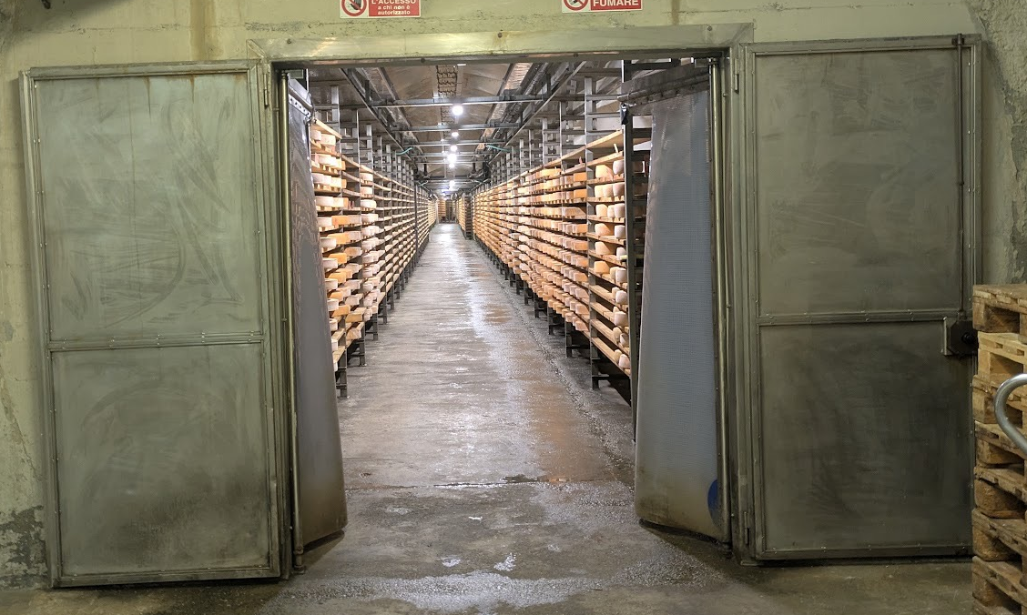
Looking into the Fontina cooperative’s seemingly endless cheese cave capable of holding over 60,000 wheels of cheese at any time
Viable scale in marginal landscapes is achieved through collective organisation, not individual expansion. Terrain, climate, and seasonality place hard limits on individual growth. These systems don't try to overcome them farm by farm. Instead, scale is achieved sideways: through coordination, pooled resources, and shared investment.
The clearest expression of this is seasonal herd amalgamation. In Beaufort and Fontina, livestock managed separately in winter are brought together on the alpages into large, collectively managed herds. Milk is pooled, labour shared, cheesemaking organised collectively. This allows systems to justify processing facilities, quality control, and skilled labour without requiring individual producers to permanently expand.
Scale is bounded territorially — a joined-up valley system, a defined mountain district — large enough to support shared infrastructure and coordinated markets, small enough to remain governable and rooted in place.

Case Study: Fontina PDO — A territorial food system at regional scale
Fontina PDO is not simply a traditional cheese. It is a single, tightly defined product operating as a coherent food system across an entire autonomous region: the Valle D’Aosta. Few European cheeses demonstrate so clearly how scale, coordination, and territorial governance can align without collapsing into industrial standardisation.
Produced exclusively within Valle d’Aosta, Fontina PDO links high-altitude alpeggi, valley-floor farms, communal pastures, research institutes, cooperatives, private affineurs, and a regional consortium into one integrated structure. Around 360,000 wheels are produced annually, drawing on a cattle population of approximately 38,000 cows, all belonging to native Valdostana breeds. This represents one of the largest examples in Europe of a territorially bounded food system operating entirely through locally adapted livestock.
Crucially, this scale is achieved on marginal mountain land, much of which would struggle to support viable agriculture under conventional models. Production takes place without reliance on imported feed, without breed substitution, and without separating milk production from place. The PDO rules explicitly require the use of the three Valdostana breeds only, anchoring the system to animals evolved for steep terrain, long daily movement, and forage-based diets.
Fontina is produced both in summer alpeggi and winter valley dairies, but not all producers perform all functions. Many alpeggi make Fontina during the summer months yet lack the labour or space to age it. Fresh wheels are therefore transferred into a network of cooperative and private maturation caves, where ageing, grading, and preparation for market occur. Final certification is carried out under the authority of the Fontina PDO consortium, which verifies both maturation and compliance before the cheese can be sold under the name.
This division of labour is not fragmentation; it is designed interdependence. It allows small, seasonal producers to remain viable without forcing them to internalise the full capital costs of caves, laboratories, logistics, or marketing. At the same time, it enables regional-scale consistency without erasing variation between alpeggi, seasons, and individual producers.
What distinguishes the Fontina system is that scale is territorial rather than individual. No single farm expands to dominate production. Instead, value is accumulated collectively through shared rules, shared infrastructure, and a shared product identity that is robust enough to operate at volume while remaining place-bound. Even private affineurs and buyers are structurally embedded within this framework: access to the Fontina name is conditional on compliance with PDO rules and consortium oversight.
For this research, Fontina stands out as one of the clearest demonstrations that large-scale, high-value food production in marginal landscapes does not require industrialisation. When governance, breeds, infrastructure, and knowledge are aligned at the level of territory rather than the level of the individual farm, fragility can be transformed into durability.
The lesson from Fontina is that regional ambition, when coupled to strict limits and collective design, can support scale without sacrificing integrity.
There are alpine examples where coordination is absent, and provide a useful counter-point:
In the Hautes-Alpes, dairying collapsed without territorial organisation, shared standards, or coordinated supply chains. What remains — sheep and beef farming combined with off-farm employment — is in many ways similar to Scotland today. In the Bern region of Switzerland, a high concentration of alpage cheesemakers lacks collective infrastructure or governance; despite high activity, the system is widely regarded as fragile, particularly around succession.
These are not failures of effort or skill. They are failures of scale design.

Case Study: Catherine Richard and Bleu de Termignon: When individual brilliance is not enough
Catherine Richard is widely regarded as one of the most legendary cheesemakers in France. The Bleu de Termignon she produces has an almost mythic status within French cheese culture. It is frequently described as one of the purest expressions of terroir in the country: raw, volatile, and inseparable from the high, inhospitable alpine landscape in which it is made.
This is not a refined or domesticated cheese. It is intense, unpredictable, and deeply place-bound. A product that seems to carry the climate, flora, altitude, and isolation of Termignon directly into its paste. Among cheesemakers and affineurs, Catherine Richard occupies an unusual position. She is not celebrated simply for technical perfection, but for having sustained a form of production so uncompromisingly rooted in place that it resists categorisation. Her reputation carries an aura of legend rather than brand.
We visited Catherine Richard during the final week of the alpine season, just before the descent from the alpage. The cows were about to be brought down, milking was ending, and the summer cycle was closing. It was a poignant moment, made more so by the knowledge that this may have been her final season producing Bleu de Termignon in the mountains. Both she and her partner are approaching retirement, and once they stop, the cheese will almost certainly cease to be made.
The recipe and method Catherine Richard uses were passed down through her family — from her mother and grandmother — and have been practised in the same place for generations. Today, only a handful of other producers, perhaps three or four, still make Bleu de Termignon in the area. None operate at a scale or within a structure capable of sustaining the cheese independently of individual makers.
When Catherine Richard stops, Bleu de Termignon is likely to disappear.
This is not a failure of skill, commitment, or cultural value. It is the result of structural absence. The cheese survives through the brilliance, endurance, and personal authority of one exceptional individual. There is no collective infrastructure to carry it forward, no shared processing facilities, no coordinated system of succession, and no institutional framework capable of absorbing her knowledge and redistributing it across a new generation of producers.
Catherine Richard is, in every meaningful sense, a food hero. But what she produces is not a food system.
This distinction matters. Exceptional individuals can preserve practices for a lifetime, but they cannot reproduce them socially without supporting structures. Where production depends on singular mastery rather than collective organisation, continuity becomes impossible once that individual steps away.
The likely extinction of Bleu de Termignon is therefore not a cautionary tale about failure. It is a clear-eyed illustration of a structural truth: individual brilliance, however revered, is not sufficient to sustain a system. Without collective scale, shared infrastructure, and mechanisms for succession, even the most celebrated expressions of terroir remain fragile.If the aim is to build durable, place-based food economies, reliance on heroes is not a strategy. Systems must be designed so that excellence can outlive the exceptional individuals who embody it. Systems that rely on heroes are structurally fragile, regardless of cultural value.

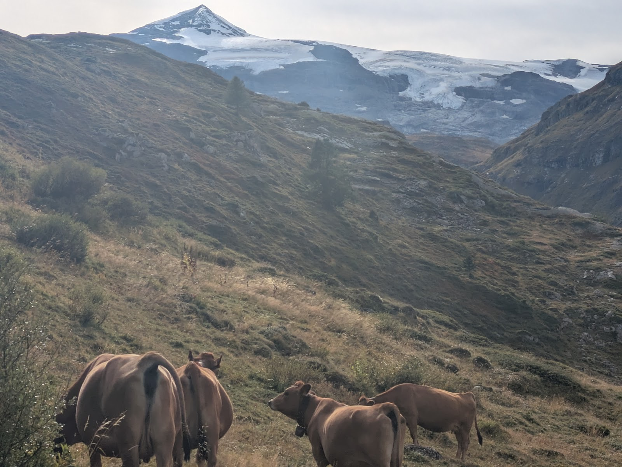
Some of Catherine’s cattle grazing at 2100 meters just below a glacier

2.3 Separating ownership from access enables participation and resilience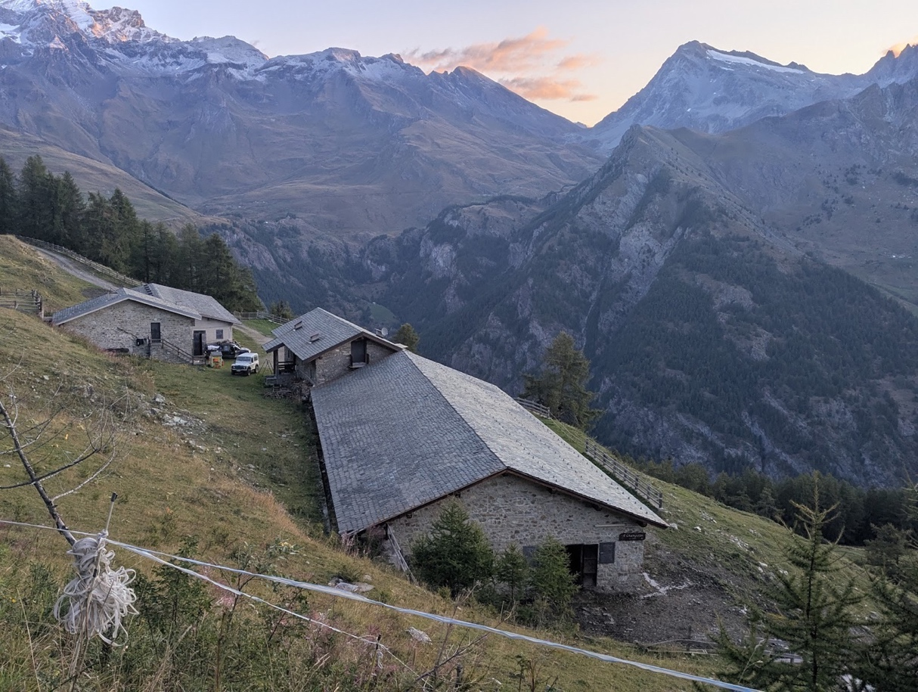
A large alpeggio owned by the commune and rented by the producer
A consistent structural feature across these systems is the deliberate separation of ownership from access. In the Fontina system, an estimated 80% of cattle on the alpeggios are rented rather than owned by cheesemakers. Alpages and buildings are often commune-owned, with producers operating as tenants. Participation in complex, high-value production therefore doesn't depend on inheriting assets or taking on unsustainable debt.
Decoupling access from ownership reduces capital thresholds, spreads risk, and supports continuity — when a producer leaves, land, livestock, and infrastructure remain embedded in the territory. Stewardship is maintained through clear tenancy rules rather than ownership obligations.

System Notes: Native breeds as system infrastructure
Across the Alpine systems studied, appellations (AOP / PDO) do not merely protect products. They mandate the use of specific native cattle breeds. Breed choice is treated as a structural condition of production, not an individual decision. Entire territories are organised around breeds that evolved in those landscapes:
Valle d’Aosta: Fontina PDO may be made only from Valdostana breeds
Beaufort: Primarily Tarentaise (Tarine), with tightly limited cross-breeding
Abondance / Reblochon: Minimum and rising thresholds for Abondance cattle within herds
In some regions, this means tens or hundreds of thousands of animals across a whole territory belonging to just two or three locally adapted breeds.
These breeds are protected because they function as ecological infrastructure. Physically suited to steep terrain, altitude, and long walking distances, they thrive on forage-based diets and produce milk with fat and protein profiles optimised for cheesemaking. High-yield breeds — most notably Holsteins — were repeatedly described as structurally incompatible: fragile in mountain conditions and poorly suited to long-aged cheeses.
Breed protection is actively enforced through minimum percentages, milk price penalties, and periodic tightening of appellation rules. These systems don't just restrict breeds. They invest in them, with regional programmes selecting for mountain mobility, longevity, and milk quality rather than yield. Where breed rules are absent or weak, as in parts of Switzerland, Holsteins are common - a situation French and Italian producers consistently described as destabilising over time.

2.4 Infrastructure precedes viability (and is held in common)
Transhumant dairy systems don't grow incrementally from individual investment. They function because substantial shared infrastructure is already in place before producers enter. The infrastructure is not peripheral. It is the system.
In regions such as Fontina and Beaufort, cooperatives operate large ageing caves, testing laboratories, packaging facilities, logistics networks, and in some cases abattoirs. These assets represent levels of capital investment inconceivable for individuals. These are professionally managed by salaried staff, with strategic oversight remaining accountable to producers. Some regions, notably Beaufort, also use mobile milking parlours to bring milking close to summer pastures; individually operated, these feed directly into shared downstream processing. Flexibility at the pasture level is paired with permanence downstream.
Where this logic is absent, fragility dominates: high capital costs, low utilisation, and capacity that disappears when individuals exit. Shared infrastructure absorbs variability and enables continuity. It is a precondition for viability, not a reward for success.

System Notes: Three examples of enabling infrastructure
Infrastructure precedes viability, but it need not always take the form of fixed buildings. Three recurring examples from the fieldwork show how broadly the term should be understood: infrastructure that moves, infrastructure that is biological, and infrastructure borrowed from other industries entirely.
Milking infrastructure that moves.
Not all infrastructure must be permanent. Beaufort separates the heavy downstream plant that is built once and held in common — ageing caves, laboratories, processing halls — from the milking layer closest to the animals, which is mobile. Milking there is now done almost entirely in mobile parlours: fully equipped units towed by tractor and repositioned through the season to follow the herd and the grass. Developed locally with the national research institute (INRA) during a labour crisis, they let the milking point follow the animals rather than the reverse, preserving rotational grazing and even manure distribution across the whole alpage — where the Swiss and Italian alternative of fixed milking buildings would have demanded several permanent structures, in one producer’s words ‘more substantial than a house.’ Mobility is not the absence of infrastructure — a unit is a durable asset costing around €200,000, and still needs prepared platforms, tracks, and water — but the layer closest to the animals can be relocatable rather than built in stone.
Microbial infrastructure.
Infrastructure can also be biological. In the Aosta Valley, Fontina production is supported by indigenous starter cultures — bacteria isolated from local alpine environments, conserved and distributed centrally by regional research institutes since the 1980s, and authorised for Fontina alone. Transhumant cheesemaking is microbiologically vulnerable: when a product’s identity depends on ambient flora, that identity can quietly erode as environments and practices change. Holding the cultures centrally treats microbial continuity as a collective responsibility rather than leaving it to chance. Their use is optional and, producers stress, stabilising rather than expressive — keeping production within the recognised bounds of the cheese’s character without standardising it or substituting for skill. Like ageing caves or laboratories, the culture is shared territorial infrastructure: researched collectively, conserved centrally, and stewarded over time. The same instinct rescued the native Reblochon strains, recovered from the last hand-made wheels in the 1980s, that now anchor that cheese’s identity.
Borrowed access: roads built for ski and hydro.
Infrastructure can be borrowed. Reliable access roads are fundamental — for milk collection, labour, maintenance, and emergencies — yet across the regions studied they were rarely built for farming. In the Aravis, the road serving the Reblochon alpages exists chiefly to maintain the ski-lift network in summer, and those restricted tracks are shared between lift operators and farmers. In the Beaufortain, the dependable tracks date from the post-war dam-building era — producers are explicit that the valley roads were improved because of the dams — and the hydro scheme reached further still: compensation paid by EDF for pastures flooded at Roselend supplied the capital that founded the Beaufort cooperative in 1957, after the agricultural bank refused to lend. Producers were equally clear about the costs, since the dams also flooded land and drew labour away, so this is no endorsement of such schemes; but infrastructure built for energy or tourism repeatedly became the backbone on which a food system could be rebuilt, wherever agriculture was positioned to use it.
Read together, these widen what counts as infrastructure: it can move, it can be alive, and it can be inherited from another industry. For the Gàidhealtachd — short of fixed plant, capital, and easy access — that breadth is encouraging, since viability need not wait on building everything new. The durable access now being opened into previously inaccessible glens by renewable-energy and grid schemes is an especially direct parallel, taken up in Recommendation 8.
2.5 Local governance must be producer-owned, clear, and enforceable
Governance functions as infrastructure: formal, designed, and unavoidable. Robust systems share four characteristics:
- strategic control rests with active producers through one-member, one-vote structures;
- roles between members and employed managers are clearly defined and understood;
- participation is binding through multi-year commitments;
- and compliance with agreed standards and volumes is enforced consistently.
Where governance lacks authority, individual rationality overwhelms collective logic. Overproduction, unilateral exit, and rule-breaking become attractive even as they undermine the system. Producer-owned, enforceable governance turns cooperation from aspiration into practice.
2.6 Bespoke regulation enables transhumant systems
These systems endure because they are formally recognised as a distinct category of production. Appellation frameworks (AOPs, DOPs, PDOs) function not as branding devices but as constitutional structures defining geographic boundaries, permitted breeds, seasonality, processing methods, and production volumes. Regulation here is system architecture, not constraint.
Producers outside these criteria are excluded from the appellation economy, preventing drift toward intensification or substitution. Production limits and quotas stabilise prices, discourage speculative expansion, and make long-term planning possible.

System Notes: Alpine food safety regulation as enabling infrastructure
Across Switzerland, alpine cheesemaking is governed by a dedicated national food safety framework for alpage production. This regulation—approximately 167 pages long—defines hygiene, self-control, and production standards specifically adapted to seasonal, high-altitude dairy systems. It operates as a distinct regulatory category, separate from default international industrial HACCP food safety regimes (Hazard Analysis and Critical Control Points).
What problem it solves
Standard HACCP systems are designed around industrial assumptions: sealed buildings, fixed infrastructure, continuous production, and highly standardised workflows. Applied directly to alpine cheesemaking, these requirements would make seasonal mountain production unworkable.
The alpine framework resolves this by retaining core food safety principles (hygiene, traceability, self-control), while redesigning their application for seasonal, mobile, and open mountain environments. This is not deregulation, but regulatory adaptation.
It sets out permitted milk production systems, approved processing methods and recipes, hygiene practices adapted to alpine conditions, documentation and inspection requirements, and the range of products allowed under alpine certification.
For this to work producers of alpage cheeses must be certified as alpage producers to access this regime. This certification functions as a gatekeeper: certified producers are inspected against alpage standards and non-certified producers cannot sell alpage products at all.
Mountain production is therefore regulated as mountain production, not as a relaxed version of industrial dairying. This regulatory framework is enabling infrastructure.
Without it alpine cheesemaking could not operate legally at scale, collective investment would be irrational, and transhumant systems would be forced into informality or collapse.
With it inspection becomes predictable, compliance becomes achievable, and mountain dairy becomes legible to regulators, markets, insurers, and lenders.
Crucially, this framework operates alongside PDO/AOP rules rather than replacing them. Appellations define what may be produced; alpine regulation defines how it can be produced safely under mountain conditions. Both are necessary.
2.7 Durable systems are designed around human labour

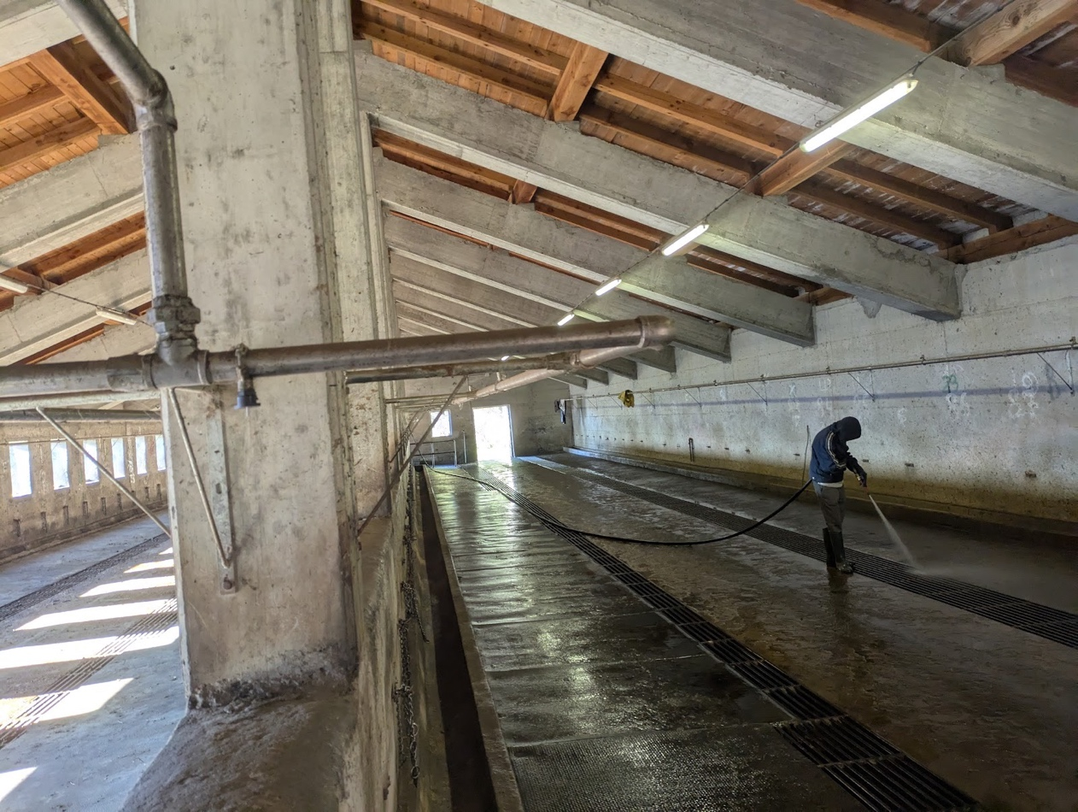
A seasonal worker from Morocco doing day-to-day labour at an Alpeggio
In the most robust systems, labour is treated as a finite and valuable resource. Work is pooled and shared through pastoral groups and cooperative structures such as GAECs; tasks are rotated, responsibility distributed, and paid employment is normal rather than exceptional. These systems don't eliminate intensity. They make it survivable and repeatable.
Where systems struggled, labour pressures were compensated for rather than redesigned, typically through reliance on migrant workers. This kept systems running without resolving underlying issues of workload or continuity. The French systems examined — organised through GAECs and pastoral groups — largely sustained domestic labour through collective organisation, price stability, and shared responsibility.
Labour outcomes are a test of genuine viability. Where work is organised so that people can imagine doing it for years, systems reproduce themselves. Where it depends on exhaustion or continual replacement, fragility persists.

Case Study: The Aime Pastoral Cooperative (Beaufort) — Designing labour for continuity
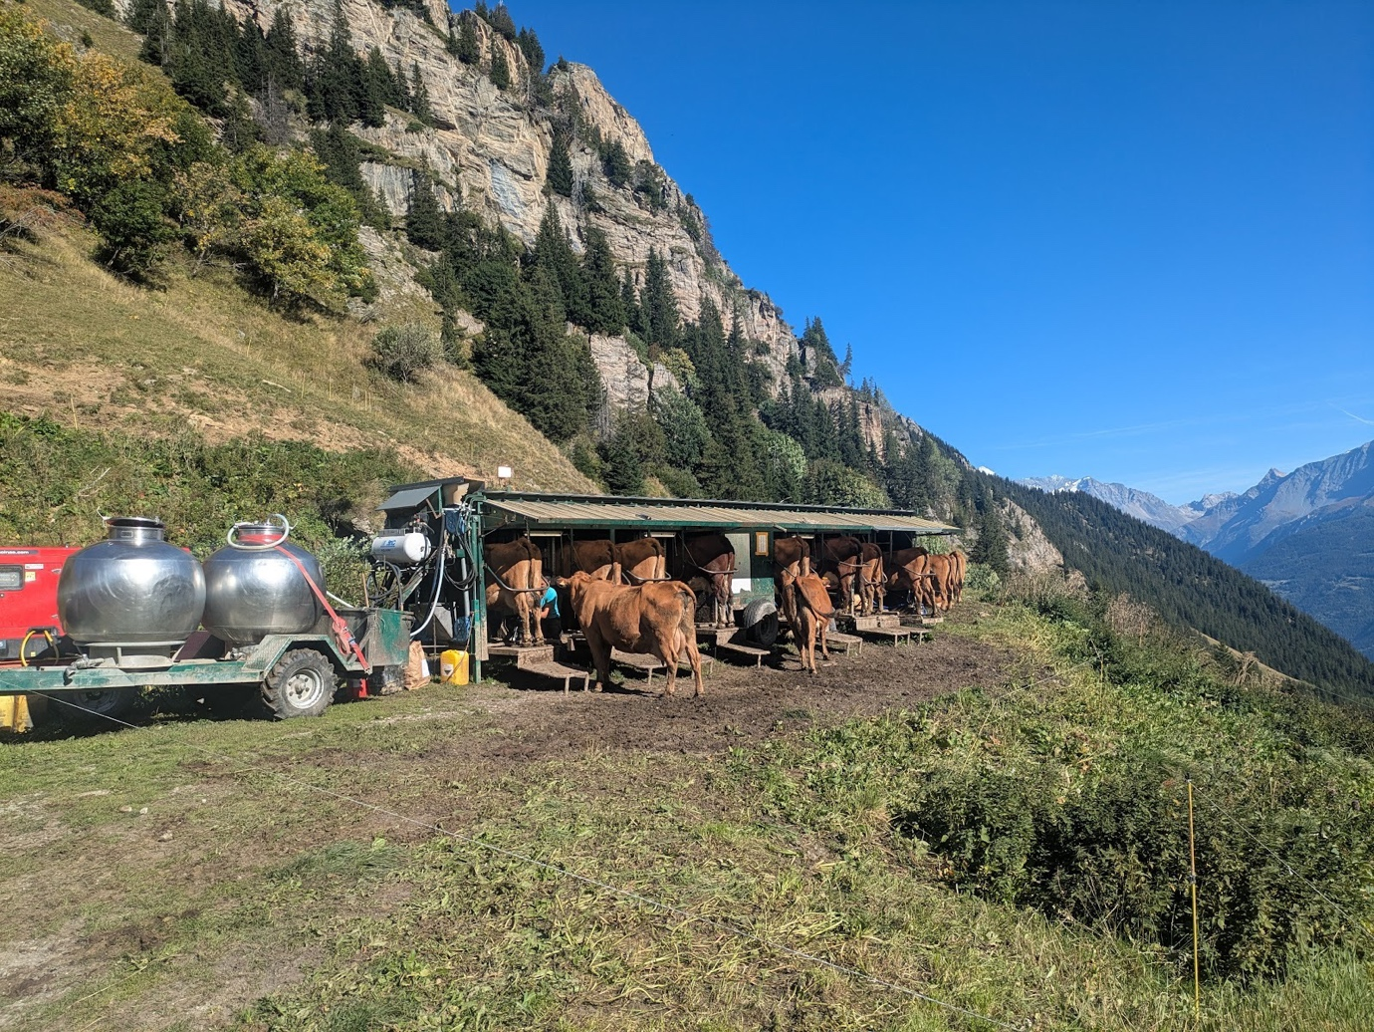
One of the mobile milking parlours used by the groupements pastoraux at Plan Pichu
The pastoral groups associated with the Aime Beaufort cooperative represent one of the clearest examples encountered during this research of labour being treated as a primary design constraint rather than a residual problem to be absorbed by individuals.
What distinguishes the Aime system is not scale alone, but the way scale is deliberately used to make labour viable.

Collective organisation at working scale
The alpage of Plan Pichu brings together ten farms into a single pastoral structure managing approximately 450 dairy cows and 300 heifers across 1,200 hectares. Rather than attempting to form a single herd—which would exceed practical limits—the system operates with three separate herds, each with its own milking installation and grazing sectors. This subdivision is not incidental: it allows work to remain manageable while retaining the benefits of collective organisation.
Decisions about investment, infrastructure, and management are taken collectively by the member farms through a formal council structure. This includes major capital investments in cheesemaking facilities, energy systems, and animal management infrastructure. Labour design is therefore embedded at the governance level, not improvised season by season.

Labour as a finite resource
Unlike many alpine systems that rely on individual producers to shoulder the majority of summer labour, the Aime alpage is operated almost entirely by salaried employees. During the summer season, twelve employees work on the alpage, including herdsmen, cheesemakers, cellar workers, and logistical staff. Farmers themselves remain primarily based in the valley, visiting regularly but not carrying the daily operational burden.
Work is structured explicitly to prevent exhaustion. Cheesemakers work on a one-week-on, one-week-off rotation. Herdsmen work twelve days followed by two days off, with an additional rotating herdsman providing cover across the three herds. Tasks are clearly delineated: grazing management, milking, milk transport, cheesemaking, cellar care, provisioning, and visitor management are assigned distinct roles.
This level of redundancy within the system is only possible because labour is pooled across farms. No single holding could justify or sustain such staffing arrangements independently.

Integration across seasons
A key strength of the Aime system is its continuity of employment beyond the summer. Several alpage employees—particularly cheesemakers—are employed year-round, transitioning from mountain production to work in the cooperative’s valley facilities once the alpage closes. This reduces seasonal precarity and supports skill retention.
Other employees return to winter work elsewhere in France, including ski stations, but do so as a stable and anticipated part of their employment cycle rather than as an emergency fallback. Labour mobility is managed, not improvised.

Communal obligation and ongoing care
Farmer involvement is maintained through a formal system of communal labour obligations. Each member farm owes three hours of maintenance work per cow per season on the alpage. This work—road maintenance, infrastructure repair, seasonal closure—is either delivered in kind or deducted financially from milk payments.
This mechanism ensures that responsibility for the alpage remains shared, even when daily labour is delegated to employees. It also prevents disengagement by those physically distant from summer operations.

Why this matters
The Aime pastoral system demonstrates that demanding agricultural work does not inevitably require personal sacrifice without limit. Where labour is treated as a design constraint—finite, skilled, and worthy of protection—systems can be built that people are willing to work within over time.
This is not a small or artisanal exception. It is a large-scale, technically complex operation producing Beaufort at volume, while maintaining working conditions that were some of the best encountered during this research.

2.8 Vision comes before structure
Systems that endure are built forward from a shared vision of what they are trying to become. Systems that struggle are typically assembled reactively in response to crisis — price collapse, regulatory change, market loss — accumulating rules and fixes without reference to an agreed future. Governance becomes opaque, responsibilities blur, and participation shifts from collective ownership toward tactical compliance.
Without a clearly articulated vision, there is no basis for distinguishing structural problems from symptomatic ones. Where vision comes first, governance and infrastructure follow coherently. Where structure precedes vision, complexity accumulates and coherence erodes.
Case Study: Vision-led design vs reactive formation
Orsières cooperative and Tzintre cooperative
This contrast illustrates how the sequence of cooperative formation—vision first or crisis first—shapes long-term coherence, legibility, and resilience.

Orsières: A contemporary cooperative designed forward
La Laiterie d’Orsières is a relatively new cooperative, established in a context of modern regulatory, financial, and technical constraints. Its significance lies precisely in the fact that it was not inherited from an older institutional landscape, but consciously designed in the present. It should be noted that most of its producers are valley producers who are not milking in the alpages.
From the outset of its formation, members articulated a clear shared vision of what the cooperative was meant to be: A milk-processing cooperative rather than a producer of individual cheeses, with a professionally run facility that producers would interface with simply and reliably.
Only once this vision was agreed did members begin designing governance, infrastructure, and finance. Rather than adapting existing buildings or assembling facilities incrementally, the cooperative took the time required to secure appropriate funding and to design a purpose-built dairy that matched its intended function.
This sequencing mattered. The facility was designed around clear physical separation between producers and processing, predictable milk delivery routines, professional operation by salaried staff, and informal social infrastructure (such as shared spaces) that supported daily interaction without blurring roles.
The result is a cooperative whose structure expresses intent rather than compromise. The distinction between members and employees is clear. Strategic control sits with producers, while operational competence is professionalised. Importantly, the cooperative did not rush to scale before it was structurally ready to do so.
Orsières demonstrates that vision-led design is achievable provided time, clarity, and restraint are treated as design inputs rather than delays.

Tzintre: Reactive formation and structural accumulation
Tzintre emerged under very different circumstances. It was formed defensively in response to market disruption following the abolition of milk quotas. The cooperative’s initial purpose was survival rather than realisation of a clearly imagined future system.
As pressures continued—regulatory, economic, organisational—the cooperative adapted through successive fixes. New rules, committees, contractual arrangements, and operational workarounds were added as problems arose. Each change addressed an immediate need, but few were tested against an overarching vision of what the cooperative was ultimately meant to become.
Over time, this produced a structure that became increasingly complex and difficult for members to navigate. Governance grew opaque, roles blurred, and participation shifted from collective shaping toward tactical compliance. Rather than consolidating purpose, adaptation accumulated friction.
This outcome did not reflect a lack of effort or commitment. It reflected a design logic shaped by urgency.

What the contrast reveals
The difference between Orsières and Tzintre is not one of geography, producer competence, or cultural disposition. Both operate in similar mountain contexts and face comparable external pressures.
The difference lies in sequencing. Orsières began by asking what kind of system do we want to build? Tzintre began by asking how do we survive this moment?
In the first case, time was taken to align vision, funding, and infrastructure before inviting full participation. In the second, structure grew reactively as participation was already underway.
This contrast underscores a central design principle: cooperatives that endure are not built by accumulating solutions to immediate threats, but by working backward from a clearly articulated future.
Vision provides a stable reference against which change can be assessed. Where vision comes before structure, systems adapt without fragmenting. Where structure precedes vision, complexity accumulates and coherence erodes.
Orsières shows that this is a viable approach for building new cooperative institutions today.
Taken together, these principles describe not a single institutional model but a set of constraints within which many different forms become possible. Durable systems are organised around continuity rather than maximisation, treating environmental limits, seasonality, and labour capacity as fixed design conditions rather than inefficiencies to overcome. Scale is achieved through territorial coordination rather than individual expansion, with land, infrastructure, and production rights held in institutions designed to outlast any single participant — ownership decoupled from access so that entry, exit, and succession don't destabilise the whole. Functions are deliberately separated: land governance, labour, production, and market coordination handled by distinct but interoperable bodies, none asked to absorb every risk simultaneously. Shared infrastructure is treated as a precondition rather than a reward — slow, territorial capital held in common and professionally managed before producers ever enter the system. Governance is binding and producer-owned, with enforceable rules and long-term commitments that align individual behaviour with collective survival. And the system is defined through regulation before the market can define it by default, with formal recognition of difference protecting quality, method, and scale from being eroded by industrial frameworks designed for other purposes entirely.
These are not design principles abstracted from theory. They are observed conditions, drawn from systems that have survived generational change, economic disruption, and political pressure. That they exist at all — and continue to function — is the most important finding this research has to offer.
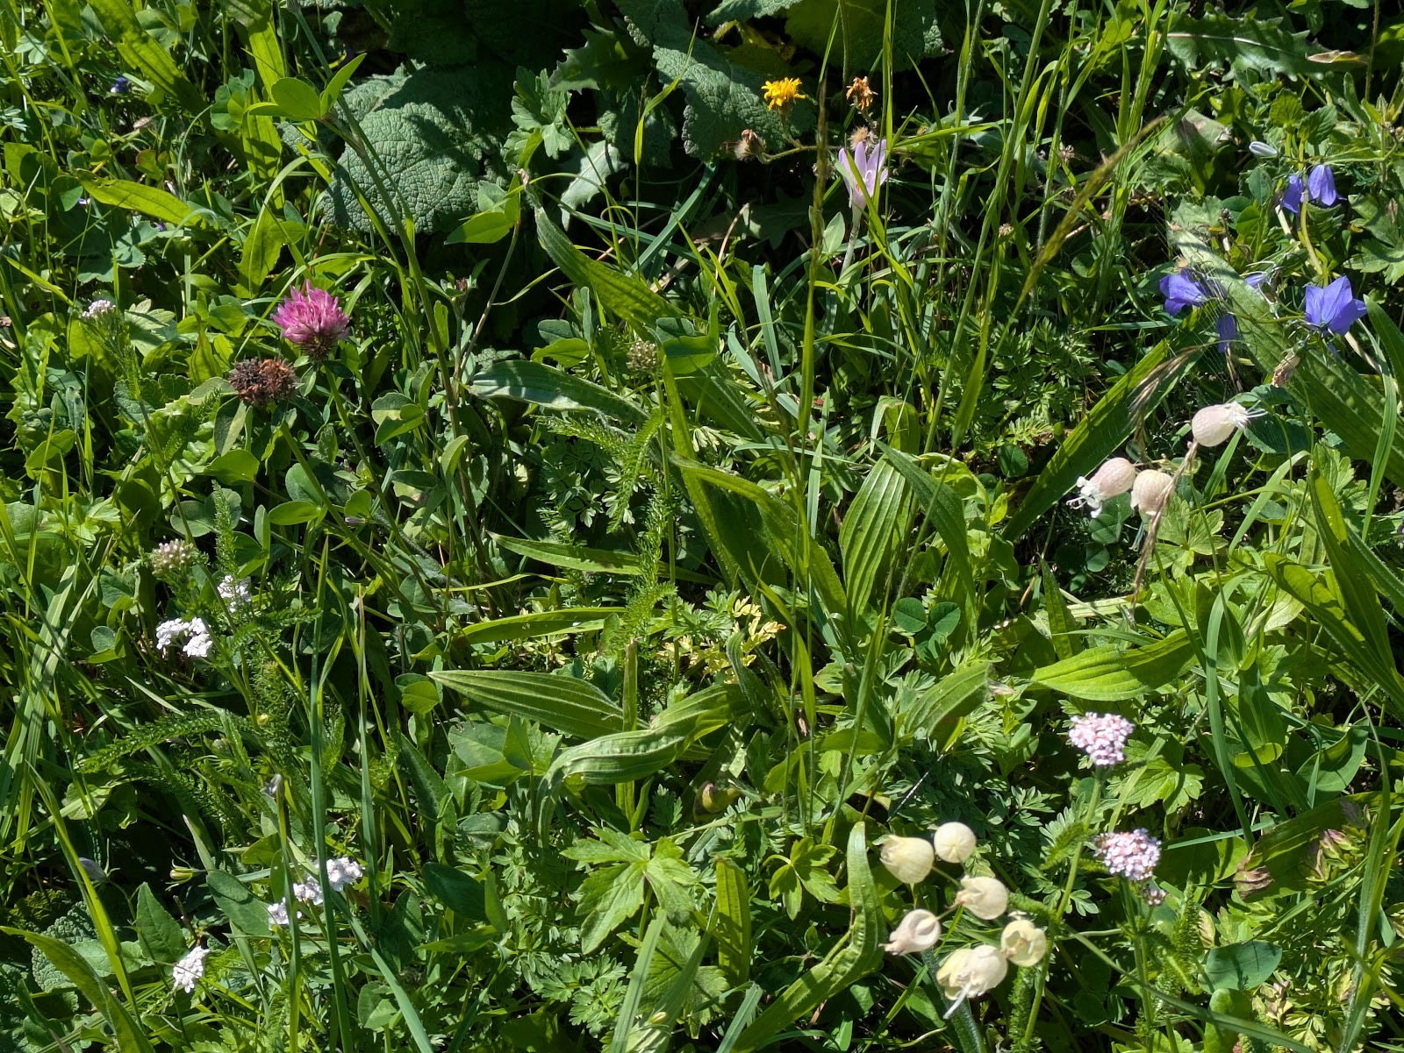
Examples of the diversity of herbs, forbs, flowers, and grasses found in alpine pastures
3. Ecological Context: What Travels and What Doesn't
Understanding what makes them possible, however, requires looking beyond the systems themselves — at the ecological conditions within which they operate, and at why those conditions cannot simply be assumed to travel.
One of the most striking observations from the fieldwork was ecological rather than institutional. The alpine and sub-alpine pastures visited were among the most botanically rich and visually vibrant landscapes encountered during the research — dense mixtures of grasses, legumes, and flowering forbs, alive with pollinators, structurally complex, and clearly in exceptional ecological health. This was not incidental. It was produced by the grazing system itself. Centuries of seasonal transhumance — movement, rest, cutting, return — had created habitats of a kind that the rewilding movement often describes as a goal. Here, they were an outcome of agriculture.
This matters because it challenges a binary that dominates UK land-use debate: the assumption that farming and ecological recovery are competing agendas. The Alpine evidence suggests they need not be. Where grazing systems are designed around restraint, seasonality, and ecological knowledge rather than maximisation, the result can be landscapes that are simultaneously productive and ecologically rich. Transhumance, at its best, is not a compromise between food and nature. It is both at once.
However, translating this finding directly into UK contexts requires one significant caution. The ecological baseline is fundamentally different.
In the Alps, forest is the dominant land cover — the default condition of the landscape. Open pasture exists as a minority habitat, maintained against the pressure of natural succession. Where grazing ceases, meadows scrub over and reforest within years. The primary ecological challenge for Alpine transhumant systems is not how to restore woodland, but how to maintain open ground within a landscape that is already overwhelmingly wooded. Sustaining pasture is the ecological work.
In the UK — and particularly in the Highlands — the situation is reversed. Scotland has some of the lowest levels of native woodland cover in Europe, and the recovery of forest and woodland is a legitimate and pressing ecological priority. The rewilding and nature recovery movements in this context are rightly focused on increasing tree cover, not defending against it. Importing Alpine arguments about the ecological value of open grazing without accounting for this difference would be misleading.
The lesson is not that transhumant grazing cannot contribute to ecological recovery in the UK. It is that the contribution will look different, and must be designed around the specific deficits and dynamics of Scottish landscapes rather than assumed from Alpine examples.
A final point concerns predators. Across every country visited, wolf predation emerged as a live and deeply contested issue. Producers described serious, repeated losses — livestock killed, flocks driven over cliffs, years of careful breeding destroyed in single nights. Coexistence measures exist but none of the producers encountered described the situation as resolved. This matters for UK debates, where Alpine systems are sometimes cited as evidence that farmers can successfully coexist with apex predators such as wolves or bears. That framing is not accurate. The question is genuinely unresolved in the Alps, and presenting it otherwise does a disservice to both the farmers living with it and the complexity of the policy challenge.
It is also worth noting, as an observation rather than a finding, that the rewilding movement was largely absent from the regions visited during this research. Where transhumant dairy systems remain institutionally intact and economically viable, there appears to be little space or appetite for large-scale rewilding as a land-use alternative. The one significant exception is instructive. The only large rewilding landscape encountered — the Dauphiné Alps — overlaps geographically with the area repeatedly described by interviewees as a cautionary tale: a region where transhumant dairying collapsed after the Second World War because producers failed to organise collectively, and where, according to those accounts, the ecology deteriorated alongside the agricultural system. What the rewilding movement is now working to restore in that landscape is, in part, what functioning transhumance once maintained.
This does not make rewilding wrong. But it does suggest that in the Alpine context at least, large-scale rewilding tends to follow agricultural collapse rather than coexist with viable pastoral systems. The implication for Scotland is uncomfortable but worth sitting with: if rewilding arrives in the Highlands as the dominant land-use narrative, it may be worth asking whether it is filling a genuine ecological gap — or the space left by a food system that was never properly supported.

4. Institutional and Land-Governance Foundations of Alpine Systems
The Key Learnings set out in Section 2 describe what durable transhumant systems look like in practice — how they organise production, enforce quality, coordinate labour, and position themselves in markets. But they leave a question unanswered: why do some of these systems persist across generations while others, facing broadly similar conditions, unravel? The ecological section suggests part of the answer — that collapse tends to follow not from ecological failure but from institutional failure, the point at which collective organisation can no longer hold. This section goes deeper into what that collective organisation actually rests on. Beneath the cooperatives, the appellations, and the pastoral groups lies a layer of land governance that is older, slower, and often invisible even to the producers working within it. It is this layer — the territorial commons, the separation of land from production, the legal structures designed to outlast individuals — that determines whether the visible institutions above it can endure. Understanding it matters not only as Alpine context, but because equivalent structures once existed in the Gàidhealtachd, and because the question of whether they can be recovered is now, in some parts of Europe, being actively answered in law.
  - Alpine commons: the invisible roots of cooperative culture
One of the more unexpected findings to emerge from the research concerned not what producers knew about their institutional history, but what they didn't. In the Valle d'Aosta, the consorteria — a form of collective landholding predating the modern Italian state — forms a foundational layer of how mountain territory has been organised for centuries. Yet many producers working within systems rooted in this history were only vaguely aware of it, or could not clearly distinguish it from the cooperatives and consortia they participate in today. In Switzerland, equivalent structures — consorts and consortage — govern shared rights over alpine pastures and infrastructure, in some cantons linked to the bourgeoisie, a collective body of local citizens holding land outside both the market and the political municipality. These too were rarely articulated as living systems by the people operating within them.
This invisibility is not evidence of irrelevance. It is evidence of depth. The cooperative instincts that animate these systems — the willingness to pool infrastructure, enforce collective standards, subordinate individual interest to shared outcomes — did not emerge from policy design or deliberate cultural cultivation. They are the sediment of land governance arrangements that go back centuries, so embedded in how these territories function that they no longer require conscious articulation. Producers cooperate, in part, because the landscapes they inhabit were shaped by systems that made cooperation the condition of survival long before any of them were born.
What makes the Italian legal work significant is precisely this: by formally recognising domini collettivi in law — establishing that these pre-state collective institutions have constitutional standing, autonomous governance, and full legal personality — Italy is not inventing something new. It is acknowledging something that was always there, making visible what had become invisible, and giving it contemporary legal weight. The Valle d'Aosta Regional Law 19/2022 builds on this, embedding consorterie within regional governance while preventing their absorption into either private property or public administration. It is an act of institutional recovery rather than institutional creation.
The Gàidhealtachd had its own equivalents — territorial, collective, and deeply operational. How those systems actually functioned in practice, and what their dismantling cost, is examined in Section 6. The point to register here is that cooperative culture in the Alps is not a cultural trait or a fortunate accident. It has roots. And the fact that those roots can be formally recognised and recovered — even after long periods of invisibility — is directly relevant to what Scotland might yet do.
4.2 A suite of mechanisms: separating functions to build resilience
Alongside these deep historical roots, the research also encountered a more recent and deliberately constructed layer of institutional tools. If the consorterie represent the deep historical root of Alpine collective land governance, the French institutional arrangements encountered during the research represent something more immediately practical: a set of contemporary legal tools, developed over the latter half of the twentieth century, that together address the specific pressures bearing down on marginal agricultural systems today.
What was striking in the Alpine context was not the existence of these mechanisms individually — most are relatively well known in French agricultural policy — but how deliberately they are combined. No single institution is asked to solve everything. Land ownership, farm operation, seasonal grazing, and market coordination are handled by distinct but interoperable bodies, each designed to do one job well.
The Groupement Agricole d'Exploitation en Commun (GAEC) allows multiple farmers to operate as a single enterprise while each retaining full professional status as a farmer. This matters particularly in mountain systems where labour demands and infrastructure costs make individual operation unviable. The GAEC organises work and production collectively, but it does not hold land — and that separation is deliberate.
Land is instead held through a Groupement Foncier Agricole (GFA), which owns it collectively and leases it back to the farming body. This prevents fragmentation through inheritance or sale, and allows previously divided land to be reassembled into coherent productive units. In the systems observed, GFAs were used explicitly as a protective wrapper — ensuring that collective farming could not be undone by property division across generations.
At a broader territorial scale, SAFER — a network of publicly mandated regional land agencies — has the power to intervene in land sales, pre-empt speculative transactions, and redirect land toward active agricultural use. It does not constitute a commons, but it acts as a market-braking mechanism, providing the stable backdrop against which GFAs and GAECs can function during moments of succession or restructuring.
Finally, at the level of summer grazing, groupements pastoraux organise the collective use of communal alpine pastures. Multiple farms pool herds, labour, and infrastructure, employing herdspeople and cheesemakers collectively, and managing seasonal production on land owned by municipalities or long-standing collective bodies. In the Aime canton, this arrangement is not an exception but the norm.
Together, these mechanisms address problems that Scotland and the Gàidhealtachd face with increasing urgency: how to keep land in productive use across generations without depending on individual wealth or inheritance; how to enable new entrants without requiring them to purchase land outright; how to achieve viable scale without sacrificing local accountability; and how to prevent speculative transfer from dismantling farming systems that have taken decades to build.
No direct equivalents to this institutional suite currently exist in Scottish land law in any coherent or coordinated form. That absence is significant. These mechanisms were not designed as a package — they evolved in response to real pressures over several decades — but their combination has proved genuinely effective. Understanding how they work together, and whether analogous arrangements could be developed within the Scottish legal context, represents a substantial and urgent area for further work. It is identified here as a clear recommendation: dedicated study of this institutional toolkit, with a view to developing Scottish equivalents, should be treated as a policy priority rather than a long-term aspiration.
6. Implications for the Gàidhealtachd
The preceding sections have set out what Alpine transhumant systems look like, why they work, and what sits beneath them. This section asks what that evidence means for the Gàidhealtachd specifically. Not as a blueprint to be copied, but as a set of conditions to be understood and, where possible, deliberately created.
The findings of this research suggest that the central challenge facing the Gàidhealtachd is not whether transhumant, dairy-led upland systems are ecologically or economically plausible. The Alpine evidence makes clear that such systems can function under conditions of severe constraint.
The deeper question is whether the institutional conditions required to support them can be re-established in a context where collective organisation has been systematically weakened.
This matters. Without examining wider structural issues, the risk is that responsibility for systemic failure is placed back onto individuals — onto crofters, new entrants, or small groups.

The illusion of individual solutions
Much contemporary policy and development discourse treats crofting as a collection of individual enterprises. Support mechanisms, compliance regimes, funding streams, and advisory services are largely structured around the assumption that viability can be secured croft by croft, through diversification, efficiency gains, or entrepreneurial initiative. While common grazings remain an important shared land base, they are primarily governed through compliance with use rules rather than supported as sites of collective enterprise, shared infrastructure, or coordinated production.
This framing is deeply misaligned with the realities of marginal land.
As the Alpine systems demonstrate, transhumant dairying depends on conditions that no individual can create or sustain alone: shared infrastructure, seasonal coordination, pooled labour, collective quality enforcement, and stable market positioning. Where these conditions are absent, individual effort — however committed — is insufficient.
The implication for the Gàidhealtachd is stark but clarifying. The absence of dairy-led transhumant systems today is not evidence of a lack of ambition, skill, or willingness on the part of crofters. It is evidence that the institutional environment no longer supports collective production at landscape scale.

Decommonising and the loss of confidence in cooperation
This helps explain a paradox that surfaced repeatedly during this research. When I presented my preliminary findings from this Alpine fieldwork to crofters at the Scottish Crofting Federation, one of the most strongly voiced hurdles was the difficulty of working together over long periods of time to realise a shared vision.
This response is significant. It signals not resistance to cooperation, but uncertainty about its durability. Many crofters recognised the logic of collective systems, yet doubted whether sustained collaboration was realistically achievable in the present context.
Seen historically, this hesitation is not surprising. As Iain MacKinnon has described, the dismantling of commons governance in the Highlands was not only material and legal, but cognitive. Over generations, collective organisation was stripped of economic function and institutional support. Cooperation came to be associated with loss, coercion, or fragility, while individualism was normalised as the only viable mode of operation. The result is a form of institutional amnesia. Structures persist in law and custom, but confidence in their capacity to deliver meaningful outcomes has eroded.
The Alpine comparison is instructive here. Long-term cooperation in those regions does not endure because participants are unusually cohesive or altruistic. It endures because cooperation is designed, enforced, and resourced. Roles are defined. Rules are clear. Conflict is mediated institutionally. Continuity is protected beyond the involvement of any single individual or generation.
Expecting durable cooperation to emerge spontaneously, without facilitation, structure, or long-term support, places an unreasonable burden on individuals. Difficulty in cooperating is a predictable outcome of institutional withdrawal.

System Notes: What historic cooperation in the Gàidhealtachd once looked like
Accounts recorded by Alexander Carmichael for the Crofters’ Royal Commission in the 1880s, and later through oral history by Eric Cregeen, describe a pattern of everyday cooperation in the Gàidhealtachd that was neither informal nor occasional, but continuous and operational.
At the level of the township (baile), land, labour, and livestock were managed collectively through established roles and routines. Grazing was held in common and regulated locally. Stocking levels were agreed, herdsmen appointed, and seasonal movements coordinated. Arable land was divided into run-rig strips that were periodically reallocated by lot, ensuring that advantage and disadvantage were shared over time rather than fixed permanently to households. After harvest, arable land reverted to common grazing, reinforcing the primacy of collective interest over individual enclosure.
Day-to-day administration was handled by locally appointed officers. The township constable, chosen by the people or jointly with the factor, oversaw the allocation of peat cuttings, organised the construction and maintenance of roads, coordinated shared labour obligations, and ensured compliance with communal rules. Labour for essential infrastructure — peat roads, dykes, cattle folds — was contributed in set amounts by each household, with tools, horses, and carts pooled as required. Tasks were scheduled to minimise disruption to agricultural work, often taking place at night or in rotation.
Risk was explicitly shared. If a household lost a horse, neighbours completed its work until a replacement could be found. If illness struck during harvest, labour was redistributed. Night watches were organised in pairs to protect crops from wandering livestock, with responsibility rotating among households. Failures were accounted for collectively, but compensation was exacted where negligence caused loss, preserving trust without collapsing into informality.
These arrangements extended beyond agriculture. Fishing grounds were allocated by lot to prevent overcrowding and conflict. Boats were redistributed when banks proved unproductive. Access to seaweed for fertiliser was regulated so that no household worked ahead of its neighbours. Even animal welfare was collectively enforced, with limits placed on the length and intensity of horse labour.
What emerges from these accounts is not an idealised picture of harmony, but a working system: one that balanced individual holdings with shared assets, autonomy with obligation, and flexibility with rule-bound governance. Cooperation was not voluntary add-on behaviour. It was the means by which marginal conditions were rendered manageable.
The erosion of these practices did not occur because they were inefficient, but because the institutions that sustained them were progressively dismantled. Their detailed record matters today not as a template to be revived, but as evidence that complex, territorially scaled cooperation once functioned as a normal feature of everyday life in the Gàidhealtachd.

Collective structures without collective purpose
A further implication concerns the nature of crofting itself. Contrary to common narratives, the Gàidhealtachd has not lost its collective structures. Common grazings, grazing committees, regulated stocking densities through “soumings” and “roumings”, sheep stock clubs remain widespread. There are also increasing examples of community owned land – a movement which first emerged from within crofting communities. Many of these collective arrangements which still survive were the backbone of territorial production systems.
Historical accounts recorded by the likes of Alexander Carmichael and Eric Cregeen show that cooperation once extended well beyond grazing alone. Seasonal movement, labour sharing, livestock management, access to fuel and fertiliser, and food processing were coordinated at the level of the township or district. Risk was socialised because it had to be.
What has largely disappeared is not cooperation itself, but its economic centrality.
Today, many collective structures exist primarily to manage compliance, liability, or minimum access rights. They are treated as administrative necessities rather than productive engines. Coordination is focused on avoiding conflict rather than creating value. The result is a system that retains the shell of cooperation without its substance.
The good news is that this means that crofting does not need to invent cooperation from scratch. It needs to restore purpose to structures that already exist.

The question of scale: smaller than the state, larger than the croft
One of the most consistent lessons from the Alpine case studies is the importance of operating at the right scale.
Transhumant dairy systems function neither at the level of the individual holding nor at the level of the nation-state. They operate territorially: large enough to coordinate production, quality, and infrastructure, but small enough to remain grounded in place and accountable to participants. The Gàidhealtachd already contains analogous scales.
Historically, crofting was organised not only through townships and grazings, but through regional structures. As late as 1985, the Crofters Union maintained 45 regional branches, each capable of mobilisation, coordination, and negotiation. These were not symbolic bodies; they were functional institutions operating at a scale appropriate to the challenges of marginal land.
More recently, farmer cluster initiatives — including those documented by the Highland Good Food Partnership (2023) — demonstrate that similar territorial scales can be reactivated where facilitation, funding, and purpose are aligned. Where clusters succeed, they do so not because participants are unusually cooperative, but because time, trust-building, and coordination are resourced rather than assumed.
The implication is that the problem of scale is not abstract. The scales at which transhumant systems could plausibly operate already exist in the Highlands. What is missing is the institutional work required to reconnect those scales to production, processing, and value creation.

Learning from within: Harris Tweed as a living analogue
The Harris Tweed system, found in the Western Isles, offers a rare contemporary example of a territorially governed and scaled, quality-enforced, globally recognised product rooted in the Gàidhealtachd. Its relevance lies not in cultural symbolism, but in institutional logic.
Like the Alpine systems studied, Harris Tweed succeeds because quality is enforced, not optional, and standards are legally defined; production is constrained deliberately; value is anchored to a defined territory; operating within a distinct and defined geographic boundary; and governance operates at a scale individuals cannot bypass.
The system works and endures because it treats cooperation as essential and as infrastructure. Individual producers operate within a framework that protects the collective outcome. This demonstrates that the Gàidhealtachd is absolutely not culturally or institutionally incapable of sustaining such arrangements. Where governance, law, and market structures align, collective systems can persist.

A low point — and a decision point
Finally, the implications of this research must be situated in the present moment. Livestock numbers in the Gàidhealtachd are low. Infrastructure is thin. Labour is becoming scarcer. Confidence is fragile. At the same time, expectations of land — ecological, social, and nutritional — are increasing rapidly. This convergence creates a moment of risk, but also of possibility.
Several Alpine producers interviewed during this research observed that new institutions often emerge not during periods of stability, but at moments when existing systems can no longer sustain livelihoods. When decline becomes undeniable, cooperation shifts from being a threat to autonomy to a condition of survival. Crofting now occupies such a moment.
The implication is not that a return to past systems is possible or desirable. It is that the logic which once made marginal land liveable — collective organisation, shared infrastructure, and territorial governance — remains relevant. The choice facing the Gàidhealtachd is whether these principles are allowed to wither further, or whether contemporary institutions are deliberately designed to carry them forward under modern conditions. This is the context in which the recommendations that follow should be read.

7. Recommendations: From Marginality to Intentional Design
The re-emergence of transhumant, dairy-led upland systems in the Gàidhealtachd will not occur through individual initiative alone, nor through top-down delivery. Where food systems depend on shared infrastructure, seasonal coordination, quality enforcement, and long-term market positioning, responsibility must be held collectively. The recommendations that follow therefore set out not what individuals should try harder to do, but the conditions that must exist if crofting communities are to act and succeed together.
One institutional asset deserves particular recognition at the outset. The Centre for Mountain Studies at UHI Perth is an internationally recognised research centre focused specifically on mountain environments and the communities that depend on them, with established research themes in land and communities, global mountain sustainability, and upland culture and ecology. Based within the Gàidhealtachd's own university network, CMS represents a rare and strategic resource: a body with the comparative international reach to connect Scottish practice to Alpine and other mountain systems, and the place-based rootedness to ensure that connection remains grounded and relevant. It should be treated as a central institutional partner across this programme, not a peripheral one.

1. Commission a Scottish feasibility study for transhumant upland systems
Before collective infrastructure, governance, or product development can be designed with any precision, the basic parameters of what transhumant, dairy-led systems would look like in specific Highland and Island contexts need to be established. This research has identified the design logics and institutional conditions that underpin viable systems elsewhere. It has not — and cannot — specify which territories in the Gàidhealtachd are best placed to develop them, what scale of operation is realistic under current conditions, what the likely capital requirements would be, or what the sequencing of development should look like.
A dedicated feasibility study is therefore the necessary first step. It should be jointly commissioned by public bodies with responsibility for rural development and enterprise, with crofting organisations as active partners, and should engage directly with crofting communities rather than working around them. Research leadership should sit with an institution that has specific expertise in comparative mountain land systems and established international networks — the Centre for Mountain Studies at UHI is the obvious candidate. The study should examine terrain, infrastructure, labour, markets, regulatory environment, and existing collective capacity across candidate territories, set against the Alpine evidence presented in this report.
The study should not be designed to produce a single replicable model, but to identify two or three genuinely viable territories where the conditions for collective, dairy-led transhumant systems are strongest — and to map what would be required to support their development. Success would mean a clear, evidence-based foundation from which subsequent recommendations can be implemented with precision rather than aspiration.

2. Resource cooperation at the right scale
A consistent finding is that the primary barrier to collective action is not technical feasibility but the difficulty of sustaining cooperation over time. This cannot be assumed, and it cannot be left to unpaid volunteer labour.
Long-term facilitation capacity must therefore be funded and embedded to support cooperative organising at territorial scale: larger than the township, smaller than the national. This is the scale at which seasonal movement, shared infrastructure, and market coordination become feasible.
This work requires multi-year funding horizons, governance training, and conflict mediation capacity — the institutional glue without which cooperation repeatedly collapses. It needs to be delivered through bodies with genuine reach into crofting communities and the trust of those communities, working at territorial rather than national scale. Evidence from farmer cluster initiatives suggests that clearly defined boundaries, shared metrics, and resourced coordination are essential prerequisites. Success would be reflected in stable territorial groups with agreed goals, functioning decision-making, and the legal capacity to hold infrastructure, contracts, and long-term obligations.

3. Commission dedicated study of the French institutional toolkit for Scottish application
Section 4.2 of this report identifies a suite of French legal mechanisms — the Groupement Agricole d'Exploitation en Commun (GAEC), the Groupement Foncier Agricole (GFA), SAFER, and groupements pastoraux — that together address the specific structural problems facing marginal agricultural systems: land fragmentation across generations, barriers to new entrant participation, the need for collective operation without loss of individual professional status, and the prevention of speculative land transfer.
No equivalent institutional suite exists in Scottish land law in any coordinated form. That absence is itself a significant finding. These mechanisms were not designed together but evolved in response to real pressures over several decades, and their combination has proved effective in contexts directly comparable to the Gàidhealtachd.
Understanding whether and how analogous arrangements could be developed within the Scottish legal context is a substantial piece of work in its own right, requiring expertise in both French agricultural law and Scottish land law, engagement with practitioner experience in France, and careful analysis of what adaptation would require legislatively. It is the kind of cross-jurisdictional institutional analysis that Scotland's land reform bodies are well placed to lead, working alongside legal experts, enterprise bodies, crofting institutions, and a research partner with direct access to the French and Swiss practitioner communities whose experience must inform it. The Scottish Land Commission is the most obvious lead for this work.
The output should not be a theoretical comparison but a practical legal analysis: which functions of the French toolkit could be replicated within existing Scottish law, which would require legislative change, and what a phased implementation pathway might look like. This work should be treated as a policy priority, not a long-term research aspiration.

4. Invest in native breed development for mountain and shieling systems
Across the Alpine systems studied, native breeds are not treated as a heritage choice or a cultural preference. They are understood as biological infrastructure: animals evolved for steep terrain, long daily movement, altitude, and forage-based diets, whose milk composition is optimised for long-aged cheesemaking. The viability of these production systems depends structurally on the availability of appropriate livestock. Where breed integrity has been compromised — through crossbreeding with high-yield dairy breeds — the production system itself is weakened over time.
Scotland has its own native cattle breeds with relevant characteristics — including Highland, Galloway, and Shetland cattle —with potential relevance to low-input, extensive upland systems. However, the selective breeding programmes, population management, and institutional support required to develop these breeds specifically for transhumant dairy production do not currently exist.
Targeted investment is therefore needed in breeding programmes oriented toward upland dairy viability: prioritising traits including mountain mobility, forage conversion, longevity, temperament under collective management, and milk quality for cheesemaking rather than volume yield. This requires long breeding horizons and patient public investment — the returns are generational, not annual — and should draw on the expertise of agricultural research institutions, breed societies, and producer groups working in combination.
Success would mean a population of native or native-derived cattle genuinely suited to the conditions of Highland shieling systems, available to new and existing producers as an accessible foundation for collective dairy enterprises.

5. Develop territorial products at AOP-equivalent scale
Mountain systems become economically viable when environmental constraint is converted into value differentiation. This cannot be achieved by individual producers acting alone. It requires enforceable standards, defined production zones, and collective market positioning.
Support should therefore be directed toward the development of territorially anchored products — dairy first, but not exclusively dairy — using an AOP-equivalent approach adapted to Scottish legal and market contexts. This implies clear rules, constrained production, and collective governance rather than simple branding. Research institutions with expertise in how equivalent systems have been built and sustained in other mountain regions have an important role to play in providing the comparative evidence base that product development at this scale requires.
This work requires product development funding across technical, branding, and governance dimensions; proportionate laboratory and quality-assurance systems; and mechanisms to constrain volume in order to protect value. Success would be measured in products that retain value locally, reward good land management, and provide stable incentives over time.

6. Develop a Scottish regulatory framework for seasonal upland dairy production
Regulation is not the enemy of transhumant dairying. Inappropriate regulatory fit is. As the Swiss alpine food safety framework demonstrates, the solution is not deregulation but deliberate regulatory design for a specific production context.
Across Switzerland, alpine cheesemaking is governed by a dedicated national food safety framework that defines hygiene, self-control, and production standards specifically adapted to seasonal, high-altitude dairy systems. This framework operates as a distinct regulatory category, separate from standard industrial HACCP regimes, and retains core food safety principles while redesigning their application for mobile, seasonal, and open mountain environments. It is enabling infrastructure: without it, collective investment in alpine cheesemaking would be irrational, and transhumant systems would be forced toward informality or collapse.
Scotland currently has no equivalent. Small-scale and seasonal dairy producers are assessed against industrial assumptions they were never designed to meet, making collective investment difficult to justify and regulatory compliance disproportionately burdensome.
A formal programme should therefore be developed by food safety and agricultural policy bodies to design a proportionate, evidence-based regulatory framework for seasonal and cooperative dairy production in upland contexts. This work should draw directly on the Swiss model, engaging Swiss regulatory counterparts and drawing on practitioner experience from the Alpine systems studied. The objective is not to copy a document, but to understand its logic and translate it into a framework appropriate to Scottish conditions, legal structures, and existing food safety obligations. It also requires investment in inspector training and consistent interpretation, so that producers are assessed against standards they can actually meet, rather than industrial benchmarks that make upland dairy production structurally unviable.

7. Build domestic capability for upland dairy infrastructure
Alpine transhumant systems rely on a mature ecosystem of equipment, facilities, and skills designed specifically for seasonal, mountainous conditions. Without equivalent domestic capability, Highland systems will remain trapped at pilot scale or become prohibitively expensive.
Targeted investment is therefore required to develop a Scottish or UK supply chain for small-to-mid scale transhumant dairy infrastructure: mobile milking and processing units, seasonal chalet-scale dairies, transport solutions, and ageing or storage facilities suitable for common grazings.
This work requires commissioned design briefs informed by Alpine benchmarks, funded prototyping and procurement pathways, and training routes for installation, operation, and maintenance — drawing on enterprise bodies, universities, colleges, and existing engineering and manufacturing capacity. Success would mean the availability of standardised, inspectable, and replicable infrastructure that can be deployed across territories, rather than bespoke one-off solutions dependent on exceptional individuals.

8. Treat access infrastructure as a strategic enabler
Across the Alpine regions studied, the reliable access that makes transhumance viable — for milk collection, labour, maintenance, and emergencies — was very often not built for farming at all, but borrowed from ski-lift maintenance or hydroelectric dam-building (see the System Notes in Section 2.4). In the Gàidhealtachd, the new access routes now being created through renewable energy and grid projects may represent one of the few near-term opportunities to unlock similar viability.
Roads and access infrastructure should therefore be treated as strategic enablers of upland food systems, not incidental by-products of other development. This requires coordination across planning, infrastructure, agricultural, and enterprise policy — ensuring that where new access is created, agricultural use is explicitly accounted for and maintenance responsibilities defined over decades rather than construction phases. Success would mean reliable access that makes seasonal systems feasible rather than heroic.

9. Enable appropriate infrastructure on common grazings
Transhumant systems require the ability to live and work on the summer ground. Without lawful, financeable infrastructure — shelter, dairy space, utilities, storage, and handling facilities — such systems cannot move beyond theory.
Legal and policy mechanisms must therefore enable appropriate fixed or semi-permanent infrastructure on common grazings where locally governed and environmentally appropriate. This sits within crofting reform and land-use policy, and requires clear consenting routes, safeguards against private capture of common assets, and standard templates for leases, maintenance duties, and collective ownership — designed with grazings committees and crofting communities as the primary authorities rather than as afterthoughts. Success would mean shared assets on common grazings that are investable, governable, and protected for future generations.

10. Build an ecosystem, not a project
Finally, this research points toward the need to treat cooperation itself as infrastructure.
Alpine cooperatives provide a key lesson: cooperative economies persist when they are supported by integrated institutions for training, finance, research, governance, and continuity. No single intervention sustains them; it is the combination that creates resilience.
In the Gàidhealtachd, what is needed is the creation of a permanent cooperative development ecosystem linking skills, finance, research and development, enterprise support, and governance. This requires sustained commitment across public bodies, crofting institutions, community finance organisations, and higher education — none of which can deliver it alone.
Within this ecosystem, research capacity plays a distinctive and essential role: building and sustaining the comparative evidence base, training the next generation of practitioners and researchers in mountain land systems, and maintaining the international connections that keep Scottish practice honest, informed, and outward-looking. The Centre for Mountain Studies at UHI, with its specific focus on mountain communities and its established international networks, is well placed to anchor that function. A cooperative development ecosystem without a strong research anchor risks becoming inward-looking and reactive.
Such an ecosystem would provide patient capital and cooperative-appropriate financial instruments; training and apprenticeship pathways including dairy and infrastructure maintenance skills; and a repeatable institutional pathway from idea to cooperative to infrastructure to market — one that does not depend on rediscovering what is already known, or on the energy of a small number of exceptional individuals.
The lesson of both Highland history and Alpine practice is clear: marginal landscapes remain liveable only when cooperation is treated as infrastructure, and when institutions are designed to carry responsibility across generations.

8. Conclusion: Repair, Not Restoration
This research set out to ask whether a modern, institutionalised form of transhumant dairying could once again make marginal upland landscapes productive, liveable, and ecologically regenerative. The Alpine evidence answers that question directly. Across four countries, in conditions of altitude, slope, short seasons, and distance from markets at least as severe as those of the Gàidhealtachd, transhumant dairy systems are not merely surviving but producing high-value food, sustaining culturally rich communities, and maintaining some of the most biodiverse pastures encountered anywhere in this study — all at once, and all from the same ground. They have done so by building the technical, infrastructural, and institutional means to make constraint workable, and they have proved durable enough to pass between generations. The central finding of this report is therefore not theoretical. It is that the thing so often assumed to be impossible — productive, ecologically exemplary, and culturally living agriculture on marginal upland terrain — is already being done, a short distance away, by people working ground no kinder than our own.
The significance of this for Scotland is greatest precisely where the current debate is most stuck. Upland land use is increasingly framed as a contest between ecological recovery and food production — between the advocates of rewilding and natural regeneration on one side, and crofting and upland farming communities on the other, too often cast as adversaries. Transhumance offers a rare bridge across that divide. Beneath the genuine disagreements about breeds, densities, and management lies a point of broad agreement that is easy to miss: that large herbivores — cattle, in some form — are, when well managed, of real benefit to these ecosystems. The Alpine pastures show what that benefit looks like in practice, producing the very habitats the regeneration movement describes as a goal, not despite agriculture but because of it. A well-designed transhumant system is not a compromise between food and nature; it is the point at which the two stop being a zero-sum choice. That makes it less a battleground than the basis of a settlement.
That settlement matters because crofting is at a low ebb, in many respects in a state of managed decline. If it is to have a future distinct from slow absorption into the logic of lowland farming, it needs a way to differentiate itself — to say clearly what it is for. Transhumant dairying offers exactly that: a high-value, place-bound, collectively organised form of production that lowland systems cannot replicate, and one that reconnects these communities to a system that was once central to them. The shieling was not a marginal custom but the land use this landscape selected for over centuries. Its memory has not faded; it survives, vividly, in the songs, the place-names, the stories, and the folk memory of the Gàidhealtachd. What has gone is the living practice. The cultural memory remains; the working system does not.
How that gap is approached matters. In conversation, the anthropologist Tim Ingold drew a distinction that frames this report better than any other: between restoring and repairing. To restore is to look backward and recreate something as one imagines it once was — an act of reconstruction, and inevitably of imagination, that produces a version of a lost past. To repair is different. It is to mend something just enough that it can work again and carry on — to return it to function, and then to let it live forward on its own terms. This report is not an argument for restoration. It does not propose a heritage reconstruction of the shieling, or a museum of a vanished world. It argues for repair. Because the shieling system did not fail and fade but was deliberately dismantled by forces external to it, its loss was a political event rather than an agricultural inevitability — and what was dismantled can, in principle, be mended. The aim is not to rebuild the past, but to repair the system enough that it can function again under modern conditions, and continue.
What this cannot be is a scatter of small pilot projects, tried out to see whether anything might be learned from them. The evidence that these systems can work already exists; it has been gathered, at length, in the Alps. To treat the question as still open — to consign it to perpetual small-scale experiment — would be a poor use of time, energy, and resources, and would risk keeping the idea permanently marginal. What is required instead is serious, sustained commitment from the bodies, agencies, communities, and individuals with the capacity to treat this as a genuine sector: one capable of contributing, at scale, to the ecological, social, and economic goals these landscapes are now being asked to meet all at once.
The most immediate task, however, is neither legislative nor technical. It is narrative. Before infrastructure is built or institutions are designed, there has to be a story compelling enough to be believed and backed — a clear, evidence-grounded case that this has a future, that it is viable, that it is worth investing in, and that it is open to many hands rather than a few. Such a story could open a route into agriculture for a generation of young people for whom the existing routes are largely closed, offering a kind of opportunity that did not previously exist. That is the work this report is ultimately in service of. Its argument, in the end, is simple: this is a story that should not have ended in the first place; the evidence suggests it could yet have a genuinely bright future; and what it asks of us now is not nostalgia, but repair — the mending of a living tradition enough that it is, once again, allowed to continue.
Acknowledgements
This Fellowship was made possible by the support of the Winston Churchill Memorial Trust, whose generosity enabled the time, travel, and scope required to undertake this research. I am grateful to the Trust for supporting comparative, place-based inquiry and for recognising the value of learning across borders in addressing challenges facing land use in the UK.
I would like to acknowledge Reay Clarke, a farmer and Churchill Travelling Scholar in the 1970s, who studied transhumance and fodder production in the Alps at a time when these questions were far from fashionable. Reay was a contemporary of my grandfather and farmed locally to me, and his work — and example — has been a long-standing inspiration to me. This Fellowship feels, in many ways, like a continuation of questions he was already asking several decades ago.
I am also deeply grateful to Alistair Hutchison and Philomena de Lima, neighbours and pioneers of farmhouse cheesemaking in Scotland during the 1980s. Alistair was the first person to introduce me to the concept of transhumance and has been a generous supporter of my early thinking in this area.
I would like to thank Dr Iain MacKinnon, who has been a mentor in my thinking over the past five years. His work, generosity, and clarity of thought have profoundly shaped my perspective on land, culture, and political economy, and have helped me articulate questions that sit between practice, history, and institutional change.
My thanks go to everyone involved in, and adjacent to, The Shieling Project, and to the wider field of work, ideas, and relationships that surround it. Over many years it has been an important influence on my thinking, and a quiet but persistent beacon of what the Gàidhealtachd might yet become.
I would like to thank Dennis Overton and Tara Wight for their generosity with references, and inspiring conversations over the years, and Bronwen Percival (Neal’s Yard Dairy) and Max Jones (Up There The Last) for their advice and insight during the preparation for this Fellowship.
This Fellowship would not have been possible without Naomi Leach, who travelled with me as an interpreter throughout the fieldwork. In practice, Naomi’s role went far beyond interpretation. Her fluency in French and Italian enabled meaningful communication with everyone we visited, while her deep knowledge of cheese and cheesemaking allowed conversations to move quickly into substantive territory. More importantly, she understood the questions I was trying to ask, and her contribution felt much closer to that of a collaborator and co-investigator than a conventional interpreter. This Fellowship felt very much like a shared endeavour and for this I am enormously grateful to Naomi.
I am grateful to Yannick Prince, who played a central role in helping to arrange visits with Swiss producers and who accompanied us on all of the Swiss fieldwork. His knowledge, connections, and presence made an enormous difference to the depth and practicality of the research.
I would like to thank all those who welcomed us so generously during the fieldwork and shared their time and experience. In particular, my thanks go to:
Jérôme Groebli and Jacques Henchoz (L’Etivaz); Martin Rüegsegger (AlpKäse); Bernhard Meier; Florian Coppey, Nicolas Coppey, and Meinrad Coppey (Laiterie d’Orsières); Nicolas Remy; Jocelyn Cottard (Coopérative Fribourgeoise des Producteurs de Fromage d’Alpage); Luca Vernetti (Institut Agricole Régional); Joël Berthod; Remy (Cooperativa Produttori Latte e Fontina); Adriano Consol; Catherine Richard; Anna-Lise Francoz; Denis Perrillat; Théo Bargetzy; Léonie Viallet (Coopérative du Canton d’Aime); Ludovic Pellicier (GAEC du Consortage); Pierre Laurent (Coopérative Laitière du Beaufortain); and Stéphane and Sandrine Beaugrand. I was consistently struck by their generosity, hospitality, and willingness to share their time and stories with me and answer my questions.
Finally, I would like to thank my family. I am deeply grateful to my parents for their support, trust, and sacrifices over many years — and in particular to my father for holding the farm together while I was away. My thanks also go to my in-laws, Martin and Yvonne, for their unwavering interest and support and for letting us borrow their car to travel to the Alps with. Above all, I want to thank my wife Sarah and our son Orin Alec, who travelled with me and patiently accommodated the demands of this Fellowship, often exploring the Alps on their own terms while I disappeared into dairies and meetings. Their presence and support made this work possible in every sense.

About the Author
Col Gordon is a farmer and researcher based at his family’s farm, Inchindown, in the Gàidhealtachd, where he grows heritage grains and raises livestock. His work focuses on the relationship between land, food, and farming and how these intersect with culture, history, and power dynamics.
He narrated, wrote and co-producer of the Landed podcast series for Farmerama, which explores the past, present, and future of the family farm model through the lens of colonialism, land ownership, and ecological change.
Over the past decade, he has been involved as a director, trustee, or advisory board member with a range of organisations working on food sovereignty, land use, and rural regeneration, including Scotland The Bread, The Shieling Project, the Gaia Foundation’s Seed Sovereignty Programme, the Highland Good Food Partnership, the Landworkers’ Alliance, and the Invergordon Development Trust.
This report forms part of a Churchill Fellowship examining contemporary transhumant dairying systems in the Alps and their relevance to the future of upland land use in the Scottish Highlands and Islands.

References
This report draws on a mixture of academic research, historical sources, practitioner reports, movement literature, and field observations. References are provided to indicate key influences and sources rather than to constitute a comprehensive academic bibliography.
Clarke, R. (2019). Reay Country: Sutherland Farming 1890–1950. Edinburgh: Birlinn.
Carmichael, A. (1884/2021). Grazing and Agrestic Customs of the Outer Hebrides. Independently published.
Cregeen, E. R. (2014). Recollections of an Argyllshire Drover and Other West Highland Chronicles. Edited by M. Bennett. Grace Note Publications.
The Crofter (1985). Issue 1, October. Scottish Crofting Federation.
Fraser Darling, Frank (1956) “West Highland Survey”, Oxford University Press
MacKinnon, I. (2018). ‘Decommonising the mind: historical impacts of British imperialism on indigenous tenure systems and self-understanding in the Highlands and Islands of Scotland’. International Journal of the Commons, 12(1), 278–300.
Highland Good Food Partnership (2023). Farmer Clusters in Scotland: Collaboration at Landscape Scale. Project report.
Henn, D., Duffy, C., Humphreys, J., Gibbons, J., Byrne, K., & Styles, D. (2024). Cattle production strategies to deliver protein with less land and lower environmental impact. Journal of Environmental Management, 356, Article 120569.

