Narratives of Masculinity: Participatory Methods in Men's Mental Health
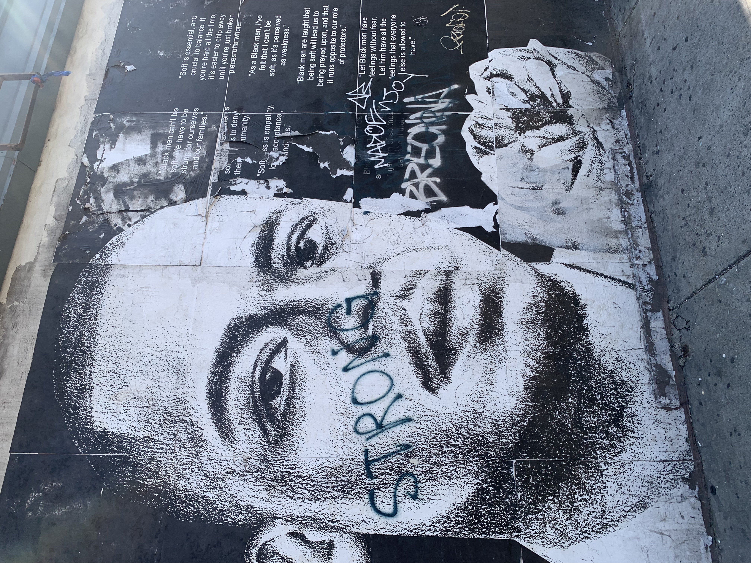
Jonathan Isserow
2020
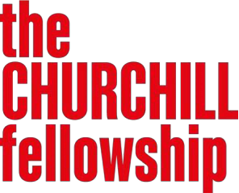 |  | 
Copyright ©2024 by Jonathan Isserow. The moral right of the author has been asserted.
The views and opinions expressed in this report and its content are those of the author and not of the Churchill Fellowship or its partners, which have no responsibility or liability for any part of the report.
Cover image Fig. 1: Tatyana Fazlalizadeh Mural, Brooklyn NYC, Copy Right, J. Isserow https://tlynnfaz.com/
Table of Contents
Abbreviations/ Glossary 4
About me 5
Executive Summary 6
Purpose of the report 8
Introduction to the project 8
Background 8
Aims and objectives 13
Findings 14
Cluster 1: Men, Masculinity and Mental Health 17
Cluster 2: Men’s Mental Health and Digital Resources 19
Cluster 3: Digital and Participatory methods 20
Conclusion and Recommendations 22
Recommendations 22
Next Steps 24
Bibliography 25
Further Reading 25

Acknowledgements
I received news that I was awarded a Churchill Fellowship in March 2020. No sooner had I begun to wrap my head around this accomplishment, than the world was plunged into the Covid-19 pandemic. At the time, travel seemed a remote possibility. My research plans fell into disarray and visiting the many people, places and organisations that I had initially contacted as part of my application, seemed indefinitely postponed.

Fast forward to the end of 2022, the world was in a different place and the opportunity emerged to finally undertake the Fellowship in 2023 and 2024. As a result of this protracted period, my acknowledgement and gratitude extend over four years!

First and foremost, I would like to thank the Churchill Fellowship for their belief in me and the importance of the project. I am immensely grateful for their support, professionalism and commitment spanning this period. I am immensely proud to be a Churchill Fellow.

My heartfelt thanks to the multiple people and organisations that I had the privilege to visit in North America. I am honoured to now call many friends.
Special thanks to the University of Roehampton and my colleagues for supporting this project. In particular, many thanks to Dr Yannis Fronimos, Dean of School of Psychology. Also, huge gratitude to my two original referees, Dr Janek Dubowski from Roehampton University and Prof. Stephen Hart from University College London.

I am grateful to also be supported in this endeavour by my family and friends including my sisters Deena, Desiree and Beverley. My friends Philippa Brown, Mark Cohen, Ken Jarold, Felicitas Rost and Guy Wilkins all of whom have provided insights into men, masculinity and mental health that continue to shape my thinking.

Last but not least, I would like to express my enormous gratitude to all the students and patients I have worked with – of all genders and identifications – and whose generosity and hard work inform my understanding of how relational creativity may foster wellbeing and at times, profound transformation.

Abbreviations/ Glossary

i. Participatory Methods
Approaches that actively involve people in shaping the research, design, or delivery of projects that affect them. Rather than being “subjects,” participants become co-creators, sharing their experiences, insights, and priorities to make the process more relevant, inclusive, and empowering.

ii. Critical Masculinities
A way of thinking that examines how ideas about masculinity are socially constructed, maintained, and linked to power. It challenges rigid or dominant forms of manhood (“hegemonic masculinity”) and explores how these norms can be harmful to both men and others, while opening space for more diverse, caring, and equitable masculinities.

iii. Art Psychotherapy
A form of therapy that uses creative art-making — such as drawing, painting, or sculpting — as a means of expression and exploration. It helps individuals process emotions and experiences that may be difficult to put into words, supporting insight, healing, and emotional wellbeing through creative practice.

iv. Intersectionality
A framework for understanding how different aspects of identity — such as gender, race, class, sexuality, and disability — intersect to shape people’s experiences of privilege and disadvantage. It reminds practitioners that men’s experiences of masculinity are not uniform but are influenced by their social and cultural contexts.

v. Feminist Lens
An analytical perspective that examines power, gender, and inequality, aiming to challenge systems that privilege men over women and reinforce gender hierarchies. In work on masculinity, a feminist lens encourages reflection on how gender norms affect everyone and promotes more equal, respectful, and compassionate relationships.

About me
I am an art therapist, documentary filmmaker and researcher at the University of Roehampton, London. I have a range of clinical experience from working in the NHS adult psychiatry, child and family mental health as well as in private practice.

Between 2006 – 2021 I was the Programme Leader of the MA in Art Psychotherapy at the School of Psychology, Roehampton where I also was the Head of the Arts and Play Therapies subject area between 2012-2021. The University of Roehampton offers a range of arts and play therapy modalities, and I have been immensely proud to have grown the art psychotherapy training from inception, alongside, and with, my colleagues. My educational and clinical experiences have deeply informed and inspired my understanding of the multiple ways that the arts may be used to engage people in therapeutic activities and may facilitate creative change.
I completed my PhD at UCL in 2018, exploring the intersection of documentary film and psychoanalysis. During this time, my interest in masculinity, representations of masculinity and the relationship between masculinity and mental wellbeing, came to the fore. In exploring developmental psychology, it quickly became evident how under-represented the role of the father is in the growth of the child.

This deepened my curiosity to understand — from both a personal and professional position — how masculinity might be negotiated, expressed and transmitted, particularly at periods of liminality such as adulthood, fatherhood, ageing or illness. As a documentary filmmaker and art psychotherapist, I have been passionate about how the visual might challenge and inform the ways that men might visually give expression to the narratives of masculinities, that may sit alongside and challenge more traditional representations. In doing so, I hope to contribute and extend the understanding of the multiple ways of being a man in the 21st Century.

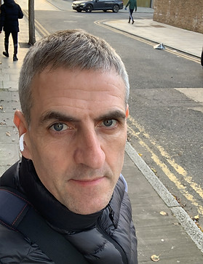

Email: j.isserow@roehampton.ac.uk

Websites:
Clinical: | https://www.jonathanisserow.co.uk/
Fellowship: | https://www.narrativesofmasculinity.org/
University of Roehampton: | https://pure.roehampton.ac.uk/portal/en/persons/jonathan-isserow
LinkedIn: | https://www.linkedin.com/in/jonathan-isserow-b25b455/?originalSubdomain=uk

Executive Summary
In the United Kingdom (UK) three out of every five men are at risk of mental health challenges. Generally, three out of every four suicides are by men, a trend seen since the mid-1990s (ONS 2023). It is sadly well-known that death by suicide is the highest killer of men aged between 20 and 34.

In complex and powerful ways, there are strong social, cultural and political forces that are shaping particular forms of masculinity that make men more susceptible to mental health difficulties. While death by suicide is high, an additional worrying phenomenon is that many men are living miserably in plain site. To begin to address this, there is a need to understand how working shoulder-to-shoulder with other men might begin to address this enormous challenge.

As part of my work as an art psychotherapist, I am interested in how digital and analogue creative mediums might offer engaging and transformative intervention. This has led me to consider if it might be possible for men – and anyone identified as male – to creatively come together, to learn from each about what it might be to be a man in the 21st century and in doing so, support men to live healthier, happier and longer lives. This interest has led me to directly explore and understand best practices for digital and participatory methods in men’s mental health. To do so, I looked outside the UK to enrich my understanding.
As a Churchill Fellow, I spent five weeks in Canada and United States of America (USA) to understand advances in masculinity, men’s mental health and creative & participatory methods.
During this time, I aimed to: 1). Gain insight into best practices of participatory visual, and digital methods that promote help seeking behaviours and well-being in men. 2) Empower men to re- present themselves in innovative & insightful ways. 3) Understand ethics and data management protocols of working safely with the transformational dimension of participatory methods. 4) Develop long-term relationships between North American organisations and myself to be able to share the learning & stay informed of new developments. 5) Develop guidelines and implement innovative programs back in the UK.
The following recommendations are a distillation of findings and insights from the Fellowship:
1. Celebrate men’s strengths to build engagement
Recognise and build on men’s existing strengths, interests and values to promote participation. Framing men as active partners, not problems to be fixed, encourages trust, motivation and sustained involvement.
2. Acknowledge that patriarchy harms men too
Recognise that rigid gender expectations restrict men’s emotional expression, relationships and wellbeing. Addressing the costs of patriarchy for men can open pathways to healthier, more compassionate forms of masculinity.
3. Prioritise participatory and co-constructed approaches
Design interventions with men, not just for them. Co-creating content and delivery ensures relevance, ownership and authenticity, strengthening both impact and sustainability.

4. Invest in preventative work
Shift from crisis response to early, preventative engagement. Equip men—especially younger men—with emotional literacy, relational skills and opportunities for healthy identity development before problems escalate.
5. Restore connection and reduce social isolation
Support initiatives that help men rebuild connection, community and friendship. Creating safe spaces for openness and mutual support can significantly reduce loneliness and improve mental wellbeing.
6. Expand ways of thinking about masculinities
Promote diverse, flexible understandings of what it means to be a man. Encouraging reflection and dialogue helps men move beyond narrow stereotypes and embrace identities grounded in empathy, care and self-awareness.
7. Confront homophobia and misogyny
Explicitly challenge the gender norms and prejudices that sustain homophobia and misogyny. Fostering respect, inclusion and equality benefits everyone and strengthens men’s emotional and relational health.
8. Harness digital resources within hybrid models
Develop high-quality digital tools that complement, rather than replace, face-to-face connection. Hybrid models offer accessibility and flexibility while maintaining the importance of human interaction and trust.
9. Use creative and participatory digital interventions
Employ visual storytelling, photography, and other participatory media to help men reflect on and re-imagine masculinity. Digital and creative approaches can engage diverse audiences and amplify authentic male voices.
10. Ensure gender-aware health responses
Health services must be attuned to how masculine norms influence behaviour, help-seeking and wellbeing. Gender-aware practice makes services more accessible, empathetic and effective for men of all backgrounds.
11. Apply an intersectional lens to promote inclusion and equity
Acknowledge that men’s experiences are shaped by race, class, sexuality, disability, culture and geography. Intersectional approaches ensure that mental health initiatives reach and resonate with all men, not just the most privileged.
12. Secure appropriate and sustained resourcing
Men’s mental health work must be properly funded, staffed and supported to achieve meaningful outcomes. Sustainable investment enables innovation, capacity-building and long-term impact.
13. Embed evaluation from the outset
Build evaluation into every stage of programme design and delivery. Ongoing reflection, evidence and learning strengthen accountability and help refine approaches over time.

Purpose of the report
The purpose of this report is to share my learning from the Churchill Fellowship and to begin to contribute to the understanding of how to effectively support men’s mental health and well-being in the U.K. through arts-based, participatory and digital interventions. The primary learning from my field study can be found synthesised into my findings.

The findings are broadly structured around three intersecting thematic clusters which are: men, masculinities & mental health, digital, arts-based & participatory methods and digital resources. Details of the people and places I visited are also grouped under each theme, which moves across geographic location. This report uses a case study of ‘Dudes Club’ which exemplifies community-based participatory intervention and some consideration of how it might inform practice in the UK is explored.

Towards the end of this report, I identify the primary recommendations from the Fellowship. I explore the importance of the interrelationship between notions of masculinity and men’s mental health and how they might be addressed through creative, participatory methods. I discuss the implications on future policy, clinical interventions and research in the UK. I articulate possible next steps that I endeavor to undertake on my return. The aim of this report is to further catalyze discussion and debate about the relationship between gender, health and well-being while holding in mind the multiple social determinants of mental health.

Introduction to the project

Background
Since undertaking the Fellowship and producing this report, the world has significantly changed. When I travelled to North America back in 2023 and 2024, the Russia-Ukraine war was – and continues to rage; the brutal occupation of Gaza was under way; Donald Trump was still a candidate in the USA elections; the UK supreme court had yet to rule on the definition of what a woman is and the impactful television show ‘Adolescence’ (Graham, S. and Thorne, J. 2025) had not yet been screened . The world felt a different place.

At the time that I visited North America, I was struck by the atmosphere that suggested to me that we were somewhat at a junction in our relationship to our ourselves and to our fellow human. This junction might be expressed in the following ways: on the one hand, do we choose to consider the world as comprised of complex and intricate interconnection where we are stronger by developing and negotiating the similarities and differences between us? On the other hand, do we choose to consider the world in simpler terms, as a threatening place with limited resources, where difference is a danger and where the optimal position is to fight to be first in an ever increasing isolationist and defensive manner? Do we embrace connection or engender separation? Or, to put it simply, do we choose love over hate?

This report emphatically champions the importance of connection, rather than isolation, of tolerance and respect, rather than fear and hatred of the unknown. It argues that each and every encounter with another human being is an opportunity for micro-practices of kindness, support and learning in everyday life. It contends that the hard work of trying to understand one another and ourselves is not only a rich and fruitful endeavour, but one that our humanity is dependent on for its survival. Centrally, this report argues that notions of gender and wellbeing are intimately connected to this relational positioning of either connection or isolation.

Broadly, it argues that more traditional socialisation of men that champions stoicism, emotional inexpressiveness, independence and power all contribute to a position of isolation. To begin to address this, there is a need to extend ways of understanding masculinity where connection and need of others is seen as a strength, rather than a vulnerability. Therefore, this report aims to celebrate the possible multiplicity of identifications and expressions of what it means to be a man in contemporary life today and how creativity might form a link to ourselves and one another. Prior to exploring this through the travelling Fellowship, this next section provides a broad context of the challenges of men’s mental health and wellbeing in the UK, that frames my research.

Crisis in Men’s Mental Health
It is estimated that globally, 60 men take their lives by suicide every hour of the day. This alarming statistic means that on average, somewhere in the world, one man dies by suicide every minute. Presented in this way, this data draws sharp attention to a crisis in men’s mental health on a global scale. Specifically, within the U.K, recent ONS (2023) data worryingly indicates the crisis in men’s mental health. In the U.K. three out of every five men are at risk of mental health challenges and generally, three out of every four suicides are by men, a trend seen since the mid-1990s (ONS 2023).

The ONS (2023) identified in 2022 that suicide rates were three times higher for men than for women. In England and Wales, suicide is the leading cause of death for men between 20-34. Provisional data for 2023 shows a 6% increase in suicides predominantly amongst middle-aged men (ONS 2024a). In addition, geographic location also has a significant impact on suicide rates in men. After accounting for age, the rate of male suicide in the North East is double that to London. It should be noted that the ONS collate data based on age, gender and geographic location. However, more detailed intersectional data to have a more nuanced understanding of is not available and would substantially inform the differentiated social determinates of men’s mental health challenges. This is a point explored further in this report.
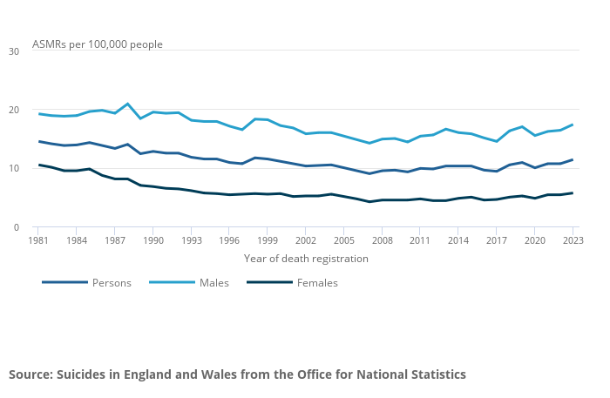
Fig. 2: ONS Age-standardised suicide rates by sex, England and Wales registered between 1981 and 2023 indicating that suicide rates increases in 2023

Hidden within these statistics is the significant mental health struggles that men endure. This may take the form of depression, anxiety and psychosis which may have a profoundly negative impact of relationships, work performance and the overall quality of life. There is something particular in the traditional social construction and socialisation of boys and men that makes the expression of feelings and help-seeking seem out of reach. Men are more susceptible to address their emotional and mental health struggles such as depression, anxiety and other mental health challenges through self-medication. This may take the form of alcohol or substance abuse, gambling and other addictive behaviours.
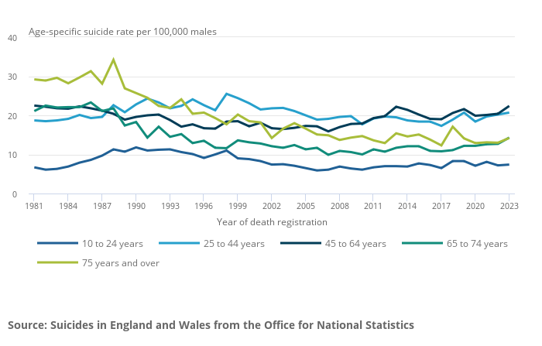
Fig. 3: ONS Age-specific rates by broad age group, males in England and Wales registered between 1981 and 2023 indicating that suicide rates for men aged 45- 64 years are highest since 2010.

Although there has been a growing intensity and proliferation of services to address men’s mental health over the past decade, there remains considerable need to develop gender sensitive mental health interventions. There is still the enormous need to support men’s mental wellbeing by increasing their sense of resilience and hope and by reducing the state of misery, where difficulties and struggles are often hidden in plain sight. My Churchill Fellowship is a modest contribution to the multiple voices and organisations that are committed to supporting men to lead healthier, happier and longer lives.

Feminist Contributions
In raising the need to further catalyse men’s mental wellbeing in the UK it is important to acknowledge the debt to feminism. Feminist theory has — since its inception — scrutinised and challenged traditional gender norms, power structures and social construction of gender, along with its impact on society and the individual. It has critically interrogated patriarchy and its ensuing power relations. It has drawn attention to how the socialisation of boys, and the raising of men, is played out, along with the mistreatment some men enact against women. Feminists’ attention to gender has advanced understanding of the way that men’s lives are also gendered, a phenomenon that is often made invisible.

In making men’s gender evident, Masculine studies lean heavily on feminist long-standing contributions that have challenge power structures and rigid gender binaries. Further, masculine studies – informed by Feminist theory - vehemently challenge men’s violence against woman and instead, promote equity and gender emancipation for all. Although it can be argued that men have historically been seen as relatively privileged, Feminist theory has also begun to understand the damage of patriarchy on both men and woman. bell hooks concisely encapsulates the cost of patriarchy for men when she writes that:

The first act of violence that patriarchy demands of males is not violence toward women. Instead patriarchy demands of all males that they engage in acts of psychic self-mutilation, that they kill off the emotional parts of themselves.

Feminist theory has significantly increased the understanding and awareness of men as men, drawing attention for the need for greater self-consciousness and explicit attention to gender and masculinity. Following this tradition, there is a growing recognition that the norms, practices and structures associated with masculinity shape a variety of social and health problems, including those associated with men’s mental wellbeing.

Theoretical Framework
This report – to state explicitly – uses a psychosocial model or lens to understand masculinity and men's mental health This lens emphasises the dynamic interplay between internal psychological factors, such as emotions, cognitive processes, & personal experiences, and external social factors, such as relationships, societal norms, social, political, cultural and environmental influences that shape thoughts, feelings and actions. By recognising the interrelationship between the social and the individual psychology, it supports the need for men to take a degree of responsibility for their wellbeing on the one hand, while at the same time acknowledging how policies substantially contribute towards the shaping of subjectivity, on the other, thereby alleviating some of the burden on the individual. In complex and interconnected way, any intervention needs to attend to both the individual where they are at, as well as the social, cultural and political level.

Intersectionality
Connected to a psychosocial framework is the understanding of men and masculinity through the idea of intersectionality. This means recognizing that men's experiences are shaped not just by their gender, but also by the interactions of different social locations that may include race or ethnicity, indigenous identity, class, sexuality, geography, age, disability/ability, migration status and religion. Further, these intersecting or interconnecting identities are also connected – in complex ways – to systems and structures of powers which may include laws, policies, government organisations, political and economic bodies, religious institutions and cultural media. In turn, through these systems and structures they may produce systems of privilege and oppression shaped by racism, ableism, imperialism, colonialism and patriarchy.

Intersectionality provides a key concept to look at the overlapping factors, to understand a more complex picture of what it means to be a man today and how different, interconnected experiences may impact men’s well-being. This approach highlights that masculinity is not a one-size-fits-all concept. It pushes us to move beyond stereotypes and recognise that each man's identity is unique and complex. When we understand these intersections, we're better equipped to offer support that genuinely meets men’s needs. It reminds us that promoting men's mental health requires questioning traditional ideas of masculinity and being aware of how societal inequalities and individual identities interact to shape every man's experience. No one lives single identity lives, and there are many experts and activators working on multiple axes, as a political act of resistance. Focussing on gender is a humble contribution towards social justice.

Multiplicity of masculinities and self-identification
It is useful to state explicitly that this report does not explore at any length notions of gender and identity politics. In the endeavour to be a practical record of my Fellowship, it embraces the multiplicity of what it might mean to be a man and to identify as one. We live in an age when gender norms are being challenged, and it is my belief that we can pick up and put down different dimensions and attributes to create our own evolving definition in how we consciously or unconsciously perform gender.

Trans and non-binary people challenge traditional ideas of masculinity by showing that gender is diverse and fluid. Their experiences open up new ways of understanding what it means to be masculine, helping to expand and enrich the many different forms of masculinity in the world today. As such, this report actively moves away from monolithic constructions of masculinity to the notion of a multiplicity of masculinise and identification with masculinity, that can extend and illuminate the multiplicity of men’s experience in the 21st Century. Haywood (2003), powerfully writes that:
Men’s and boy’s experiences are in fact being understood through an increasing number of different masculinities. A consequence of this is that the diversity, richness and multifaceted nature of men’s and boy’s experiences became pigeonholed into theoretical models of masculinity (Haywood, p.24)

This Fellowship has at its heart the creative endeavour to both ‘do’ and ‘undo’ different forms of masculinity and in doing so, promote non-violence, gender equity and gender emancipation as a primary creative act and a route to mental wellbeing.

Participatory and Creative Methods
In the exploration of making spaces where men can learn from other men, this investigation has been driven by participatory and creative methods. These methods represent a shift from traditional top-down approaches to research, policy-making, and development projects. They emphasize the active involvement of partners, especially those who are usually marginalized, in the process of knowledge creation and decision-making. While these methods foster inclusivity and innovation, they are not without limitations. As explored further in the report, participatory and creative methods can be time-consuming and require careful planning to ensure all voices are genuinely heard.

They may also be challenging to implement consistently. Analysis of data collected through participatory and creative approaches can be complex, as it often involves interpreting non-traditional forms of communication or expression. Despite these challenges, these methods can foster trust, build community, and enable participants to express their experiences and ideas in ways that are comfortable and meaningful, often leading to richer, more authentic insight. Therefore, the method is in synergy with developing insight and connection within and between men

Impact of Covid-19, BLM and Me Too# on my Churchill Fellowship
Within weeks of finding out that I had the enormous honour to receive a Churchill Fellowship, the world was plunged into the Covid-19 pandemic. All plans I had made where in disarray and I wrote to all my contacts to say that my Fellowship was postponed. In the face of an unknown future, it was challenging to maintain my passion in men’s mental health. The pandemic and the emergence of the Black Lives Matter movement, following the death of George Floyd, brought to light the deep inequalities that exist in our society and the ways certain groups continue to hold dominant positions. These moments made me pause and reflect on my own privilege—on how my experiences are shaped by systems that advantage some while marginalising others—and challenged me to think more deeply about my role in addressing these imbalances.

Impact of Covid-19, BLM and Me Too# and Men’s Health
The COVID-19 pandemic, Black Lives Matter movement, and Me Too# movement have significantly influenced the discourse within Masculine Studies. The pandemic has laid bare the vulnerabilities and inequities experienced by individuals across gender lines, prompting a re-evaluation of traditional notions of masculinity centred on stoicism and self-reliance. Black Lives Matter has shed light on the intersectionality of race and gender, highlighting the unique challenges faced by men of colour and emphasizing the importance of addressing systemic injustices in understanding masculinity. Social determinants of health came to the fore.

Similarly, the Me Too# movement has sparked conversations about toxic masculinity, consent, and power dynamics, prompting scholars within Masculine Studies to examine the ways in which gendered expectations contribute to instances of harassment and violence. These movements collectively push Masculine Studies to adopt a more intersectional and inclusive approach, acknowledging the diverse experiences and identities within masculinity while advocating for positive change and social justice.

It should also be noted that I’ve found the term toxic masculinity useful for naming some of the harmful pressures and behaviours linked to traditional male roles, but I also see how it can be limiting. It risks painting all expressions of masculinity with the same brush, creating another fixed idea rather than recognising the many different ways men experience and express their identities.

Aims and objectives
The overarching aim of the Fellowship was to understand how best to support men have healthier, happier and longer lives in the UK and how arts-based, participatory and digital interventions might contribute towards this. To this end, I wanted to explore contemporary practices into this area in two international contexts of Canada and USA, to understand and link up a range of thought leaders and organisations working in this space and to learn from them how they conceive and deliver participatory interventions in men’s mental health.

Men’s Health Forum's published report (2014), ‘How to make mental health services work for men’ identifies the need for service user designed, shoulder-to-shoulder, activity-based, interventions. As an art therapist I am passionate that visual & participatory methods can creatively engage men in life sustaining services & represent men anew. It is crucial to research best practices from innovative leaders & projects in North America to transform men’s mental health & well-being back in the UK.

To support this, my Fellowship sought to meet the following objectives:
- Gain insight into best practices of participatory visual, and digital methods that promote help seeking behaviours & well-being in men
- To empower men to re- present themselves in innovative & insightful ways •Understand ethics and data management protocols of working safely with the transformational dimension of participatory methods
- Develop long-term relationships between North American organisations & myself to be able to share the learning & stay informed of new developments •Develop guidelines and implement innovative programs back in the UK
- Evaluate the achievement and the impact of the program in promoting well-being. It uniquely draws on digital, art therapy & participatory methods in the design, delivery & research of men's mental health services in the UK
- Explore ways of engaging anyone who identifies as a man to come together and learn from each other, across intersectional axes
To meet these objectives, I travelled to the USA and Canada in June 2023 and March 2024. In total, I spent five weeks travelling North America and had the opportunity to meet academics, practitioners and services in Vancouver, Denver, Los Angeles, Boston, Amherst and New York. During this time, I attended the UBC Reducing Men’s Suicide, Research Excellence Cluster conference in Vancouver in June 2023, which constituted one of the highlights of my Fellowship.

Findings
On my Fellowship, I was incredibly fortunate to meet many thought leaders and visit inspiring organisations. The breadth and depth of the experience can be found on my blog. The range of people, places and organisations has been listed in the table below along with the key coding that is structured into three thematic clusters. These findings explicate some of the highlights of the investigation.

People, organisations and geographic locations visited as part of the Fellowship:

Location | Visit | Links | Theme Key
Denver | Joe Conrad, Man Therapy | https://mantherapy.org/
 | Jarrod Hindman,  LivingWorks | https://www.sprc.org/users/Hindman
 | Dave Morlan, Fellowship Denver Church | https://www.thegospelcoalition.org/profile/david-morlan/
 | Marty Ortanez, Denver University | Denver University
Los Angeles | Elan Javanfard, Didi Hirsch Suicide Prevention Centre | https://didihirsch.org/about-us/  https://didihirsch.org/services/suicide-prevention/
 | Dr Joshua Cohen,  Film and video-based Therapy | https://filmandvideobasedtherapy.com/about-us/
 | Elisabeth Nails,  Creative Wellbeing, Suicide Prevention Network | https://www.linkedin.com/in/elisabethnails/
 | Michelle Carlson  Movember USA | https://us.movember.com/
Vancouver | Dr John Ogrodniczuk,  UBC | https://headsupguys.org/
 | Reducing Male Suicide  UBC | https://reducingmalesuicide.ubc.ca/
 | Dr Paul Gross  Dudes Club | https://dudesclub.ca/
 | Prof David Kuhl  UBC | https://www.blueprint.ngo/
Boston | Sebastian Molano, Oxfam Gender Advisor | https://www.oxfamamerica.org/explore/people/sebastian-molano/
Amherst | Dr Aline Gubrium, University of Massachusetts | https://www.umass.edu/family/people/aline-gubrium
 | Dr Sally Campbell Pririe, University of Massachusetts | https://sallypirie.com/about/
Springfield | Boysen Hodgson, Man Kind Project, USA | https://mkpusa.org/boysen-hodgson/
New York | Jason Tan de Bibiana, Next Gen Men | https://www.nextgenmen.ca/
 | Mark Greene, Remaking Manhood | https://remakingmanhood.com/
 | Ludo Gabriele, Catalyst | https://www.catalyst.org/
 | Michael Kimmel | https://www.michaelkimmel.com/
 | The Animation Project | https://www.theanimationproject.org/team

Cluster 1: Men, Masculinity and Mental Health
This theme explores the intricate relationship between men, masculinity, and mental health, highlighting how societal expectations and cultural norms may influence men's experiences and attitudes toward mental well-being. By examining these connections, the section aims to shed light on the barriers men often face in seeking support and how a reframing of masculinity may foster better mental health outcomes. In June 2023 I travelled to New York where I met Mark Green who is a thought-leader in the gender equity and men's mental health space. On his website, Remaking Manhood you can also find the Remaking Manhood: Healthy Masculinity Podcast ,which he co-hosts with Charles Matheus. It makes for rich listening and is another amazing resource to explore the progressive men's work taking place on the East Coast.
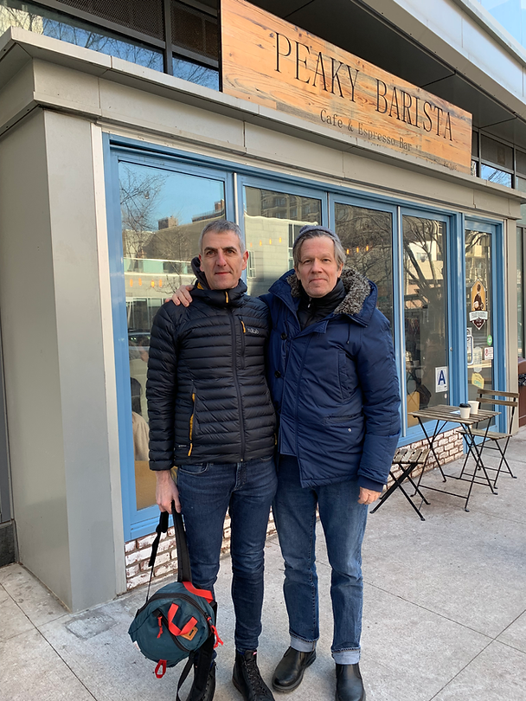 | Fig. 4: Mark Green and me discussing Remaking Manhood and Healthy Masculinity Podcast in New York. (Credit: J. Isserow)

One of the central tenants that Mark draws on is the idea of the Man Box. This is the narrow and limiting codes of conduct around masculinity that young boys are inculcated into from the get-go that severs them from more vulnerable and relational feelings that may be perceived as either feminine and/or gay. From inside the Man Box, boys and men police each other and themselves, in order to comply with its regulations and to stay within. The cost of this, to personal connections and to the self, is high.
Mark has thoughtfully written about the History of the Man Box , tracing its development from Paul Kivel's "Act like a Man Box', to Tony Porter's user friendly 'Man Box' in his A Call To Men site and hugely popular TED talk. The seven pillars of Man Box that have become cultural edicts include: self-sufficiency, acting tough, physical attractiveness, rigid gender roles, heterosexuality and homophobia, hypersexuality, and aggression and control.

The difficulty with Man Box culture is that it privileges success over connection. It perpetuates isolation and disconnection. It is the restoration of this connection that Mark places as central to his work by illuminating these dangers of Man Box. The concept of the Man Box can be a useful shorthand to understand a particular kind of construction of masculinity. Alongside this is also the need to develop subtle conceptualisations of healthy masculinity to ensure all kinds of men might engage with this work. Another dimension of our discussion included Mark providing insights into where energy might be placed for future work. We discussed doing this at the level of early childhood - to challenge and expand notions of masculinity. We also discussed the need to support men restore connection at all developmental stages. I am immensely grateful to Mark for his insights, time and generosity! I was left from the encounter thinking about how the man box keeps at bay anxieties about the feminisation of men as well as clear homophobia. These are powerful unspoken barriers to challenging the man box. To have another view of masculinity means stepping out or coming out of the man box. It also means a return or renewal of ideas about masculinity and to understand that, it is useful to turn to the work of Steven Botkin.

A foundational return:

I had the opportunity of meeting Steven Botkin in Amherst. Steven founded the Men’s Resource Center of Western Massachusetts in 1982 and received his doctoral degree in Social Justice Education from the University of Massachusetts several years later. He guided the MRC from a grass-roots group of volunteers into a successful non-profit community-based organization, whose programs became a model for men’s organizing in communities around the world. For an exemplar of this, see RWAMREC in Rwanda. Steven's thoughts and insights into men's mental health and gender equity are far ranging and do not need to be rehearsed here. However, a good introduction to his work can be found in his recent talk on Best Practices for Training Men to Engage in Gender Equality.

There is a need to return to his foundation 'Beliefs About Men', that which Steven articulates as being:
- Boys are born naturally loving, caring and sensitive
- Boys are trained to be masculine in a way that leads to domination and violence as well as disconnection and confusion
- Boys have been traumatised by violence and abuse as victims, and as witnesses. This may be in our families, on the street, through the media, racism, classism, homophobia etc
- Men are both privileged and damaged by masculinity and violence
- Violence and domination are used by to control and vulnerability, to protect privileges
- Men are eager to reclaim our natural caring and hungry for re-connection with ourselves, our loved ones and our community
- Men can become role models for positive masculinity and agents of change in their families and communities
- As partners with people of all genders, men can play an important role in ending the cycles of violence, supporting gender equality and creating healthy families and strong communities

In thinking about men's mental health and where to place energy to bring potential change, do you focus on the social or the personal? Steven reminded me that there is a need to move away from the dichotomy of the 'or' but rather to replace this with the 'and'. In terms of gender and men's work, there is a need to focus on stopping violence against woman AND there is a need to focus on supporting men. The 'or' sets up a tension and if we are to be successful, we need to see it as an 'and' of both psychological and social focus.
That the training and socialisation of masculinity of boys leads to disconnection, and how we return to connection, is at the heart of the work, and in turn, central to this Fellowship.

Check out Steven's Merge for Equality site with its wonderful range of tools and resources. It is really a treasure trove, along with the Men Engage Alliance YouTube channel. There is a cornucopia of learning opportunities. More than anything, the encounter with Steven was deeply personal, honest and moving. His humanity and modesty engender an I — Thou relationship. It is this connection that I carry with me from our meeting, beyond all the rich insights and understanding.

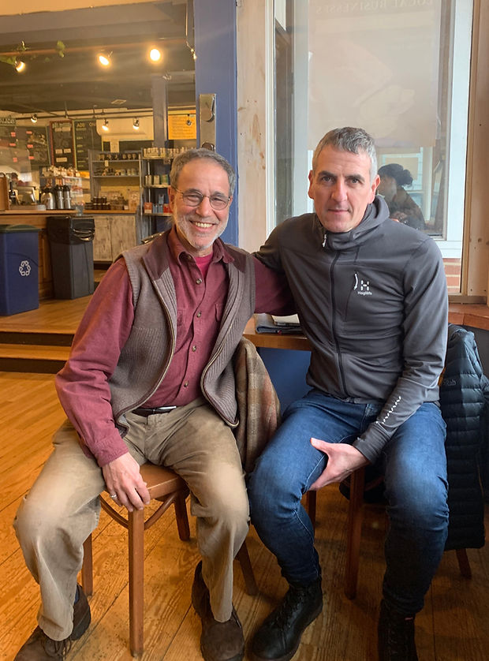 | Fig. 5: Steven Botkin and me discussing the formation of the Men’s Resource Centre in Amherst, Mass. (Credit: J. Isserow)

Cluster 2: Men’s Mental Health and Digital Resources
In an increasingly digital world, the use of online resources has become essential for addressing men's mental health and masculinity. Digital platforms offer accessible, stigma-reducing environments where men can explore their identities, seek support, and access vital information. Recognising the evolving landscape of mental health support, this report highlights the importance of leveraging digital resources to promote well-being, challenge stereotypes, and foster healthier expressions of masculinity.

Case Study: Man Therapy
I had the unique opportunity to meet Joe Conrad - CEO of Grit Digital Health whose team generated ‘Man Therapy’. This was a passion project, made at breakneck speed on a small budget. Through their talent, creativity and daring they produced video content that uses humour to engage men in potentially life-saving psychoeducational material. When I first encountered the video content, I was slightly dubious about the fictional therapist ‘Rich Mohagany' as he seemed to perpetuate traditional notion of masculinity. However, from speaking to Joe and exploring the material further, this character provides the hook to engage men who otherwise would be completely averse to accessing support. It seems to have found the sweet-spot for being familiar-enough for guys to identify with, yet sufficiently different to motivate behavioural change.

Impressively, recent independent research has confirmed its meaningful impact. The results for a four-year, $1.2 million study, funded by the CDC, shows that Man Therapy not only helps reduce depression, suicide risk, and poor mental health days, it also improves help-seeking behaviour in working-aged men. Explore the research.

To address issues of greater representation, Grit are aiming to include voices of different, actual therapists to inform the material in Man Therapy 3.0. One of the challenges of Man Therapy is the use of humour to engage men but in doing so, there is a danger of perpetuating, rather than challenging, a stereotypical notion of masculinity. The conceptualisation is certainly interesting, and recent research suggests it is efficacious. However, a more nuanced representation of masculinity might have broader appeal. Whether one personally engages with Man Therapy or not, this project has demonstrated its longevity which is evident of its appeal.

 | 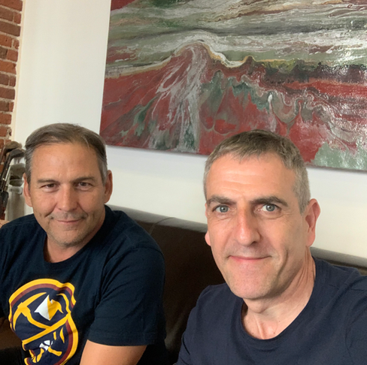 | 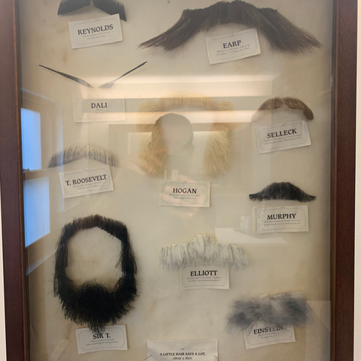

Fig. 6: Joe Conrad and me at Grit Digital Health in Denver. (Credit: J. Isserow)

Cluster 3: Digital and Participatory methods
In addressing men's mental health, traditional intervention approaches often overlook the importance of engaging men as active participants in their own well-being. The integration of participatory and digital methods offers a promising avenue to enhance outreach, facilitate open communication, and tailor support to individual needs. These approaches foster a more inclusive and accessible environment, encouraging men to share their experiences and access resources in ways that resonate with their lifestyles. This report explores the critical need for adopting participatory and digital strategies to improve mental health outcomes among men and highlights their potential to transform intervention practices.

Case Study: DUDES Club, Vancouver, Canada
The DUDES Club has managed to find the 'secret sauce' to generative men's mental health intervention. The DUDES Club was established in the Vancouver Downtown Eastside in 2010 and since then clubs have been set up in communities across British Columbia. The DUDES Club is a proven model for Indigenous men’s wellness promotion that builds solidarity and brotherhood, enabling men to regain a sense of pride and purpose in their life. Frank Cohn , Jacob Fitzpatrick and his team provided a comprehensive overview of their service which is uniquely participant-led for men's health and wellness.

This means that at times the process is messy and the progress slow. However, it also means substantial by-in by the men who make the DUDES club their own. Steeped in local indigenous cultural, they provide a space for non-western forms of healthcare practices that privilege cultural competencies, relationships and connection to the land. Interestingly, their evaluation embraces both western and non-western, or post-colonial epistemologies. This approach makes me consider the possible development of a progressive masculine methodology and epistemology, which is yet to be fully developed. I am deeply grateful to Frank, Jacob and all the people at The DUDES club for such an awe-inspiring visit!

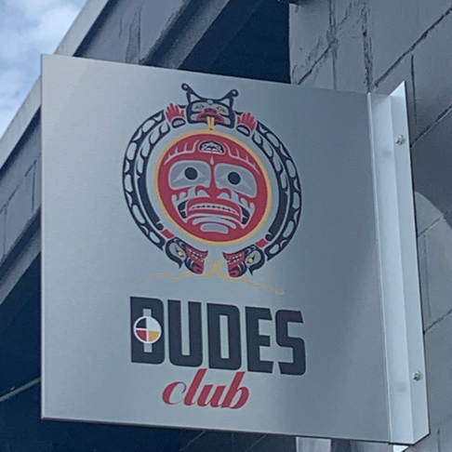 | 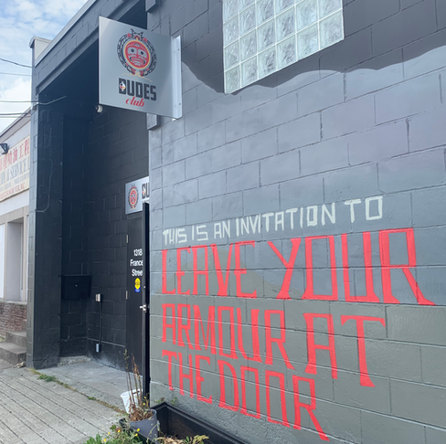 | 
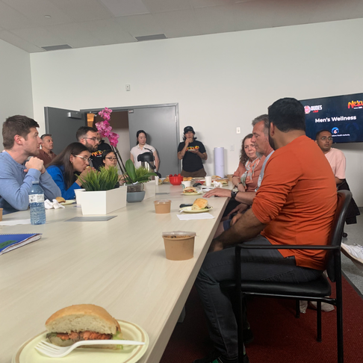 | 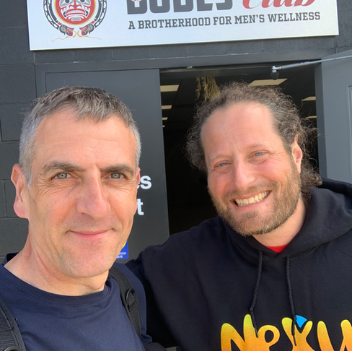 | 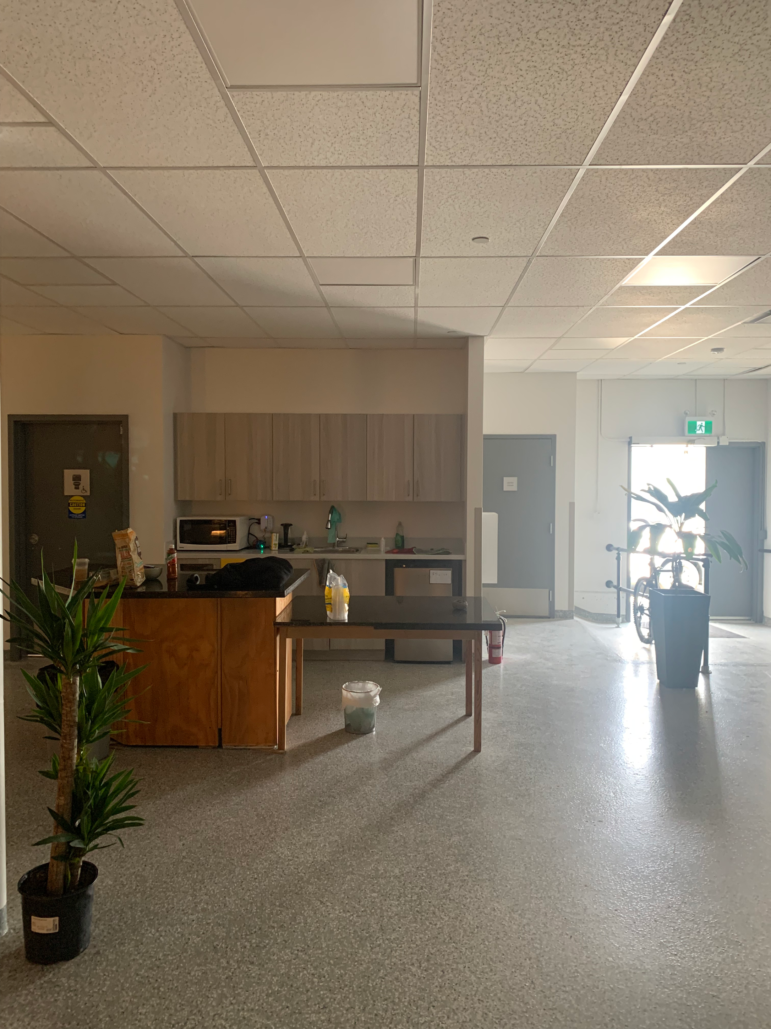
Fig. 7: Frank Cohn and me at Dudes Club in downtown Vancouver. (Credit: J. Isserow)

Conclusion and Recommendations
This Fellowship has underscored that meaningful progress in men’s mental health requires moving beyond deficit-based approaches towards strength-based, inclusive and participatory models. By recognising the costs of rigid masculine norms, celebrating men’s capacities, and working collaboratively to reshape narratives of masculinity, we can foster connection, empathy and wellbeing. Sustainable change will depend on continued investment, intersectional awareness and embedded evaluation to ensure that interventions remain relevant, effective and equitable.
Ultimately, reimagining masculinities is not only a mental health imperative but a social one—creating space for men to live, relate and thrive with authenticity and compassion.

Recommendations
The following recommendations are a distillation of findings and insights from the Fellowship:
  - 1. Celebrate men’s strengths to build engagement
- Effective engagement begins by recognising men’s existing strengths — such as commitment, responsibility, and a desire to contribute.
- Approaches that highlight men’s value and potential are more successful than those that frame them as problems to fix.
- Celebrating men’s skills and lived experiences fosters participation and ownership in mental health initiatives.
  - 2. Acknowledge that patriarchy harms men too
- Patriarchal norms that reward toughness and emotional restraint harm men’s mental health and relationships.
- Recognising these costs helps men question restrictive expectations and embrace more open, connected ways of being.
- Naming patriarchy’s impact reframes men’s wellbeing as part of gender equality, not separate from it.
  - 3. Prioritise participatory and co-constructed approaches
- Involving men in designing and leading interventions ensures relevance and authenticity.
- Co-creation builds trust, commitment, and sustainability by valuing men’s voices and lived experience.
- Participatory models shift the relationship from “service user” to “co-creator,” leading to stronger outcomes.
  - 4. Invest in preventative work
- Early intervention is crucial: teaching emotional literacy and communication skills before crisis points reduces long-term harm.
- Preventative initiatives should focus on schools, workplaces, and community spaces where men already gather.
- Framing mental health as strength-building rather than problem-solving helps normalise support-seeking behaviour.
  - 5. Restore connection and reduce social isolation
- Many men face loneliness due to norms that discourage emotional openness or dependency.
- Creating safe, non-judgmental spaces for men to connect fosters belonging and resilience.
- Rebuilding community ties strengthens men’s wellbeing and prevents crises of isolation and despair.

  - 6. Expand ways of thinking about masculinities
- Masculinity is not one fixed ideal; there are multiple, healthy ways to “be a man.”
- Encouraging men to explore and redefine masculinity allows for emotional range, empathy, and care.
- Broadening representations of men challenges stereotypes and promotes mental health through flexibility and acceptance.
  - 7. Confront homophobia and misogyny
- Tackling prejudice and rigid gender boundaries is essential for healthier masculinities.
- Challenging homophobia and misogyny helps men form more respectful and authentic relationships.
- This work benefits not only others but men themselves, freeing them from limiting social pressures.
  - 8. Harness digital resources within hybrid models
- Digital tools expand access, especially for men who may be reluctant to engage face-to-face.
- Online platforms can complement in-person work, offering anonymity, flexibility, and ongoing connection.
- Blending digital and in-person approaches ensures reach without sacrificing relational depth.
  - 9. Use creative and participatory digital interventions
- Visual storytelling, photography, and other creative media help men explore and express identity in accessible ways.
- Participatory digital methods let men author their own narratives of masculinity, challenging stereotypes through authentic stories.
- These approaches work particularly well in hybrid environments where digital sharing reinforces real-world reflection.

  - 10. Ensure gender-aware health responses
- Services should consider how masculine norms shape men’s engagement, risk-taking, and help-seeking.
- Gender-aware health responses adapt language, settings, and delivery to make support feel approachable and relevant.
- Integrating an understanding of masculinity improves both access and outcomes across health systems.
  - 11. Apply an intersectional lens to promote inclusion and equity
- Men’s experiences differ across race, class, sexuality, disability, and culture — one size does not fit all.
- Intersectional practice helps ensure that interventions are inclusive and responsive to diverse needs.
- Recognising overlapping inequalities is essential for addressing health disparities among men.
  - 12. Secure appropriate and sustained resourcing
- Long-term, stable investment is essential for meaningful and lasting change.
- Proper resourcing supports skilled staff, training, creative approaches, and the infrastructure needed for hybrid delivery.
- Short-term funding limits impact; sustainable investment ensures continuity and community trust.
  - 13. Embed evaluation from the outset
- Evaluation should be integral, not an afterthought — informing design, delivery, and refinement.
- Built-in learning loops allow programmes to adapt and demonstrate real impact.
Evidence-based reflection strengthens accountability, attracts funding, and improves future practice. (See Galdas, P., Seidler, S. and Oliffe, J. 2023).

Next Steps
Building on the learning and reflections from this Fellowship, the next stage is to embed these insights into practical, creative, and collaborative action. The focus should be on developing inclusive spaces that support men’s wellbeing, challenge limiting gender norms, and amplify diverse voices and stories of masculinity. Sustained impact will depend on partnership working, creative engagement, and the integration of evidence, reflection, and compassion across all levels of practice and policy.
Five key next steps:
- Establish a staff men’s group at my place of work — Create a supportive, confidential forum where men can discuss wellbeing, relationships, and identity, fostering connection and emotional openness in the workplace.
- Develop partnerships with local and national organisations — Build collaborations with men’s health networks, community initiatives, and advocacy groups to share resources, learning, and practical approaches.
- Pilot a creative, participatory project — Use digital media, photography, or spoken word to help men explore and express their experiences of masculinity, identity, and mental health in empowering ways.
- Host an international conference on men’s mental health and masculinities — Explore ways to bring together academics, practitioners, policy-makers, and participants to share research, practice innovations, and lived experience, fostering global dialogue and collaboration.
- Develop a digital resource hub — Curate an online platform that showcases creative outputs, research, and practical tools for engaging men in wellbeing and identity work across diverse contexts.

Bibliography
Office for National Statistics (ONS), released 29 August 2024, ONS website, statistical bulletin, Suicides in England and Wales: 2023 registrations

Galdas, P. M., Seidler, Z. E., & Oliffe, J. L. (2023). Designing men’s health programs: The 5C framework. American Journal of Men's Health, 17(4), 15579883231186463.

Haywood, C., & Mac an Ghaill, M. (2003). Men and masculinities: Theory, research and social practice. Open University Press.

Further Reading
Chu, J. Y., & Gilligan, C. (2014). When boys become boys: Development, relationships, and masculinity. In When Boys Become Boys. New York University Press.

hooks, b. (2000). All about love: New visions.

Kimmel, M. (2017). Angry white men: American masculinity at the end of an era. Hachette UK.

Reichert, M. C. (2020). How to raise a boy: The power of connection to build good men. Penguin.

Way, N. (2011). Deep secrets: Boys' friendships and the crisis of connection. Harvard University Press.

Way, N., & Chu, J. Y. (2004). Adolescent boys: Exploring diverse cultures of boyhood. New York University Press.

Yarrow, A. L. (2018). Man out: Men on the sidelines of American life. Bloomsbury Publishing USA.

