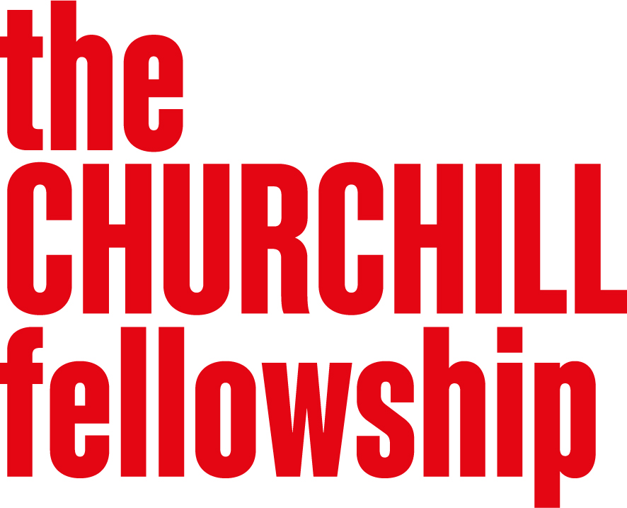
Promoting Lifelong Health
Programme Brief

  - Background
The foundations of lifelong health are laid long before illness appears. From the earliest stages of life through to older age, the environments we live in, the opportunities available to us and the support we receive all shape our health and wellbeing. Yet across the UK, more people are living with long-term health conditions, while significant health inequalities mean that not everyone has the same opportunity to live a healthy life.
Improving the nation's health has become a growing priority for governments, health services and communities alike. While much attention is rightly focused on treating illness, there is increasing recognition that lasting change comes from understanding how to promote health throughout people's lives and address the factors that influence wellbeing long before someone reaches a hospital or clinic. This challenge is reflected in recent data showing that healthy life expectancy in the UK has fallen to around 61 years for both men and women, meaning people can expect to spend only around 61 years of their lives in good general health despite living considerably longer.
When developing this programme in 2024, we recognised an opportunity to explore lifelong health in its broadest sense — from pre-conception to later life. We were interested in learning from promising approaches around the world that help people stay healthier for longer, prevent or better manage long-term conditions, and reduce inequalities in health outcomes. By learning from promising approaches around the world, Fellows can help bring fresh perspectives and practical ideas to the UK's own health and wellbeing challenges.
The first cohort of Fellows was awarded in 2025, and a second cohort will be announced in 2026. Applications for the final cohort will open in September 2026, continuing the programme's focus on identifying practical solutions that can help more people live healthier lives throughout the life course.
You can find more information about the projects supported under this programme on our website. Exploring a similar issue will not count against your application, but we encourage you to consider your unique perspective and approach.
  - Why this programme matters
The UK faces growing pressures from an ageing population, rising levels of chronic illness and persistent health inequalities. While these challenges are often discussed in terms of healthcare, many of the factors that shape health sit beyond the health and care system itself.
We were particularly interested in approaches that recognise this reality. Some of the most effective solutions can come from unexpected places — from schools and workplaces to housing, transport, community organisations and local environments. They recognised that improving lifelong health requires action across many different parts of society, as well as support for people living with long-term conditions.
The programme therefore takes a broad view of what contributes to lifelong health, recognising that better outcomes can be achieved through action at many different points across the life course and across many different sectors.
  - What we are looking for
We welcome applications on any topic that aims to improve lifelong health by preventing, reducing or helping people live well with long-term health conditions.
Projects may focus on any stage of life, from conception to later life, and can address health challenges at an individual, community, organisational or system level.
We are particularly interested in projects that explore how to:
- Prevent ill health and improve health outcomes
This might include approaches that support healthy development, reduce risk factors, improve early intervention, strengthen prevention or help address inequalities in health outcomes.
- Help people live well with long-term health conditions
This might include improving quality of life, access to support and services, self-management, inclusion, independence or experiences of care for people living with long-term conditions and their families.
- Create the conditions for better health
This might include exploring how factors such as education, housing, employment, social connection, community participation, public services or the built environment influence lifelong health and wellbeing.
We welcome projects from a wide range of sectors and disciplines. Strong applications will demonstrate a clear connection between the issue being explored and the potential to improve lifelong health outcomes in the UK.
  - We are less likely to support projects that:
- Focus primarily on a single treatment, therapy, intervention or clinical technique without demonstrating broader relevance to lifelong health.
- Focus mainly on individual fitness, wellness or lifestyle activities without a clear connection to health outcomes, prevention or health inequalities.
- Do not demonstrate a clear connection to improving lifelong health, reducing inequalities or supporting people living with long-term health conditions.
- Lack a clear rationale for learning from other countries and communities.
- Do not show how the learning could inform positive change in the UK.
  - Developing your application
When developing your application, we encourage you to:
- Think broadly about where opportunities to improve lifelong health might lie. Health is shaped by many factors across people's lives, including communities, services, environments and wider systems
- Clearly define the challenge, opportunity or area for improvement that you want to explore, ideally one that you are already working on or have a strong connection to
  - Explain why it matters and who it affects, particularly where there is an opportunity to improve lifelong health, reduce inequalities or support people living with long-term health conditions
Who should apply
- We welcome applications from people with lived experience, community leaders, practitioners, professionals, researchers, policymakers, campaigners and others who are working to improve health and wellbeing in the UK.
- Applicants may come from a wide range of sectors, including health and care, public health, education, housing, local government, charities, social enterprises, academia, business and community organisations.
- You do not need to work in healthcare to apply, nor do you need to be an established expert in your field. We welcome applications from people at all career stages and from a wide range of backgrounds.

